Harmonised principles for Baltic LFC reserve prequalification

Elering AS

AS “Augstsprieguma tīkls”

LITGRID AB

Table of Contents

1 Objective 4

1.1 Abbreviations 4

1.2 Definitions 5

2 Prequalification process description 7

2.1 Prequalification process 7

2.2 Prequalification requirements 10

2.3 Data exchange requirements 10

3 General technical requirements for LFC Reserve Units 12

3.1 Frequency ranges 12

3.2 Voltage ranges 12

3.3 Immunity to voltage disturbances 13

3.4 ROCOF withstand capability 14

3.5 Delivery points and LFC reserve provision 14

4 FCR service technical requirements and prequalification testing procedures 15

4.1 FCR service description 15

4.2 FCR service technical requirements 16

4.2.1 FCR service activation process and requirements 16

4.2.2 FCR activation accuracy requirement 18

4.2.3 FCR service continuity and FCR provider availability 20

4.2.4 FCR provision in in case of large frequency transients and emergency state 20

4.2.5 Real-time data requirement for FCR service providers 22

4.2.6 Requirement of the reserve connecting TSO 23

4.3 Additional requirements for LER FCR providers 23

4.3.1 LER FCR provider energy reservoir management requirements 23

4.3.2 LER FCR minimum full activation time in alert state 24

4.3.3 LER FCR providing unit prequalification scaling 26

4.3.4 Real-time data requirement for LER FCR providers 27

4.4 Additional requirements for FCR reserve providing groups 27

4.4.1 Activation of FCR providing groups 27

4.4.2 Composition of FCR providing group 28

4.4.3 Composition change requirements for FCR providing group 28

4.4.4 Data provision requirements for FCR providing groups 29

4.5 FCR prequalification procedure 30

4.5.1 Characterisation of static parameters of frequency control 30

4.5.2 Characterisation of dynamic parameters of frequency control 33

4.5.3 Additional tests for potential FCR providers with LER: Confirming the Reserve Mode activation and operation 36

5 FRR prequalification technical requirements and testing procedures 38

5.1 Frequency restoration process description 38

5.2 aFRR service description 39

5.3 aFRR service technical requirements 40

5.3.1 Activation of aFRR 40

5.3.2 Accuracy of measurement and control for aFRR 40

5.3.3 aFRR service continuity and aFRR provider availability 41

5.3.4 LER aFRR provider energy reservoir management strategy description 41

5.3.5 Real-time data requirement for aFRR service provider 42

5.3.6 Requirement of the reserve connecting TSO 43

5.4 Additional requirements for aFRR providing groups 43

5.4.1 Activation of aFRR providing group 43

5.4.2 Composition of aFRR providing group 43

5.4.3 Composition change requirements of aFRR providing group 44

5.4.4 Data provision requirements for aFRR providing group 44

5.5 aFRR prequalification procedure 44

5.5.1 Purpose of the Test 45

5.5.2 Initial conditions 45

5.5.3 Testing method 45

5.5.4 Data analysis 46

5.6 mFRR service description 47

5.7 mFRR technical requirements 47

5.7.1 Activation of mFRR 47

5.7.2 mFRR service continuity and mFRR provider availability 47

5.7.3 Accuracy of measurement and control for mFRR 48

5.7.4 LER mFRR provider energy reservoir management strategy description 48

5.7.5 Data exchange requirements for mFRR providers 48

5.7.6 Requirement of the reserve connecting TSO 49

5.8 Additional requirements for mFRR providing Groups 49

5.8.1 Activation of mFRR providing group 50

5.8.2 Composition of mFRR providing group 50

5.8.3 Composition changes of mFRR providing group 50

5.8.4 Data provision requirement for mFRR providing group 51

5.9 mFRR prequalification procedure 51

5.9.1 Purpose of the Test 51

5.9.2 Initial conditions 52

5.9.3 Testing method 52

5.9.4 Data analysis 53

# Objective

Transmission System Operators (hereinafter referred to as TSO) in Baltic – Elering AS, AS Augstsprieguma Tīkls and Litgrid AB (hereinafter refer to as Baltic TSOs) plan to establish Baltic LFC block with three LFC areas representing each TSO and enable co-operation on the Baltic LFC capacity market. Further information on the Baltic LFC concept is provided in the Baltic LFC concept document ([link](https://elering.ee/sites/default/files/2021-01/Baltic%20Load-Frequency%20Control%20concept%20document.pdf)). To ensure level playing field for capacity market participants, the Baltic TSOs need to harmonise the main technical requirements and prequalification principles.

In this document Baltic TSOs describe the technical requirements for all LFC reserve types and the prequalification procedures. The final obligation of developing prequalification rules lies on each TSO, then Baltic TSOs agree to follow the requirements and principles in the national prequalification procedures.

The document is divided into four main sections:

1. Prequalification process description;
2. General technical requirements for LFC providing units;
3. FCR technical requirements and prequalification testing;
4. aFRR and mFRR technical requirements and prequalification testing.

## Abbreviations

|  |  |
| --- | --- |
| aFRR | Automatic Frequency Restoration Reserve |
| BSP | Balancing Service Provider |
| DCC | COMMISSION REGULATION (EU) 2016/1388 of 17 August 2016 establishing a Network Code on Demand Connection |
| DSR | Demand side response |
| EIC | Energy Identification Code |
| ERM | Energy Reservoir Management |
| FAT | Full Activation Time |
| FCP | Frequency Containment Process |
| FCR | Frequency Containment Reserve |
| FRC | Frequency Restoration Controller |
| FRP | Frequency Restoration Process |
| FRR | Frequency Restoration Reserve |
| LER | Limited energy Reservoir |
| LFC | Load Frequency Control |
| MTU | Market Time Unit |
| mFRR  RR | Manual Frequency Restoration Reserve  Replacement Reserve |
| RfG | COMMISSION REGULATION (EU) 2016/631 of 14 April 2016 establishing a network code on requirements for grid connection of generators. |
| RPG | Reserve Providing Group |
| RPU | Reserve Providing Unit |
| SOGL | COMMISSION REGULATION (EU) 2017/1485 of 2 August 2017 establishing a guideline on electricity transmission system operation |
| TSO | Transmission System Operator |

## Definitions

1. **Reserve Provider** – a legal entity with a legal or contractual obligation to supply FCR, FRR or RR from at least one Reserve Providing Unit or Reserve Providing Group.
2. **Connection Point** – the interface at which the power generating module, demand facility, distribution system or HVDC system is connected to a transmission system, offshore network, distribution system, including closed distribution systems, or HVDC system, as identified in the connection agreement.
3. **Delivery point** – the point on electric power network where the LFC reserve is delivered. This point is associated with measurement equipment which allows TSO to accurately assess the delivery of the service. The Delivery point may be different than the Connection Point.
4. **EIC code** - The Energy Identification Code or EIC is a 16-character identifier (code) used in Europe to uniquely identify market participants and energy resources (entities and objects) related to the electricity and gas sector.
5. **Technical Entity** – a power generating module, demand unit or aggregation of power generating modules and/or demand units at common delivery point, which are not capable of providing LFC reserves alone.
6. **Reserve Unit** – Reserve Providing Unit or Reserve Providing Group.
7. **Reserve Providing Unit** – a single power generating module, demand unit or an aggregation of technical entities connected to a common connection point fulfilling the requirements to provide FCR, FRR or RR.
8. **Reserve Providing Group** – an aggregation of technical entities and/or reserve providing units connected to more than one connection points fulfilling the requirements to provide FCR, FRR or RR.
9. **Responsible TSO** – a transmission system operator who is responsible on carrying out LFC prequalification on Reserve Units connected to the transmission system operators operating area.
10. **Reserve connecting TSO** – TSO responsible for the monitoring area to which a reserve providing unit or reserve providing group is connected.
11. **LER FCR provider** – FCR providers which rely on an energy reservoir that limit theirs FCR availability shall guarantee their FCR contribution without any limitation as long as the system remain in normal state. As of triggering the alert state and during the alert state, each FCR provider with Limited Energy Reservoir shall ensure a continuous FCR full activation for a time period no less than 30 minutes.
12. **Market Time Unit** – The standard time unit for which reserves are procured in the reserve markets of FCR, mFRR and aFRR. For FCR and mFRR an MTU is equal to 15 minutes. For aFRR an MTU is equal to the length of a PICASSO AOF run (expected to be 4 seconds or less).
13. **Validity Period** – The period when the FCR/aFRR/mFRR bid offered by the balancing service provider can be activated, where all the characteristics of the product are respected. The validity period is defined by a start time and an end time. By the 4th quarter of 2023 the Validity Period of all LFC reserves in the Baltics shall be equal to 15 minutes. (Until then, the validity period of reserves is equal to 1 hour)

# Prequalification process description

## Prequalification process

Baltic TSOs describe the general process overview that each TSO shall implement in the national prequalification procedures.

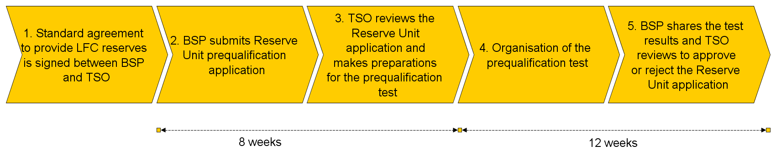

Figure 1. General LFC reserve prequalification process

The prequalification process steps shown in Figure 1 are described as:

1. Standard agreement signing:
   1. If the application fulfils all the requirements the market participant and responsible TSO shall sign the BSP contract and market participant is eligible to start prequalifying Reserve Units and provide balancing services.
2. Reserve Unit submission to prequalification:
   1. BSP shall provide the application for Reserve Unit prequalification. The application includes information on
      1. LFC reserve type: FCR, aFRR, mFRR;
      2. LFC reserve maximum capacity for prequalification;
         1. FCR symmetrical upward and downward capacity;
         2. aFRR upward and/or downward capacity;
         3. mFRR upward and/or downward capacity for each operating status[1]
      3. Reserve Unit type: Reserve Providing Unit, Reserve Providing Group;
      4. Documentation of grid acceptance records or certificates to verify Reserve Unit and technical entities fulfilment of chapter 3 requirements;
      5. EIC information for RPU or RPG[2];
         1. For RPU the full list of technical entities must be provided;
         2. For RPG the full list of technical entities and RPU-s must be provided;
         3. For Reserve Units the Z EIC code shall be provided and in addition W EIC code shall be provided, if available.
      6. Information about Delivery points including the data on measurement transformers, measuring equipment and data connections;
      7. Reserve Unit technical description with device type and service contribution[3];
      8. Information specific to Limited Energy Reservoirs (Capacity, ERM description). ERM requirements are described in following chapters:
         1. FCR requirements are described in chapter 4.3.1;
         2. aFRR requirements are described in chapter 5.3.4;
         3. mFRR requirements are described in chapter 5.7.4.
      9. Company details;
      10. Connection information;
      11. Connection point information;
      12. Minimum activation capacity (indivisible or partly indivisible bid or bids) for each operating status;
      13. Technical limitation for uninterrupted provision (for example restricted operation zone for mFRR Reserve Unit).
   2. The detail prequalification application shall be developed individually by each TSO considering Service agreement requirement and national terms and conditions. Reserve Units that fulfil the technical requirements for LFC services providers can be prequalified.
3. Reserve Unit submission review and preparations:
   1. TSO shall review the application submitted by the BSP to make sure it follows the TSOs requirements. TSO shall complete their review of the application as soon as possible, but no later than 8 weeks after having received the application from the BSP.
   2. The requirements are defined in the following chapters:
      1. General technical requirements are defined in chapter 3;
      2. FCR service requirements are defined in chapter 4.2;
      3. aFRR service requirements are defined in chapter 5.3;
      4. mFRR service requirements are defined in chapter 5.7.
   3. After the application is approved the TSO shall prepare for the prequalification test by ensuring the data exchange configuration and providing the testing agenda.
4. Prequalification testing:
   1. BSP and TSO shall agree upon a mutually acceptable time for the prequalification test to take place within 12 weeks.
   2. The prequalification test shall be carried out during the agreed prequalification test period.
   3. Prequalification tests shall follow the principles for each reserve type described in the following chapters:
      1. FCR prequalification tests are defined in chapter 4.5;
      2. aFRR prequalification tests are defined in chapter 5.5;
      3. mFRR prequalification tests are defined in chapter 5.9.
   4. BSP has the obligation to measure the prequalification test results and provide testing data to reserve connecting TSOs.
5. Review of prequalification testing data and Reserve Unit acceptance stage:
   1. BSP shall provide responsible TSO the prequalification test data, not later than 1 week after the prequalification test.
   2. TSO shall review the prequalification test data within 4 weeks and has right to prolong the period by 4 weeks if additional information is needed from the BSP.
   3. After reviewing the testing data TSO shall accept or reject the Reserve Unit for certain type of reserve service.
   4. In case of rejection the TSO shall highlight the reasoning.

## Prequalification requirements

Reference: Article 155 of SO GL

Article 159 of SO GL

Market participant who wishes to prequalify Reserve Units for LFC reserve system services has to be a balance service provider (hereinafter referred to as BSP) within the reserve connection TSOs area. BSP can submit Reserve Units for LFC prequalification in case the Reserve Unit is accepted to the grid in accordance with the national grid code or is in the process of grid acceptance testing. Reserve Unit can be connected to only one reserve connecting TSO.

The qualification of LFC Reserve Units shall be re-assessed:

1. at least once every 5 years;
2. in case the technical or availability requirements or the equipment have changed;
3. in case of modernization of the equipment related to LFC reserve activation.

## Data exchange requirements

The requirements on data and information to be delivered to the connecting TSO and, to evaluate the provisions of balancing services pursuant to article 154(1), article 154(8), article 158(1)(e), article 158(4)(b), article 161(1)(f) and article 161(4)(b) of SO GL. The exchange of information for the performance of the BSP Contract is performed though real-time communication and online communication. Connecting TSO will check the communication channels of the BSP.

The BSP should comply with the real-time communication requirements set individually by the connecting TSO. Data and information exchange test shall be performed prior to LFC prequalification test referring to the connecting TSO rules and the signal requirements for each LFC service type. During the prequalification processes the data and information exchange is verified to reflect the LFC service provision.

Real-time data is provided to TSO SCADA system continuously according to the data exchange requirements defined by each TSO for their SCADA system. Timestamped data is collected on the BSP side with at least 10 second frequency and submitted manually or automatically to TSO with agreed periodicity to TSO data exchange system. The periodicity rate when BSP submits timestamped data to TSO will be agreed between each TSO and BSP.

Real-time communication requirements set individually by the connecting TSO shall be published (be available for BSP) prior to LFC prequalification process. Data exchange between the individual BSP and TSO shall be treated as confidential. Baltic TSOs can collect and share aggregated data per TSO between Baltic TSOs.

# General technical requirements for LFC Reserve Units

Baltic TSOs provide general technical requirements for the LFC reserve providing units providing any type of LFC reserve. The general requirements make sure that during the case of disturbances in the power system, where load frequency control is required, the responsible LFC reserve providing units can provide the necessary support.

**LFC reserve providing units shall comply with the requirements set in this paragraph if the equipment was commissioned after the date of entry into force of RfG and DCC.**

**If the equipment was commissioned before the date of entry into force of RfG and DCC, LFC reserve providing units shall comply with the national requirements at the time of commissioning.**

**Including but not limiting to what is stated in the Table 1, LFC reserve providing units shall comply with the requirement for unlimited operation, until frequency ranges are within the intervals of 49.0 – 51.0 Hz.**

## Frequency ranges

A potential LFC reserve providing unit shall be capable to provide any LFC reserve type within the frequency range defined in RfG article 13(1) and article 12 (2) of DCC.

It means that each LFC reserve provider shall provide the expected LFC reserve type as long as it remains connected to the system. For the Baltic power system, the frequency range (together with the time period required for operation) are indicated in the following Table 1.

|  |  |
| --- | --- |
| **Frequency range [Hz]** | **Minimum time period for operation** |
| 47.5 – 48.5 | 30 minutes |
| 48.5 – 49.0 | 30 minutes |
| 49.0 – 51.0 | Unlimited |
| 51.0 – 51.5 | 30 minutes |

Table 1: Minimum time period for operation in Baltics

FCR providers shall be able to continue their FCR provision (FCR full activation) also if the frequency deviation exceeds the full activation frequency for CE (±200 mHz).

## Voltage ranges

A potential LFC reserve providing unit shall be able to remain connected to the network and to operate without limitation of time when the voltage at the Connection Point is within the values set in the Table 2. The p.u. voltage shall be calculated with respect to the nominal voltage at connection point (hereinafter referred to as CP).

|  |  |  |
| --- | --- | --- |
| CP voltage | min Voltage, p.u. | max Voltage. p.u. |
| 330 kV | 0,9 | 1,097 |
| 110 kV | 0,9 | 1,118 |
| <110 kV | 0,9 | 1,1 |

Table 2. Allowed voltage ranges for LFC reserve units

A potential LFC reserve providing unit shall be able to remain connected to the network and to operate minimum time period when the voltage at the Connection Point is within the values set in the Table 3 for minimum operation time period. The p.u. voltage shall be calculated with respect to the nominal voltage at CP.

|  |  |  |  |
| --- | --- | --- | --- |
| CP voltage | Voltage range, p.u. | Voltage range, p.u. | Time period for operation |
| 330 kV | 0,88 - 0,9 | 1.097 - 1.15 | 20 minutes |
| 110 kV | 0,85 - 0,9 |  | 30 minutes |
| 110 kV |  | 1,118 - 1,15 | 20 minutes |
| <110 kV | 0,85 - 0,9 | 1,1 – 1,15 | 30 minutes |

Table 3. Minimum operation time period for voltage ranges outside the normal operation

## Immunity to voltage disturbances

A potential LFC reserve providing unit shall contribute to the overall stability of the power system by providing immunity towards dynamic voltage changes, especially those due to secure faults on the higher voltage level networks. The requirements below apply to all kind of disturbances (1ph, 2ph and 3ph).

A potential LFC reserve providing unit shall be capable of remaining connected to the grid as long as the retained voltage Uret at the connection point during the fault, and fault clearing time tclear complies with the vales set in the Table 4. The p.u. voltage shall be calculated with respect to the nominal voltage at CP. The requirement is referred to the smallest phase to phase voltage.

|  |  |  |
| --- | --- | --- |
| CP voltage | Uret, p.u. | tclear, ms |
| 330 kV | 0 | 250 |
| 110 kV | 0 | 250 |
| <110 kV | Shall be compliant with national grid code requirements | 250 |

Table 4. Requirements for voltage disturbances

The voltage recovery after the fault clearance profile shall comply with the connecting TSO's requirements set in accordance with RfG articles 14 3(a) and 16 3(a).

After the fault is cleared and the voltage returned within the voltage normal operating range, the pre-disturbance operating conditions (active & reactive power) shall be recovered as fast as possible and with a tolerance of ±10% of the potential LFC providing unit or group of units rated active and reactive powers.

## ROCOF withstand capability

A potential LFC reserve providing unit shall be capable to go through frequency transients with frequency within the frequency normal operating range and with ROCOF value up to 2,5 Hz/s (assessed on a rolling window of 500 milliseconds).

## Delivery points and LFC reserve provision

The LFC reserve provision consists of active power deviation from control program either in response for certain parameters (frequency) or activation signal received from TSO. To ensure the ability to evaluate the provision of LFC reserves, for each Reserve Unit the Delivery point or Delivery points shall be defined.

The Delivery point shall have the network configuration and associated measurement equipment allowing TSO to fully control the provision of the LFC reserves. The Delivery Point may be the same as the Connection Point or different.

When evaluating compliance with the above stated technical requirements for provision of either service, the sum of activations for all participating power generating modules and/or demand units at their respective Delivery points within a Reserve Unit is taken into account.

Each Delivery Point can belong to only one Reserve Providing Unit or Reserve Providing Group.

As a normal practice, each power generating module or demand unit capable of providing any LFC reserves shall be qualified as separate Reserve Providing Unit (or Group if it has multiple connection points).

The power generating module or demand unit shall be aggregated with other Technical Entities to form either Reserve Providing Unit or Reserve Providing Group in the cases listed below:

1. The power generating module or demand unit is not able to provide the LFC reserves without other Power Generating Modules or Demand Units due to technical limitations;
2. The maximum amount of LFC reserves that the power generating module or demand unit can provide is smaller than minimum amount of LFC reserve set by TSO.

# FCR service technical requirements and prequalification testing procedures

## FCR service description

Frequency Containment Process (hereinafter referred to as FCP) is a fast-action, automatic and decentralized function provided by prequalified FCR units, and is independent from the activation of other types of regulation processes.

The objective of FCP is to maintain the real-time balance between generation and demand within the SA. FCP aims at the operational reliability of the power system of the Synchronous Area. It stabilises, in the timeframe of seconds, the system frequency at a stationary value after a disturbance or incident occurs, without restoring the system frequency and the power exchanges to their reference values.

The FCP targets are defined in terms of maximum disturbance to be covered, maximum quasi steady-state frequency deviation after the maximum disturbance and maximum frequency deviation during the transient following the maximum disturbance. Such parameters, combined with synchronous area (hereinafter referred to as SA) characteristics - such as system inertia - lead to the definition of minimum requirements for primary control provided by the qualified units (in terms of minimum primary reserve, minimum frequency characteristic and minimum time of deployment).

The TSOs of the CE synchronous use the FCR from the FCR providers to swiftly balance the power generation with the load consumption within the synchronous area and to stabilise the system frequency in the time frame of few seconds. The FCP takes place by means of the decentralized activation of the FCR of the SA. The activation is driven by the frequency deviation of the system. Each FCR provider locally measures the frequency deviation with respect to nominal frequency (50 Hz) and provides primary regulation proportionally to it.

The provision of FCR from FCR providers consist in:

1. During the scheduling phase, defining a load program of the unit with sufficient upward and downward margin for the provision of the FCR assigned to the unit,
2. During the real-time, to activate and deliver the partial or full value of the assigned FCR in accordance with the measurement of the system frequency deviation.

FCR service can be provided by Reserve Units that have successfully completed the FCR prequalification process.

Such part shall be completed defining the types of grid users which can apply for the qualification of FCR providers. Especially, the authorised candidates shall be accurately described in terms of:

1. Single Reserve Providing Unit or Reserve Providing Groups of units virtually aggregated through measurements;
2. Categories of grid users: generating units, demand facilities, storage facilities;
3. Nominal voltage at the Connection Point of the units: 330kV, 110kV and <110kV.

## FCR service technical requirements

### FCR service activation process and requirements

Reference: Articles 142, 154 of SOGL

FCR providers delivers their FCR by means of a proportional control reacting to frequency deviations. For generation units the proportional activation is negative - in case of positive frequency deviation , the power output of the FCR provider shall decrease and vice versa. For demand units the proportional activation is positive - in case of positive frequency deviation, the power output of the FCR provider shall increase and vice versa.

The generic activation scheme of a FCR provider is shown in Figure 2. The graph represents on the y-axis the FCR activation (in p.u. of the dimensioned value) and on the x-axis the frequency deviation (mHz) that causes this activation. The curve is intended to be static, it refers to the condition reached once the transient of FCR deployment is completed.

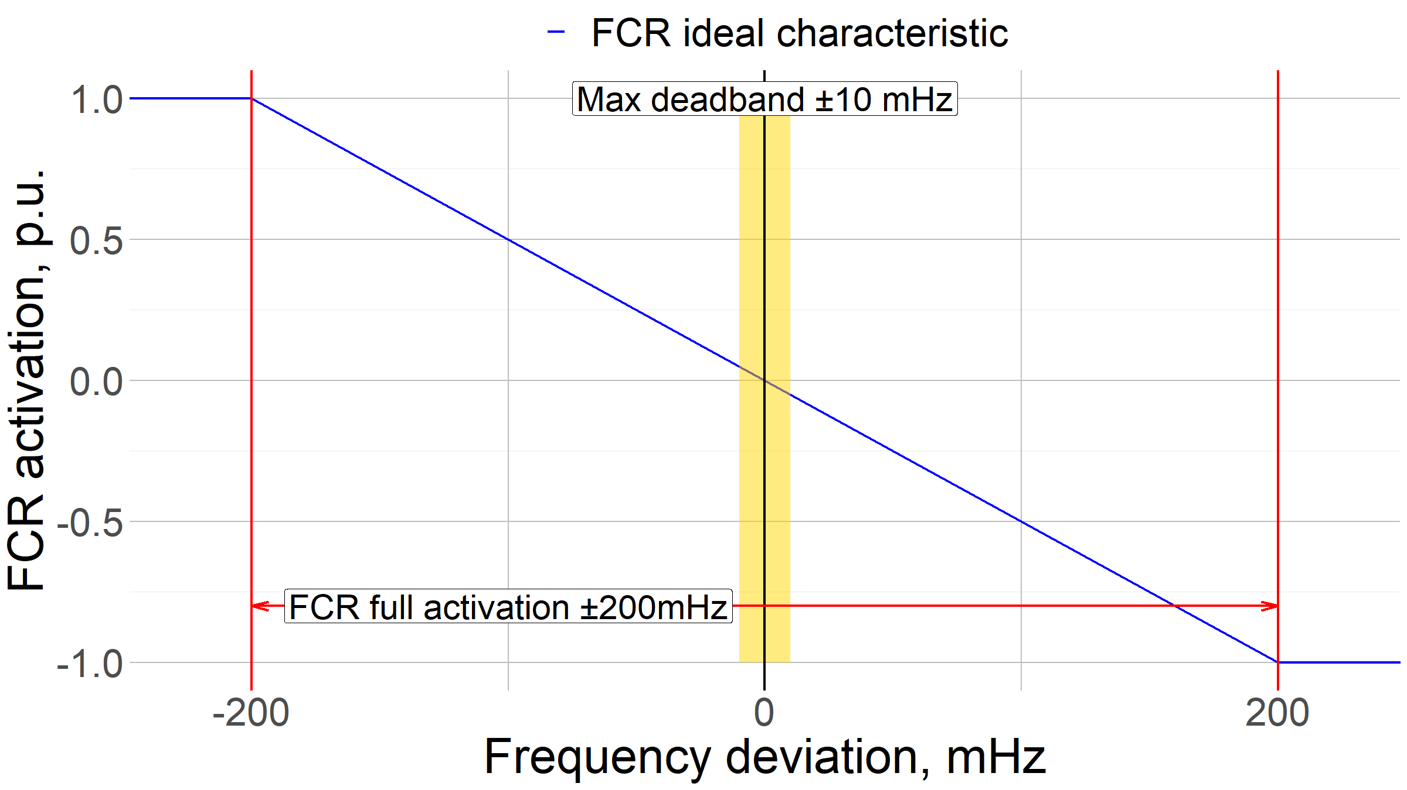

Figure 2. Static frequency deviation / FCR activation example curves

The provided FCR shall be activated by means of a proportional governor reacting to frequency deviations or alternatively based on a monotonic piecewise linear power-frequency characteristic in case of relay activated FCR. It is required that the MW/Hz characteristic curve (FCR activation vs frequency deviation – e.g. Figure 2) shall be linear or monotonic piecewise linear.

The full activation of the provided FCR shall be reached with a frequency deviation of ±200 mHz. It means that the FCR provided by an FCR provider shall be completely deployed when the frequency deviation of the SA reaches 200 mHz. The positive FCR is deployed with -200mHz, the negative FCR is deployed with +200 mHz.

The FCR full activation time is not more than 30s ( $t_{2}$ in Figure 3). It gives a maximum time for the full activation to be provided. The activation of the FCR by each provider shall begin as soon as possible but no later than 2 s ( $t_{1}$ in Figure 4) after a frequency deviation. No intentional delay for the activation is allowed. If a provider has need for a delay in the initial activation of active power frequency response greater than 2 s, it is requested to demonstrate the technical reason for the need.

The FCR activation shall rise linearly or quicker in time. This requirement implies that, as a result of a step-wise frequency deviation, the FCR shall be activated at least linearly in time: it is not acceptable for an activation to take place with a function less than linear (e.g. as a function ${FCR}_{t}=k∙t^{m}$ with t: time and m<1). Graphical representation of the formula is provided in Figure 3, which means that in the event of a frequency step change FCR providing unit shall be capable of activating full active power response at or above the line shown in Figure 3.

Figure 3. FCR activation curve

The maximum combined effect of the inherent insensitivity of frequency response and the intentional insensitivity provoked by frequency dead-band inserted in the governors of the FCR providing units or FCR providing groups is 10 mHz. It means that the FCR response shall be provided as the frequency deviation exceeds ±10 mHz. The maximum intentional/unintentional dead band is ±10 mHz.

### FCR activation accuracy requirement

Reference: Article 154(1) of SOGL.

A potential FCR providing unit or group of units shall be capable of controlling its active power to a set-point value with a steady-state error not greater than ±10% of the current FCR activation volume or 0,1 MW, whichever is larger, if not defined differently in the national terms and conditions or other legislation. The frequency measurement used for the frequency control and the determination of the FCR to be provided shall have an accuracy at least 10mHz.

### FCR service continuity and FCR provider availability

Reference: Article 156(4)(5)(7) of SOGL.

The FCR providers which do not rely on energy reservoir that limit their capability to provide FCR shall activate their FCR for as long as a frequency deviation persists. Generally, there is no maximum time for the provision of FCR. A potential long-lasting unidirectional frequency deviation shall be covered by FCR providers without limitation.

Each FCR provider shall guarantee its FCR contribution for at least the Validity Period of successful FCR capacity bids with exception of forced outages. If due to a forced outage, an FCR provider is not able to provide its FCR contribution (even partially) it shall communicate its unavailability to the connecting TSO as soon as possible.

The only exception to this rule is allowed for Limited Energy Reservoir (hereinafter referred to as LER) FCR providers which rely on an energy reservoir that limit their availability. LER FCR providers shall activate their FCR as long as the frequency deviation persists, unless their energy reservoir is exhausted in either the positive or negative direction. More detailed description of requirements for LER FCR providers are defined in chapter 4.3.

### FCR provision in in case of large frequency transients and emergency state

In case of frequency deviations greater than ±200 mHz, a potential FCR provider shall activate considering what follows:

1. The activation supports the stability of the frequency, adjusting the power output according to the characteristics presented in Figure 4 for over-frequency transients and Figure 5 for under-frequency transients. In the figures, the parameters have the following significations:
   * ΔΡ represents the expected power adjustment for the frequency support;
   * Δf represents the frequency variation measured at the CP;
   * Pref represents the nominal active power of the potential FCR provider;
   * fn is the nominal frequency of the grid (50 Hz);
   * s2 and s3 represent the frequency droops; their values shall be set to 5% if not differently instructed by TSO;
   * Δf1 and Δf2 are the frequency thresholds for the activation of the frequency support and shall be set to +200 mHz and -200mHz;
2. The active power response shall be provided in addition to the provision of FCR and shall not be intentionally limited below the actual capabilities of the unit;
3. The power adjustment shall not be intentionally delayed and shall be delivered as fast as feasible without compromising the stability of the unit;

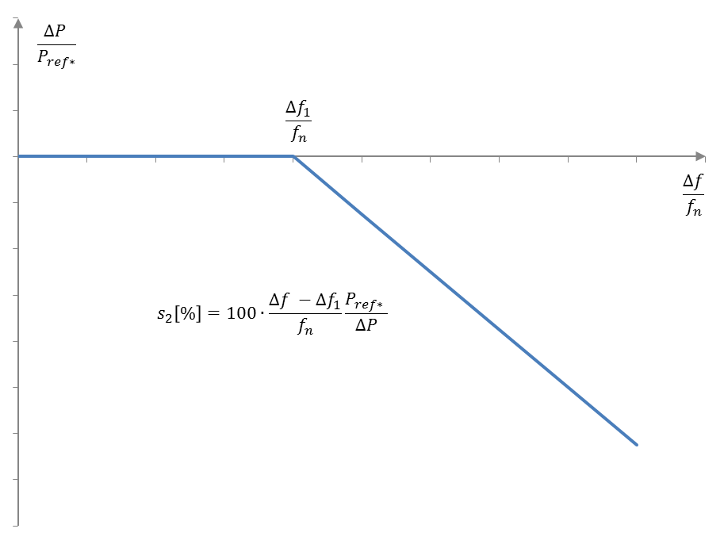

Figure 4. Frequency support in case of large over-frequency transients

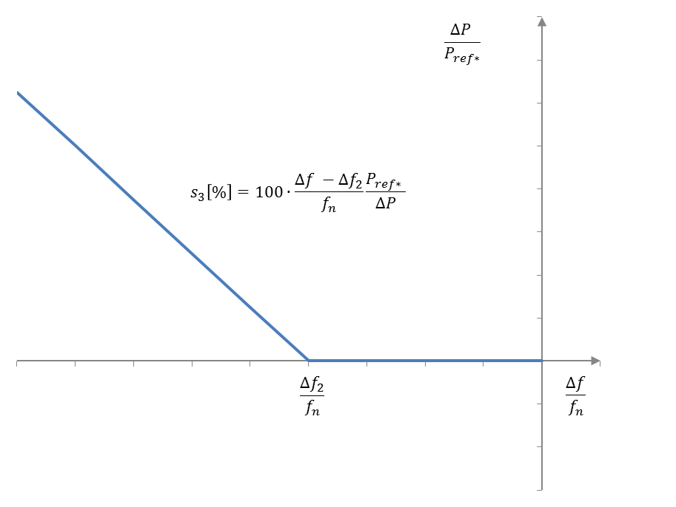

Figure 5. Frequency support in case of large under-frequency transients

### Real-time data requirement for FCR service providers

Reference: Article 154 (8)(10) of SOGL.

The potential FCR provider shall be equipped with a communication interface compliant with TSO requirements. The potential FCR provider shall provide the reserve connecting TSO real-time data on following data points:

|  |  |
| --- | --- |
| Signal parameter | Explanation |
| FCR status | The status of FCR provision, on or off |
| Scheduled active power output | Scheduled set-point of active power output of the unit that is providing FCR in MW. |
| Active power output | Active power output of the unit that is providing FCR in MW |
| FCR output* | FCR provision volume in MW |
| FCR droop value (or equivalent parameter) | FCR droop in % (or equivalent parameter) parameter shall be provided for TSO to monitor FCR provision based on frequency deviation. |
| FCR deadband | FCR deadband value within 0-±200 mHz interval shall be provided for TSO to monitor FCR provision based on frequency deviation. |

Table 5. Signal list of data points that are provided by FCR providing unit to the reserve connecting TSO

*Optional based on TSO implementation

The potential FCR provider shall be equipped with a communication interface compliant with connecting TSO requirements. At the request of the connecting TSO[4], these data shall be provided in real-time with a time resolution of at least 10 s.

The inaccuracy of measurements shall not exceed 2% achieved either by direct measurement using a meter of 1.0 class (B class) or indirect using a measurement transformer and meter of class 0.5 (C class) each, if not defined differently in the national terms and conditions or other legislation. The data is used for verification and monitoring of FCR service.

### Requirement of the reserve connecting TSO

Reference: Article 154(5) of SOGL.

B-13 and B-15 of SAFA Policy 1

Each FCR provider shall have only one reserve connecting TSO (the reserve connecting TSO is the TSO responsible for the monitoring area to which a reserve providing unit or reserve providing group is connected). It means that an FCR provider can be considered connected to only one TSO.

## Additional requirements for LER FCR providers

A FCR provider is deemed to be a FCR provider with LER in case a full continuous activation of its FCR for a period of 2 hours in either positive or negative direction might, without consideration of the effect of an active energy reservoir management (hereinafter referred to as ERM), leads to a limitation of its capability to provide the full FCR activation due to the depletion of its energy reservoir. ERM controls the State of Charge (hereinafter referred to as SOC) of the LER FCR providers energy reservoir. LER FCR providers which rely on an ERM that limits theirs FCR availability shall guarantee their FCR contribution without any limitation as long as the system remain in normal state[5].

### LER FCR provider energy reservoir management requirements

Each LER FCR provider shall provide a comprehensive description of the active ERM of the LER FCR provision by providing information on the following points:

1. Full capacity of energy reservoir;
2. Operational limits that affect usage of reservoir;
3. Operable capacity of reservoir;
4. Permissible charge/discharge power;
5. Description of planned ERM strategy (energy source used for management);
6. Information on the rate of use of ERM (continuous, each 5 min, etc.);
7. Simulation of ERM operation for 24 hours frequency data (TSO shall provide test data);
8. Strategy for operation in alert state and "Reserve Mode";
9. Expected bid regularity and size.

### LER FCR minimum full activation time in alert state

As of triggering the alert state[6] and during the alert state, each LER FCR provider shall ensure a continuous FCR full activation for a time period no less than 30 minutes, defined as TminLER of LER FCR providers. The TminLER requirement is fulfilled by dimensioning the energy reservoir to meet the minimum requirement.

Power system states are defined as described on the following Figure.

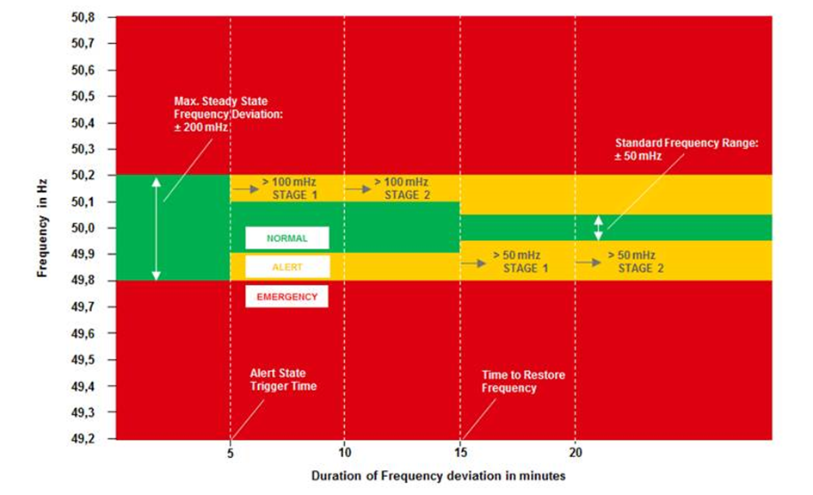

Figure 6. Power system state according to frequency deviations and SOGL [source ENTSOE]

A potential FCR provider with LER shall have an active ERM which can ensure that a continuous activation of FCR when the power system is in normal state according to the SOGL Article 156. It especially means that, when the power system is in normal state, the energy reservoir of the FCR providing unit with LER shall be kept within the ranges indicated in the Figure 77.

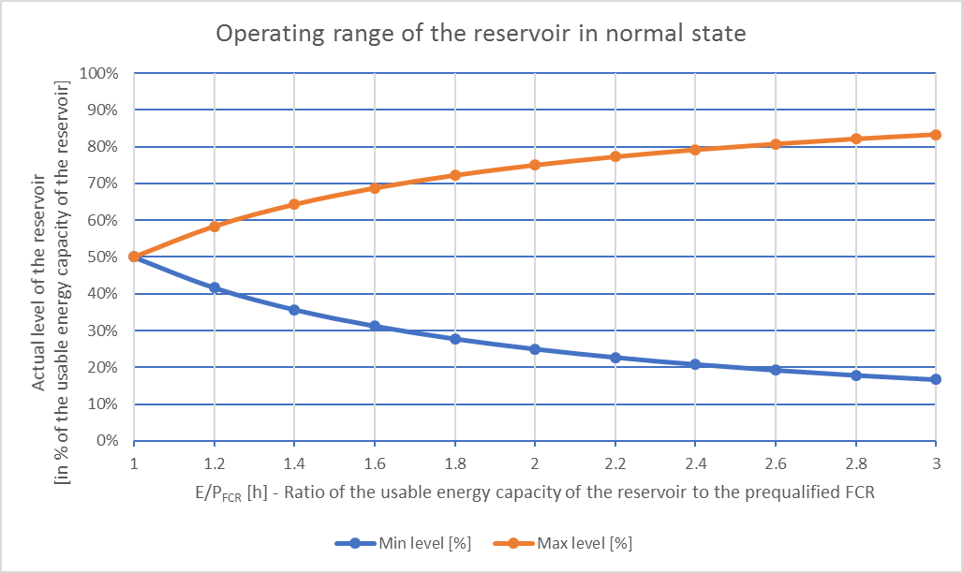

Figure 7. Management of the energy reservoir of a FCR providing unit with LER

FCR providers which rely on energy reservoirs that limit theirs FCR availability (LER) shall have an active SOC management that allows them to ensure a continuous physical activation of FCR in normal state.

The SOC management is an active operation condition in which the SOC is kept within a level that ensure the full activation for a time period no less than 30 minutes whenever an alert state is triggered. This condition is achieved by the FCR provider operating on the energy market or directly exchanging energy with other plants. The SOC management shall not rely on over fulfilment of activation. The activated FCR shall depend only on frequency deviation.

FCR providers with LER shall implement a specific operational status called “Reserve Mode”. This operation consists in limiting the FCR contribution from LER only to short-term frequency deviations, and not to the mean value.

During a long-lasting frequency deviation, as a LER is approaching the exhaustion condition (reservoir completely full or empty), the “Reserve Mode” shall be triggered. The consequence is that the provided FCR is not proportional to frequency deviation anymore. With “Reserve Mode” the FCR is proportional only to the short-term frequency deviations, the mean value is not provided anymore.

The LER shall provide only the FCR proportional to the following signal:

$${∆f}_{RM}\left(t\right)=∆f\left(t\right)-\frac{1}{n({t-t}_{aFRR FAT})}\left(\sum_{i=o}^{n({t-t}_{aFRR FAT})}{∆f(t-t_{i})}\right)$$

Where:

$∆f\left(t\right)$ is the frequency deviation at the time t;

$t_{aFRR FAT}$ is the Full Activation Time of aFRR of 5 minutes;

$n({t-t}_{aFRR FAT})$ is the number of frequency deviation samples within $t_{aFRR FAT}$ ￼

The FCR contribution associated to the mean value ($∆f\left(t\right)-{∆f}_{RM}\left(t\right)$) shall be taken over by aFRR. The Figure helps to explain the work of the “Reserve Mode”.

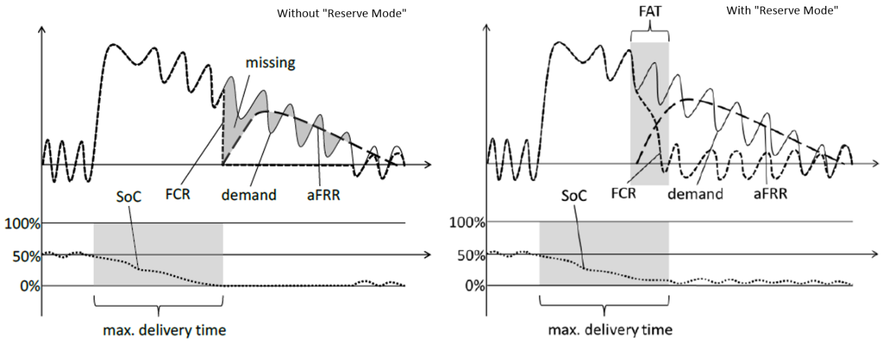

Figure 8. LER "Reserve Model"

The fulfilment of this requirement shall be verified during the prequalification process specified in chapter 4.5.4.

### LER FCR providing unit prequalification scaling

According to “All CE TSOs’ proposal for additional properties of FCR in accordance with Article 154(2) of the Commission Regulation (EU) 2017/1485 of 2 August 2017 establishing a guideline on electricity transmission system operation”, additional requirements for LER FCR providers are required. Guideline defines that FCR providing unit with LER shall have a ratio of rated power to the prequalified FCR of at least 1.25:1 to ensure that the LER FCR operating the ERM is able to provide continuous support of FCR during normal state and is able to provide FCR for TminLER during alert state.

### Real-time data requirement for LER FCR providers

In addition to the real-time data requirement described in chapter 4.2.6 (Real-time data requirement for FCR service providers), LER FCR providers shall provide connecting TSO following data points in real-time with time resolution of at least 10s:

|  |  |
| --- | --- |
| Signal parameter | Explanation |
| SOC level | The state of charge of the LER FCR providing unit |
| Reserve Mode status | The status of Reserve Mode, on or off |

Table 6. Additional data points LER FCR providers need to provide to the reserve connecting TSO

The inaccuracy of measurements shall not exceed 2% achieved either by direct measurement using a meter of 1.0 class (B class) or indirect using a measurement transformer and meter of class 0.5 (C class) each, if not defined differently in the national terms and conditions or other legislation. The data is used for verification and monitoring of LER FCR service.

## Additional requirements for FCR reserve providing groups

FCR provision can be provided by technical entities that cannot comply alone with the FCR service technical requirements. To ensure that the FCR provision is possible from these technical entities, FCR service can be provided by FCR providing groups that can consist of multiple generation, demand or storage units and/or Reserve Providing Units. FCR provider shall ensure that FCR providing group shall have symmetrical capacities available within FCR providing group.

In case the FCR providing group includes LER FCR providers then requirements of chapter 4.3 apply to the FCR reserve proving group as well. Baltic TSOs describe in this chapter the principles required from FCR providing groups to ensure the service quality and capability to monitor the service.

### Activation of FCR providing groups

In presence of technical entities within FCR providing groups activated via centralized system, it shall be guaranteed that a local activation of each technical entity is still possible even in presence of system split or communication problems. All the units shall implement a decentralized frequency measurement per connection point and the measures shall be made on local frequency that always ensure an autonomous FCR activation capability.

Furthermore, technical entities within FCR providing groups activated via centralized system shall be equipped with a functionality aiming at detecting any error in the decentralized system (e.g. loss of communication with decentralized units, failure of the units, etc.). If an error is detected, the provider shall provide the countermeasures needed to ensure the FCR capability.

For each FCR providing group using a centralized system for frequency assessment a separate frequency measurement is required to be established to prevent FCR activation malfunction with frequency measurement failure.

In accordance with SO GL Article 154.9, Baltic TSOs allow the use of centralized frequency measurement for FCR groups with a prequalified FCR capacity <= 1.5 MW. If a BSP decides to prequalify several FCR groups <= 1.5 MW using centralized frequency measurement, a different frequency meter must be used for each concerned FCR group for redundancy reasons. For any other FCR group, Baltic TSOs require as per product definition local frequency measurement on each delivery point within that FCR group.

### Composition of FCR providing group

Baltic TSOs define following principles for the composition of FCR providing groups:

1. The BSP is responsible of defining the list of technical entities for FCR providing group;
2. Each technical entity can be part of only one FCR providing group;
3. Prequalified FCR providing group cannot be considered as a part of larger FCR providing group;
4. FCR providing group can provide FCR capacity contribution for each technical entity in the prequalification application documentation. The FCR capacity contribution is to manage the composition change of FCR providing group defined in chapter 4.4.3.

### Composition change requirements for FCR providing group

The composition of technical entities with the maximum FCR capacity contribution from the FCR providing group is recorded in the prequalification application and confirmed after successful prequalification process.

A potential FCR provider can increase the maximum FCR capacity contributions in following ways:

1. New prequalification process is completed with additional technical entities that provide additional capacity to the FCR providing group;
2. Single power generating module or demand unit, or an aggregation of technical entities connected to a common connection point that can fulfil the FCR prequalification requirements as a Reserve Providing Unit can be prequalified successfully and added to the existing FCR providing groups maximum capacity.

A potential FCR provider can add additional technical entities to the FCR providing group for additional flexibility, if the potential FCR providing group maximum capacity is not increased.

If a technical entity is removed from FCR providing group, the TSO shall reduce the maximum FCR capacity provided by the FCR providing group by the contribution volume of the concerned technical entity. The FCR contribution of each technical entity should be provided with the prequalification application. In case, single technical entity contribution cannot be calculated or the technical entity has significant effect on the FCR provision, the FCR providing group will need new prequalification procedure to determine the new maximum FCR capacity for the FCR providing group.

If FCR providing group is using a ERM the FCR provider needs to confirm to the TSO that by removing the technical entity the ERM operation is not altered. If removal of technical entity has impact on ERM new prequalification of FCR providing group is required

### Data provision requirements for FCR providing groups

Reference: SOGL Article 154(9)

In addition to real-time data requirements defined in 4.2.5 and 4.3.4 the FCR providing group has the right to aggregate the real-time data to timestamped data for more than one technical entity if the maximum power of the aggregated units is below 1,5 MW and clear activation of FCR is possible.

If the connecting TSO needs more detailed information to verify the FCR activation, the FCR provider shall however be able to make available the requested timestamped data information regarding each technical entity belonging to the aggregate with a time resolution of at least 10 seconds.

## FCR prequalification procedure

Reference: Article 155 of SOGL

The FCR qualification is the process by which a potential FCR provider demonstrate its compliance to all the FCR requirements (as indicated in chapters 4.2 to 4.4). The successful completion of the qualification process is required for the potential FCR provider to provide FCR. The counterpart of the process is the TSO responsible for the LFC Area the FCR provider is connected to. The qualification in an LFC Area belonging to a LFC Block is valid for the whole Block.

The following tests for the pre-qualification shall consist in the verification of the correct configuration of the information exchange with TSO and in the simulation, within the control systems of the potential FCR providing unit or group of units, of simulated frequency variations of increasing amplitudes and different durations. The tests are deemed passed if the consequent active power variations of the potential FCR providing unit or group of units is in accordance with the technical requirements of chapters 4.2 to 4.4. During prequalification of LER FCR providers the operation of ERM is allowed and verified.

The testing procedures shall be prepared by the owner of the potential FCR providing unit or group of units and submitted to TSO. The tests can be carried out only after TSO has given its formal approval to the testing procedures. These procedures shall be completed of instrumentation and measurements devices used to perform the tests, detailed methodology for the conduction of the tests, indicative duration of the tests, process to be followed for the analysis of measurements, expected results and a proposal of schedule.

### Characterisation of static parameters of frequency control

#### Purpose of the test

The aim of this test is to characterize the steady state parameters of the frequency control, especially the frequency dead band and the frequency droop. A fictitious frequency disturbance is simulated in the control system of the potential FCR providing unit or group of units to produce active power variations.

#### Initial conditions

The potential FCR providing unit or group of units be connected to the grid and in normal operating conditions.

Initial settings of control:

1. Status of FCR: ON
2. Active power setpoint: Any value permitting full range of activation for FCR (the selected value shall not be modified during the test)
3. Voltage/Reactive power setpoint: Any value
4. Droop setting According to the maximum FCR provision

#### Testing method

The test is carried out simulating fictitious frequency ramps within the control system of the potential FCR providing unit or group of units and recording the corresponding active power variations. The simulation shall be done possibly blocking the disturbances due to the real frequency variations of the grid. The simulating of the frequencies shall be performed by the FCR provider. The simulation of the frequencies shall be recorded during the test and provided for TSO in xls, csv or txt formats. It is required to measure active power response and simulating frequencies with at least 100 ms sample rate.

For the verification of the BSP capability to comply with the requirements for FCR provision in case of large frequency transients and emergency state set in the chapter 4.2.4, the testing with -/+400 mHz frequency variations shall be performed. The frequency response of FCR providing units is verified during large frequency deviation cases. Frequency response of FCR providing unit has to fulfil minimum FCR provision requirements. FCR providing unit can provide additional FCR in case the frequency deviation exceeds bonds of +/- 200 mHz.

Starting from the initial conditions indicated above, the test shall be done as follows:

1. Define a certain setpoint (base line) around which the following steps will take place.
2. Maintain this setpoint for 30 seconds before the next step, the baseline for the prequalification test is defined by taking the average active power value over the 30 seconds.
3. Simulate a frequency variation *dfsim* from 0 mHz up to 200 mHz with a ramp of 0.4 mHz/s (or similar),
4. Wait for at least 5 minutes (or more if necessary) to reach steady-state conditions,
5. Start a new variation of *dfsim* up to 400 mHz with a ramp of 0.4 mHz/s (or similar),
6. Wait for at least 5 minutes (or more if necessary) to reach steady-state conditions,
7. Start a new variation of *dfsim* from 400 mHz to 200 mHz with a ramp of -0.4 mHz/s (or similar),
8. Wait for at least 5 minutes (or more if necessary) to reach steady-state conditions,
9. Start a new variation of *dfsim* from 200 mHz to -200 mHz with a ramp of -0.4 mHz/s (or similar),
10. Wait for at least 5 minutes (or more if necessary) to reach steady-state conditions,
11. Start a new variation of *dfsim* from -200 mHz to -400 mHz with a ramp of -0.4 mHz/s (or similar),
12. Wait for at least 5 minutes (or more if necessary) to reach steady-state conditions,
13. Start a new variation of *dfsim* from -400 mHz to -200 mHz with a ramp of 0.4 mHz/s (or similar),
14. Wait for at least 5 minutes (or more if necessary) to reach steady-state conditions,
15. Start a new variation of *dfsim* from -200 mHz to 0 mHz with a ramp of 0.4 mHz/s (or similar).

The frequency profile which shall be simulated within the control system of the potential FCR providing unit or group of units is reported in Figure 9.

|  |
| --- |
| Figure 9. Simulated frequency profile for the static characterization of the frequency control |

#### Data analysis

The recordings shall be analysed to derive the static parameters of the frequency control performed by the unit and compare them with the service requirements; especially the following parameters shall be assessed:

1. frequency dead band settings,
2. frequency droop,
3. accuracy of frequency control.

The frequency dead band is identified as the frequency band in which the potential FCR providing unit does not provide an appreciable power contribution.

The frequency droop value is calculated considering the electric power *P*, its reference *Pref* and the value of *dfsim*. Data collected during the test shall be filtered to remove the dynamics of the control.

### Characterisation of dynamic parameters of frequency control

#### Purpose of the Test

The aim of this test is to characterize the dynamics of the frequency control. A fictitious frequency disturbance is simulated in the speed governor to produce active power variations.

#### Initial conditions

The potential FCR providing unit or group of units shall be connected to the grid and in normal operating conditions.

Initial settings of control:

1. Status of FCR: ON
2. Active power setpoint: Any value between (min+20%) and (max-20%)

(the selected value shall not be modified during the test)

1. Voltage/Reactive power setpoint: Any value

The test shall be performed at least at two different active power set-point close to the minimum and maximum values of the operating range of the potential FCR providing unit or group of units

#### Testing method

The test is carried out simulating fictitious frequency steps within the control system of the potential FCR providing unit or group of units and recording the corresponding active power variations. The simulation shall be done possibly blocking the disturbances due to the real frequency variations of the grid.

For the verification of the BSP capability to comply with the requirements for FCR provision in case of large frequency transients and emergency state set in the paragraph 4.2.4 of entire document, the testing with -/+400 mHz frequency variations shall be performed. The frequency response of FCR providing units is verified during large frequency deviation cases. Frequency response of FCR providing unit has to fulfil minimum FCR provision requirements. FCR providing unit can provide additional FCR in case the frequency deviation exceeds bonds of +/- 200 mHz.

Starting from the initial conditions indicated above, the test shall be done as follows:

1. Simulate a frequency step *dfsim* of 200 mHz,
2. Wait for 30 minutes,
3. Simulate a new step of frequency *dfsim* from 200 mHz to 400 mHz,
4. Wait for at least 5 minutes (or more if necessary) to reach steady-state conditions,
5. Simulate a new step of frequency *dfsim* from 400 mHz to 0 mHz,
6. Wait for at least 5 minutes (or more if necessary) to reach steady-state conditions,
7. Simulate a new step of frequency *dfsim* from 0 mHz to -200 mHz,
8. Wait for at least 5 minutes (or more if necessary) to reach steady-state conditions,
9. Simulate a new step of frequency *dfsim* from -200 mHz to -400 mHz,
10. Wait for at least 5 minutes (or more if necessary) to reach steady-state conditions,
11. Start a step variation of *dfsim* from -400 mHz to 0 mHz,
12. Wait for at least 5 minutes (or more if necessary) to reach steady-state conditions,

The resulting simulated frequency profile is reported in Figure 10.



Figure 10. Simulated frequency profile for the dynamic characterization of frequency control deployment

#### Data analysis

The recordings shall be analysed to derive the dynamic parameters of the frequency control performed by the unit and compare them with the service requirements; the following parameters of the control shall be assessed:

1. Activation and full activation times. The FCR providing BSP shall be capable of activating full active power response at or above the line shown in Figure 3.
2. Temporary over-fulfilment (overshoot) and stability of the control.

The stability of the frequency control is assessed considering the overall behaviour of the electric power *P* and the value of *dfsim*. For steady frequency value, the generated power shall also be steady at its steady state value. The overshoots shall be less than 10 percent of maximum FCR service amount. If overshoot exceeds 10% of maximum FCR service amount, technical explanation shall be provided.

### Additional tests for potential FCR providers with LER: Confirming the Reserve Mode activation and operation

#### Purpose of the test

The aim of the test is to confirm the Reserve Mode capability of LER FCR providers as described in chapter 4.3.2

#### Initial conditions

The potential LER FCR providing unit or group of units be connected to the grid and in normal operating conditions.

1. Status of FCR: ON
2. Status of energy reservoir within range of 40-60% SOC
3. Active power setpoint: Any value which allows to keep the energy reservoir stable at its initial value
4. Voltage/Reactive power setpoint: Any value

#### Testing method

The test is carried out by simulating fictious frequency steps within the control system of the potential LER FCR providing unit or LER FCR providing group. The simulation shall be done possibly blocking the disturbances due to the real frequency variations of the grid.

Starting from the initial conditions indicated above, the test shall consist in:

1. Start of the test with frequency deviation of 0 mHz;
2. Step from *dfsim* 0 mHz to *dfsim* +150 mHz and wait for 5 minutes;
3. Reserve Mode status shall be activated and oscillation of simulated frequency between range of +/- 50 mHz shall be simulated to reflect the short-term frequency deviations for 15 minutes;
4. Frequency deviation set-point is changed to *dfsim* 0 mHz and Reserve Mode is deactivated wait for 5 minute;
5. Step from *dfsim* 0 mHz to *dfsim* -150mHz and wait for 5 minutes;
6. Reserve Mode status shall be activated and oscillation of simulated frequency between range of +/- 50 mHz shall be simulated to reflect the short-term frequency deviations for 15 minutes;
7. Frequency deviations is returned to *dfsim* 0 mHz and Reserve Mode is deactivated.

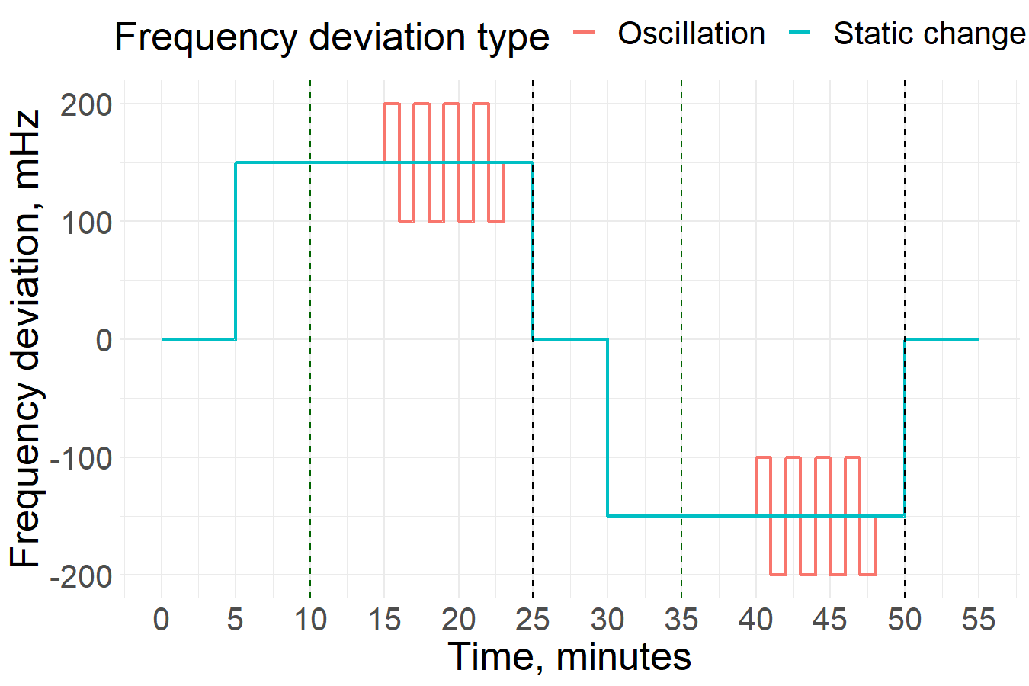

Figure 11. Example LER FCR Reserve Mode test with frequency deviation oscillation

#### Data analysis

The recordings shall be analysed to derive the frequency oscillation response in Reserve Mode. The actual response of the unit shall be compared with the service requirements, where the LER FCR provider with Reserve Mode activated must be able to follow the frequency oscillation activations.

# FRR prequalification technical requirements and testing procedures

## Frequency restoration process description

Reference. Article 143 of SOGL

The Frequency restoration process (hereinafter referred to as FRP) is a process aiming at restoring the system frequency to its nominal value and at restoring the power balances between LFC Areas to their scheduled values. The FRP takes place by mean of activation of dedicated reserves called FRR.

Following a system power imbalance, the FRR activation timeframe is in the order of minutes; it is therefore a process that operates after the FCR activation. As the system frequency recovers to the nominal value thanks to the activation of FRR, the activated FCR is freed (the activated FCR directly depends on the frequency deviation). In this sense one of the aims of the FRP is also to replace the effects of the FCR and therefore to restore the full activation potential of FCR.

This scheme is synthetically shown in Figure .

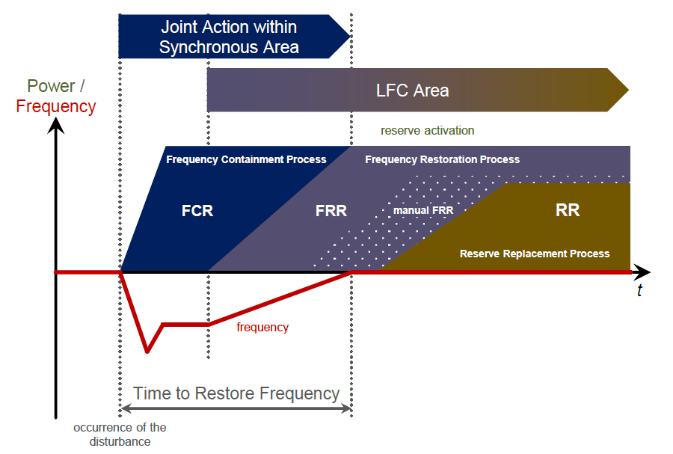

Figure 12. FCR/FRR Activation scheme

One of the main characteristics that distinguishes the FRR activation from the FCR activation is that the FRP relies on a centralized mechanism: while the activation of FCR of every FCR provider is driven by the system frequency measured locally by each FCR provider, the FRR activation is driven by a central control signal sent by the TSO (or TSOs) of an LFC Area (or Block) to each single FRR provider.

The FRR can be:

1. Manual (mFRR): the FRR activation is provided to the FRR provider as a dispatching order from the reserve instructing TSO (within the required timeframe);
2. Automatic (aFRR): the FRR is activated by a Frequency Restoration Controller (FRC).

Both services are provided by FRR providers, consisting of single qualified units or groups of units which can be centrally coordinated. The regulation capacity is a band of possible power variation around the scheduled value. This regulation capacity is activated according to the signal sent by the TSO to the provider; the activation of FRR consists in a variation of the power output within the band.

## aFRR service description

The aFRR is operational reserve used by TSO to balance power generation and load consumption within its own network, to restore to schedule the exchange of power with neighbouring countries and to restore the FCR already activated.

The provision of aFRR from aFRR providers consist in:

1. during the scheduling phase, to define a load program of the unit with sufficient upward and/or downward margin for the provision of the aFRR assigned to the unit,
2. during the real-time, to activate and deliver the partial or full value of the assigned aFRR in accordance to the control signal sent by TSO.

Authorised candidates for aFRR shall be accurately described in terms of:

1. Single unit or groups of units virtually aggregated through measurements;
2. Categories of grid users: generating units, demand facilities or storage facilities;
3. Nominal voltage at the Connection Point of the units: 330kV, 110kV and <110kV.

## aFRR service technical requirements

### Activation of aFRR

The activation and deployment of the aFRR shall be based on the instruction received from TSO. The instruction consists in a control signal sent by TSO to the aFRR provider though the communication interface between the Frequency Restoration Controllers (hereinafter referred to as FRC) and aFRR provider and represents the amount of the aFRR assigned to the aFRR provider which shall be activated. The activation signal for aFRR shall be sent to the aFRR providing unit within 1-10 second intervals following optimisation cycle requirements for the aFRR Platform PICASSO. In case of signal error, where no new signal has been received, the aFRR activation shall continue activation based on the last received aFRR activation signal.

The Baltic TSOs shall implement the FRCs by 2025 and before that the aFRR providing units are prequalified by simulating FRC activation signals. When the FRCs are implemented at TSO level additional communication interface tests with aFRR providing units may be required to verify the FRC operability.

A potential aFRR providing unit or group of units shall:

1. control its active power according to the control signal value sent by the TSO, with a steady-state error not greater than value indicated in 5.3.2.
2. fully deploy its assigned aFRR value in a time not greater than the full activation time of 5 minutes. In case of step variations of the control signal sent by TSO, the initial activation time (or delay) shall be as small as possible and in any case not greater than 30 seconds.

### Accuracy of measurement and control for aFRR

A potential aFRR providing unit shall be capable of controlling its active power to a set-point value with a steady-state error not greater than ±10% of the requested aFRR volume or 0,1 MW, whichever is larger, if not defined differently in the national terms and conditions or other legislation.

The resolution of the signal used by the aFRR providing unit to define the quantity of aFRR to be activated shall be at least 0,1 MW, unless defined differently in the national implementation of FRC.

### aFRR service continuity and aFRR provider availability

Each prequalified Reserve Unit prequalified for aFRR must be able to deliver continuously aFRR for at least 1 Validity Period. In case potential aFRR provider has limitation on continuous aFRR provision over one Validity Period, the limitation on maximum continuous Validity Periods for maximum upward and downward bid size must be described in the aFRR prequalification application.

The aFRR provider must be available during time periods when aFRR energy service is provided to the market. The availability requirement is not verified during prequalification process. This availability requirement is only applicable for the reserved volume that is offered during the bidding process.

### LER aFRR provider energy reservoir management strategy description

An aFRR provider is deemed to be an aFRR provider with LER in case a full continuous activation of its aFRR for a period of 2 hours in either positive or negative direction might, without consideration of the effect of an active ERM, leads to a limitation of its capability to provide the full aFRR activation due to the depletion of its energy reservoir.

Each LER aFRR provider shall provide a comprehensive description of the active ERM of the LER aFRR provision by providing information on the following points:

1. Full capacity of energy reservoir;
2. Operational limits that affect usage of reservoir;
3. Operable capacity of reservoir;
4. Permissible charge/discharge power;
5. Description of planned ERM strategy (energy source used for management);
6. Information on the rate of use of ERM (continuous, each 5 min, etc.);
7. Expected bid regularity and size.

### Real-time data requirement for aFRR service provider

The potential aFRR provider shall be equipped with a communication interface compliant with TSO requirements. The potential aFRR providing unit shall provide the reserve connecting TSO real-time data on following data points.

|  |  |
| --- | --- |
| Signal parameter | Explanation |
| aFRR status | The status of aFRR provision, on or off |
| Available aFRR upward capacity | The maximum available aFRR upward capacity of the Reserve Unit that can be activated in MW. The available capacity depends on the operation point of the aFRR providing unit. |
| Available aFRR downward capacity | The maximum available aFRR downward capacity of the Reserve Unit that can be activated in MW. The available capacity depends on the operation point of the aFRR providing unit. |
| Scheduled active power output | Scheduled set-point of active power output of the unit that is providing aFRR in MW. |
| Active power output | Active power output of the unit that is providing aFRR in MW. |
| Activated aFRR upward capacity | The volume of upward aFRR that has been activated in aFRR providing unit |
| Activated aFRR downward capacity | The volume of downward aFRR that has been activated in aFRR providing unit |
| TSO signal confirmation of upward activation | A signal of upward activation is returned. This signal is used to identify data exchange problems/disturbances. |
| TSO signal confirmation of downward activation | A signal of downward activation is returned. This signal is used to identify data exchange problems/disturbances. |
| Signal connectivity confirmation | A signal of connection check is returned. This signal is used to identify data exchange problems/disturbances. |
| SOC level | The state of charge of the LER aFRR providing unit |

Table 7. Signal list of data points that are provided by aFRR providing unit to the reserve connecting TSO

The reserve connecting TSO shall provide following real-time data signals to the aFRR providing unit.

|  |  |
| --- | --- |
| Signal parameter | Explanation |
| aFRR upward activation | The volume of upward aFRR TSO requires to be activated by the aFRR providing unit according to aFRR requirements |
| aFRR downward activation | The volume of downward aFRR TSO requires to be activated by the aFRR providing unit according to aFRR requirements |
| Signal connectivity confirmation | A signal of connection check is returned. This signal is used to identify data exchange problems/disturbances. |

Table 8. Signal list of data points that are provided by the reserve connecting TSO to the aFRR providing unit

The inaccuracy of measurements shall not exceed 2% achieved either by direct measurement using a meter of 1.0 class (B class) or indirect using a measurement transformer and meter of class 0.5 (C class) each, if not defined differently in the national terms and conditions or other legislation. The data is used for verification and monitoring of aFRR service.

The list of signals is the best available knowledge from Baltic TSOs. The signal list may change depending on national implementation of FRC or during implementation of PICASSO.

### Requirement of the reserve connecting TSO

Reference: Article 158(1) of SOGL.

B-13 and B-15 of SAFA

Each aFRR provider shall have only one reserve connecting TSO. It means that an aFRR provider can be considered connected to only one TSO.

## Additional requirements for aFRR providing groups

aFRR provision can be provided by technical entities that cannot comply alone with the aFRR service technical requirements or prequalification requirements. To ensure that the aFRR provision is possible form these technical entities, aFRR service can be provided by aFRR providing groups that can consist of multiple generation, demand or storage units and/or Reserve Providing Units.

Baltic TSOs describe in this chapter the principles required from aFRR providing groups to ensure the service quality and capability to monitor the service.

### Activation of aFRR providing group

aFRR providing group shall have a single point of activation for aFRR activations. Activation of aFRR providing group shall follow activation requirements according to principles in chapter 5.3.1.

### Composition of aFRR providing group

Baltic TSOs define following principles for the composition of aFRR providing groups:

1. The BSP is responsible of defining the list of technical entities for aFRR providing group
2. Each technical entity can be part of only one aFRR providing group
3. Prequalified aFRR providing group cannot be considered as a part of larger aFRR providing group
4. aFRR providing group can provide aFRR capacity contribution for each technical entity in the prequalification application documentation for both upward and downward regulation. The aFRR capacity contribution is to manage the composition change of aFRR providing group defined in chapter 5.4.3.

### Composition change requirements of aFRR providing group

A potential aFRR provider can increase the maximum aFRR capacity contributions in following ways:

1. New prequalification process is completed with additional technical entities that provide additional capacity to the aFRR providing group
2. Single power generating module or demand unit, or an aggregation of technical entities connected to a common connection point that can fulfil the aFRR prequalification requirements as a Reserve Providing Unit can be prequalified successfully and added to the existing aFRR providing groups maximum capacity after.

### Data provision requirements for aFRR providing group

In addition to real-time data requirements defined in 5.3.5 the aFRR providing group has the right to aggregate the real-time data to timestamped data for more than one technical entity if the maximum power of the aggregated units is below 1,5 MW and clear verification of activation of aFRR is possible.

If the connecting TSO needs more detailed information to verify the aFRR activation, the aFRR provider shall however be able to make available the requested timestamped data information regarding each technical entity belonging to the aggregate with a time resolution of at least 10 seconds.

## aFRR prequalification procedure

Reference: Article 159 of SOGL

### Purpose of the Test

The aFRR prequalification is the process by which a potential aFRR provider demonstrate its compliance to all the aFRR requirements (as indicated in 5.3 and 5.4). The successful completion of the qualification process is required for the potential aFRR provider to provide the service. The counterpart of the process is the reserve connecting TSO. The qualification in an LFC Area belonging to a LFC Block is valid for the whole block.

The following tests for the pre-qualification shall consist in the verification of the correct configuration of the information exchange with TSO and in the simulation, within the communication interface of the potential aFRR providing unit or group of units, of a simulated control signal of increasing amplitudes and different durations.) The tests are deemed passed if the consequent active power variations of the potential aFRR providing unit or group of units is in accordance with the technical requirements of chapter 5.3 and 5.4.

In case aFRR providing unit provides asymmetric aFRR services, the testing schedule shall be designed by applying the provided aFRR upward and aFRR downward as the maximum step values, which shall be tested. If service is provided for single direction, the testing schedule for opposite direction is excluded. During prequalification of LER aFRR providers the operation of ERM is allowed and verified.

### Initial conditions

The potential aFRR providing unit or group of units be connected to the grid and in normal operating conditions.

Initial settings of control:

1. Status of aFRR: ON
2. Active power setpoint: Any value permitting full range of activation for aFRR (the selected value shall not be modified during the test)
3. Voltage/Reactive power setpoint: Any value

### Testing method

aFRR service verification test is carried out by sending aFRR activation signals to the aFRR provider. The maximum upward and downward aFRR capacity that are tested and prequalified are determined based on the aFRR prequalification application submitted by the BSP. The prequalification test is following testing principles shown in Figure 13. Yellow line indicates activation signal. Blue area indicates aFRR activation tolerance.

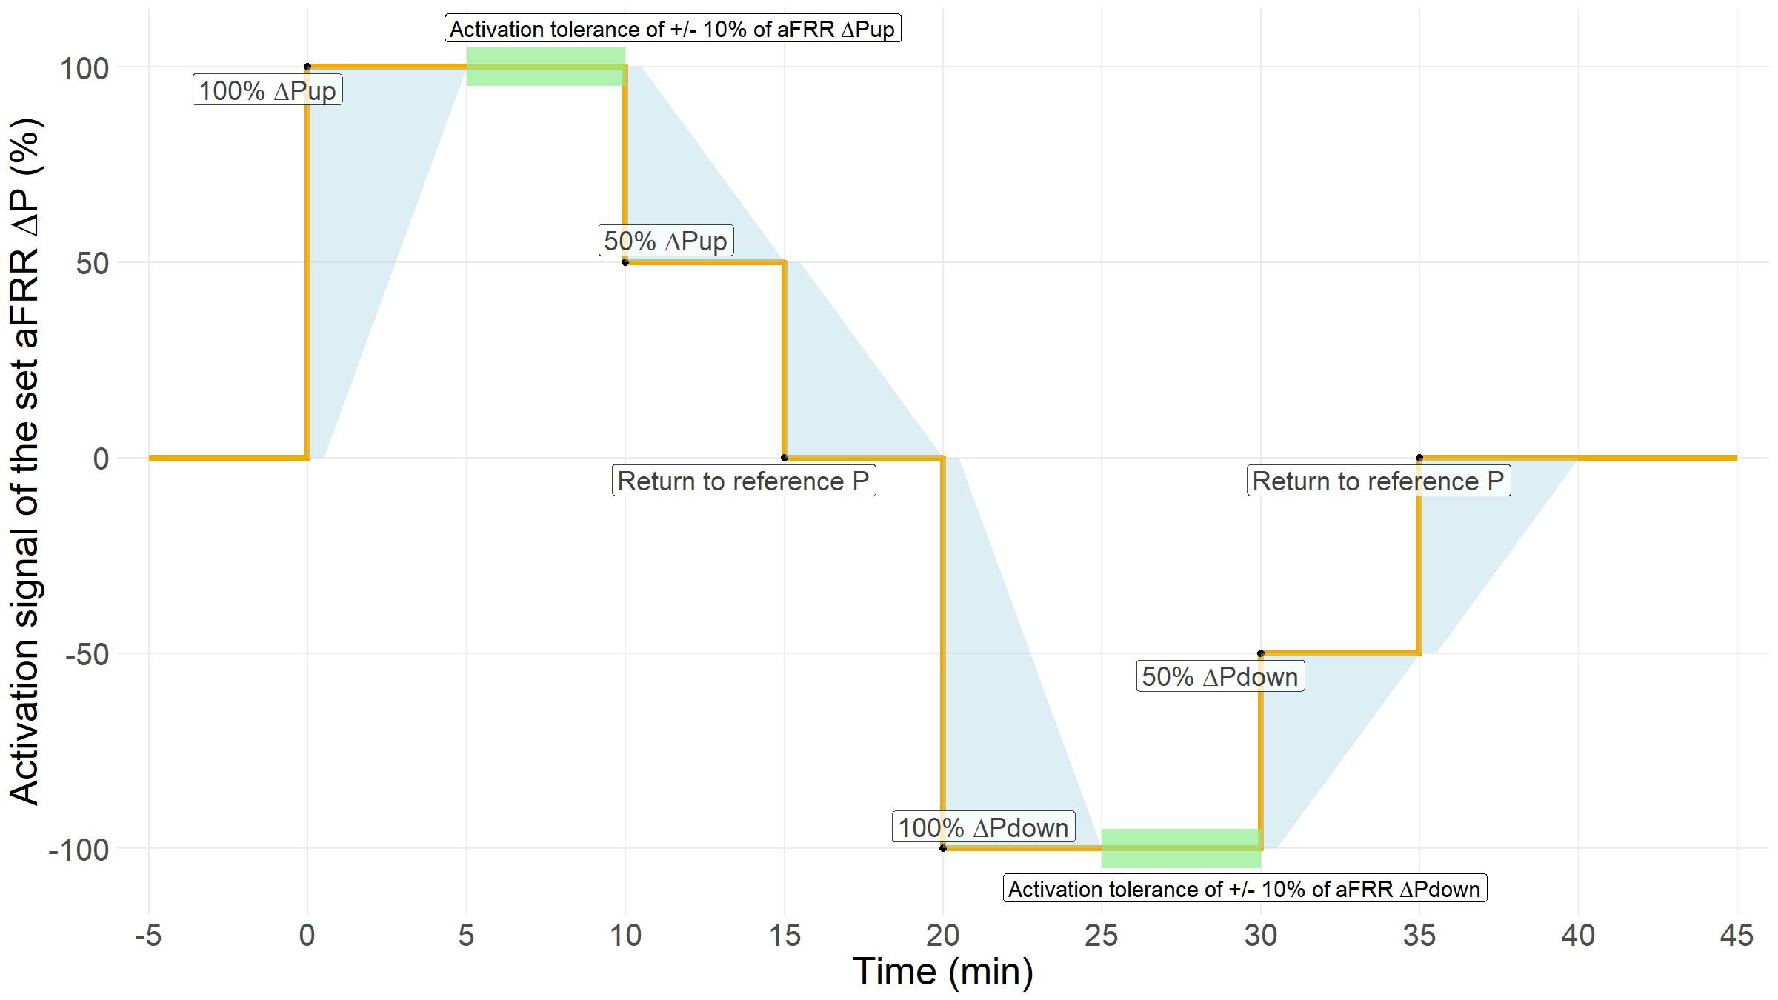Figure 13. aFRR prequalification testing schedule example

### Data analysis

The recordings shall be analysed to derive the parameters of the active power control for the provision of aFRR control performed by the unit and compare them with the service requirements; the following parameters of the control shall be assessed:

1. Activation and full activation times. During the aFRR activation process of aFRR service provision shall be within a blue area as shown in Figure 13.
2. Temporary over-fulfilment (overshoot) and stability of the control.

Once the aFRR provider activates the aFRR service, the activated aFRR capacity shall not deviate more than 10% of the maximum service value, if not defined differently in the national terms and conditions or other legislation. This signal shall be between the upper and lower limit as indicated in Figure 13.

## mFRR service description

The mFRR are operational reserves used by TSO to restore the reserves of already activated aFRR and to compensate large and sustained deviations of the load and production with respect to the forecasts.

The provision of mFRR from mFRR providing unit or group of units consist in:

1. during the scheduling phase, to define a load program of the unit with sufficient upward and/or downward margin for the provision of the mFRR assigned to the unit,
2. during the real-time, to activate and deliver the partial or full value of the assigned mFRR in accordance to the instruction received from TSO.

Authorised candidates for mFRR shall be accurately described in terms of:

1. Single unit or groups of units virtually aggregated through measurements;
2. Categories of grid users: generating units, demand facilities or storage facilities.
3. Nominal voltage at the Connection Point of the units: 330kV, 110kV and <110kV.

## mFRR technical requirements

### Activation of mFRR

The FAT of mFRR shall be 12,5 minutes. The activation and deployment of the mFRR shall be based on the instructions received from TSO. The instructions consist of mFRR setpoint activation value for mFRR providing unit, which is communication from TSO to mFRR providing unit by phone, email or web service.

mFRR activation preparation period must not be longer than 7 minutes, this means that mFRR activation must not start later than 7 minutes after activation signal. The deactivation period for mFRR service cannot be longer than 10 minutes.

A potential mFRR providing unit or group of units shall be able to modify its active power in accordance with the new setpoint within mFRR FAT. The mFRR setpoint shall be kept for the duration of the activation requirements.

### mFRR service continuity and mFRR provider availability

Each prequalified Reserve Unit prequalified for mFRR must be able to deliver continuously mFRR for at least 1 Validity Period. In case potential mFRR provider has limitation on continuous mFRR provision over one Validity Period, the limitation on maximum continuous Validity Periods for maximum upward and downward bid size must be described in the mFRR prequalification application.

The mFRR provider must be available during time periods when mFRR energy service is provided to the market. The availability requirement is not verified during prequalification process. This availability requirement is only applicable for the reserved volume that is offered during the bidding process.

### Accuracy of measurement and control for mFRR

A potential mFRR providing unit shall be capable of controlling its active power to a set-point value with a steady-state error not greater than ±10% of the requested mFRR volume or 0,1 MW, whichever is larger, if not defined differently in the national terms and conditions or other legislation..

### LER mFRR provider energy reservoir management strategy description

An mFRR provider is deemed to be an mFRR provider with LER in case a full continuous activation of its mFRR for a period of 2 hours in either positive or negative direction might, without consideration of the effect of an active ERM, leads to a limitation of its capability to provide the full mFRR activation due to the depletion of its energy reservoir.

Each LER mFRR provider shall provide a comprehensive description of the active ERM of the LER mFRR provision by providing information on the following points:

1. Full capacity of energy reservoir;
2. Operational limits that affect usage of reservoir;
3. Operable capacity of reservoir;
4. Permissible charge/discharge power;
5. Description of planned ERM strategy (energy source used for management);
6. Information on the rate of use of ERM (continuous, each 5 min, etc.);
7. Expected bid regularity and size.

### Data exchange requirements for mFRR providers

The potential mFRR provider shall be equipped with a communication interface compliant with reserve connecting TSO requirements.

The potential mFRR provider shall provide to the reserve connecting TSO real-time data or periodically timestamped data on following data points. If mFRR is activated via automatic measures the reserve connecting TSO shall define additional requirements for the mFRR provider.

|  |  |
| --- | --- |
| Signal parameter | Explanation |
| Scheduled active power output | Scheduled set-point of active power output of the unit that is providing mFRR in MW. |
| Active power output | Active power output of the unit that is providing mFRR in MW. |
| Activated upward mFRR volume* | Volume of upward mFRR that is activated on the request from the reserve connecting TSO in MW |
| Activated downward mFRR volume* | Volume of downward mFRR that is activated on the request from the reserve connecting TSO in MW |
| SOC level | The state of charge of the LER mFRR providing unit |

Table 9. Signal list of data points that are provided by mFRR providing unit to the reserve connecting TSO

* Possible additional requirement for automatic measures

The reserve connecting TSO shall provide following data to the BSP in case web service activation is used. BSP shall forward the activation signal to the mFRR providing unit.

|  |  |
| --- | --- |
| Signal parameter | Explanation |
| mFRR upward activation | The volume of upward mFRR TSO requires to be activated by the mFRR providing unit according to mFRR requirements |
| mFRR downward activation | The volume of downward mFRR TSO requires to be activated by the mFRR providing unit according to mFRR requirements |

Table 10. Signal list of data points that are provided by the reserve connecting TSO to the mFRR providing unit

The inaccuracy of measurements shall not exceed 2% achieved either by direct measurement using a meter of 1.0 class (B class) or indirect using a measurement transformer and meter of class 0.5 (C class) each, if not defined differently in the national terms and conditions or other legislation. The data is used for verification and monitoring of mFRR service.

### Requirement of the reserve connecting TSO

Reference: Article 158(1) of SOGL.

B-13 and B-15 of SAFA

Each mFRR provider shall have only one reserve connecting TSO. It means that an mFRR provider can be considered connected to only one TSO.

## Additional requirements for mFRR providing Groups

mFRR provision can be provided by technical entities that cannot comply alone with the mFRR service technical requirements or prequalification requirements. To ensure that the mFRR provision is possible form these technical entities, mFRR service can be provided by mFRR providing groups that can consist of multiple generation, demand or storage units and/or Reserve Providing Units.

Baltic TSOs describe in this chapter the principles required from mFRR providing groups to ensure the service quality and capability to monitor the service.

### Activation of mFRR providing group

mFRR providing group shall have a single point of activation for mFRR activation.

### Composition of mFRR providing group

Baltic TSOs define following principles for the composition of mFRR providing groups:

1. The BSP is responsible of defining the list of technical entities for mFRR providing group
2. Each technical entity can be part of only one mFRR providing group
3. Prequalified mFRR providing group cannot be considered as a part of larger mFRR providing group
4. mFRR providing group can provide mFRR capacity contribution for each technical entity in the prequalification application documentation for both upward and downward regulation. The mFRR capacity contribution is to manage the composition change of mFRR providing group defined in chapter 5.8.3.

### Composition changes of mFRR providing group

A potential mFRR provider can increase the maximum mFRR capacity contributions in following ways:

1. New prequalification process is completed with additional technical entities that provide additional capacity to the mFRR providing group
2. Single power generating module or demand unit, or an aggregation of technical entities connected to a common connection point that can fulfil the mFRR prequalification requirements as a Reserve Providing Unit can be prequalified successfully and added to the existing mFRR providing groups maximum capacity after.

### Data provision requirement for mFRR providing group

In addition to real-time data requirements defined in 5.7.4 the mFRR providing group has the right to aggregate the real-time data to timestamped data for more than one technical entity if the maximum power of the aggregated units is below 1,5 MW and clear activation of mFRR is possible.

If the connecting TSO needs more detailed information to verify the mFRR activation, the mFRR provider shall however be able to make available the requested timestamped data information regarding each technical entity belonging to the aggregate with a time resolution of at least 10 seconds.

## mFRR prequalification procedure

Reference: Article 159 of SOGL

### Purpose of the Test

The following tests for the pre-qualification shall consist in the verification of the correct configuration of the information exchange with TSO and in the simulation of an instruction from TSO. The tests are deemed passed if the consequent active power variations of the potential mFRR providing unit or group of units are in accordance with the technical requirements of 5.7 and 5.8. The qualification in an LFC Area belonging to a LFC Block is valid for the whole Block.

In case mFRR providing unit provides asymmetric mFRR services, the testing schedule shall be designed by applying the provided mFRR upward and mFRR downward as the maximum step values, which shall be tested. If service is provided for single direction, the testing schedule for opposite direction is excluded. During prequalification of LER mFRR providers the operation of ERM is allowed and verified.

During the mFRR testing the over and under provision of mFRR shall be assessed to make sure that energy volume received during the mFRR testing period is not exceeding or missing set limits. The energy limitations that are checked during the prequalification period are described in 5.9.4.

The testing procedures shall be prepared by the owner of the potential mFRR providing unit or group of units and submitted to TSO. The tests can be carried out only after TSO has given its formal approval to the testing procedures. These procedures shall be completed of instrumentation and measurements devices used to perform the tests, detailed methodology for the conduction of the tests, indicative duration of the tests, process to be followed for the analysis of measurements, expected results and a proposal of schedule.

### Initial conditions

The potential mFRR providing unit or group of units be connected to the grid and in normal operating conditions.

Initial settings of control:

1. Status of mFRR: ON
2. Active power setpoint: Any value permitting full range of activation for mFRR (the selected value shall not be modified during the test)
3. Voltage/Reactive power setpoint: Any value

### Testing method

mFRR service verification test is carried out by sending mFRR activation volume to the mFRR provider. The maximum upward and downward mFRR capacity that are tested and prequalified are determined based on the mFRR prequalification application submitted by the BSP. The prequalification test is following testing principles shown in Figure 14. Yellow line indicates activation order. Blue area indicates mFRR activation tolerance.

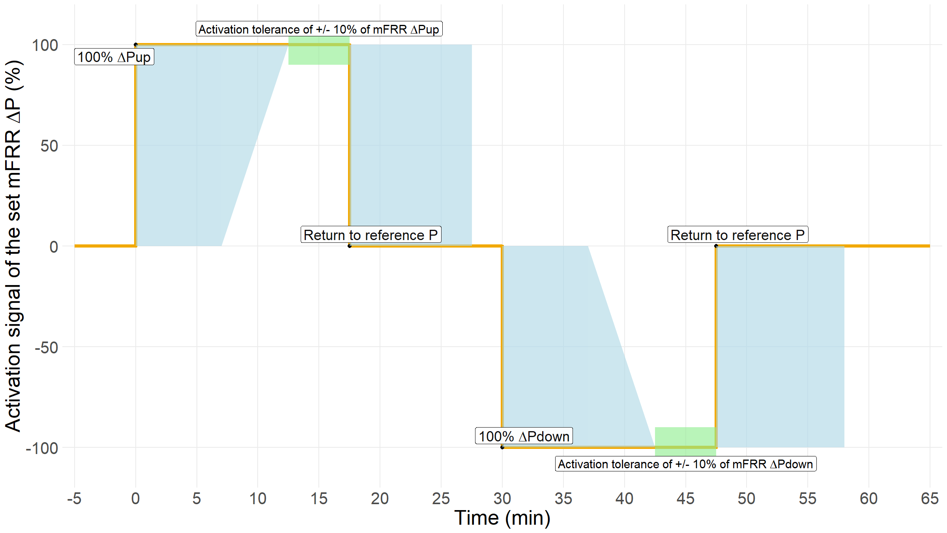Figure 14. mFRR prequalification testing schedule example

### Data analysis

The recordings shall be analysed to derive the parameters of the active power control for the provision of mFRR control performed by the unit and compare them with the balancing energy product characteristics set in Appendix A of Baltic Balancing market rules. The following parameters of the control shall be assessed:

1. Preparation period. Preparation period no longer than 7 minutes (0 – 7 min.).
2. Full activation time: ramping period together with preparation period should no more than 12,5 minutes.
3. For both directions, the mFRR activation needs to ensure that during timeframe of T+7 to T+22 mFRR providing unit supplies activated energy volume at least 80% of the maximum activated mFRR capacity for given 15-minute period. Maximum activated mFRR capacity for 15-minute period is calculated by multiplying the 100% Pup or Pdown value with 0,25h to get the energy volume.
4. For both directions, the mFRR activation needs to ensure that during timeframe of T+0 to T+27,5 the activated energy supplied by the mFRR providing unit does not exceed 120% of the maximum activated mFRR capacity for the 15-minute period. Maximum activated mFRR capacity for 15-minute period is calculated by multiplying the 100% Pup or Pdown value with 0,25h to get the energy volume.
5. Once the mFRR provider activates the mFRR service, the activation signal shall not deviate more than 10% of the maximum service value, if not defined differently in the national terms and conditions or other legislation. This signal shall be between the upper and lower limit as indicated in Figure 14.
6. Deactivation period. Deactivation period shall not be longer than 10 minutes.
7. Temporary over-fulfilment (overshoot) and stability of the control. During the mFRR activation process of mFRR service provision shall be within a green area as shown in Figure 14.

1. The operating status would reflect the Reserve Units operation mode. Reserve Unit providing mFRR service can be in stand-by and fully activate within the full activation time, but have a minimum capacity that should be activated. Additional point would be that Reserve Unit is in operation and then the provision of Reserves could be different than compared to stand-by mode.
2. DSR is subject of requirements in national terms and conditions
3. DSR is subject of requirements in national terms and conditions
4. According to Article (8)(2)(f), the real-time information request towards an FCR provider shall be published on the internet following the approval of the competent NRA.
5. The normal state is a condition in which the system is within operational security limits in the N-situation and after the occurrence of any contingency from a list of contingencies, taking into account the effect of the available remedial actions.
6. The alert state is a condition in which the system is within operational security limits, but a contingency from a contingency list has been detected and in case of its occurrence the available remedial actions are not sufficient to keep the normal state.

   Referring to frequency deviation in CE, an alert state is triggered by one the two following conditions:

   The absolute frequency deviation has continuously exceeded 50 mHz for 15 minutes.

   The absolute frequency deviation has continuously exceeded 100 mHz for 5 minutes.