EECS
Domain Protocol

for
Latvia

Prepared by Augstsprieguma tīkls (AST)
Based on EECS Rules Release 8 v14

Release [2.1] [2022]

Document Control
Version | Date | Originator | Reviewers
0.1 | 05.07.2020 | AST
0.2 | 09.08.2020 | AST
 | 25.08.2020 | AST
 | 01.10.2020 | AST
Final | 05.10.2020 | AST | Emma Kelly and Markus Klimscheffskij
1.1 | 13.01.2020 | AST | Emma Kelly and Markus Klimscheffskij
2.0 | 09.02.2021 | AST | Emma Kelly and Markus Klimscheffskij
2.1 | 22.07.2022 | AST | Emma Kelly and Jana Vynckier (replaced by Bram Van Der Hejjde)

Version | Approver | Date | Responsibility
1 | ESG | 09.10.2020 | ESG
2 | ESG | 23.02.2021 | ESG
2.1 | ESG | 22.09.2022 | ESG

Change History
Version | Description
1
2 | Changes to disclosure rules and small amendments/clarifications
3 | First periodic audit after one year of operation

Contents
A Introduction 5
B General 5
B.1 Scope 5
B.2 Status and Interpretation 6
B.3 Roles and Responsibilities 6
B.4 Issuance scope summary 7
C Overview of National Legal and Regulatory Framework 8
C.1 Energy market context 8
C.2 The EECS Framework 8
C.3 National Energy Source Disclosure 9
C.4 National Public Support Schemes 11
C.5 EECS Product Rules 12
C.6 Local Deviations from the EECS Rules 12
D Registration 13
D.1 Registration of an Account Holder 13
D.2 Resignation of an Account Holder 13
D.3 Registration of a Production Device 14
D.4 De-Registration of a Production Device 16
D.5 Maintenance of Production Device Registration Data 17
D.6 Audit of Registered Production Devices 18
D.7 Registration Error/Exception Handling 19
E Certificate Systems Administration 20
E.1 Issuing EECS Certificates 20
E.2 Processes 21
E.3 Measurement 22
E.4 Energy Carrier Conversion and Energy Storage (Including Pumped Storage) 24
E.5 Combustion Fuel (e.g. Biomass) Input and Production Devices with multiple energy inputs 24
E.6 Format 25
E.7 Transferring EECS Certificates 26
E.8 Administration of Malfunctions, Corrections and Errors 27
E.9 End of Life of EECS Certificates – Cancellation 27
E.10 End of Life of EECS Certificates – Expiry 28
E.11 End of Life of EECS Certificates – Withdrawal 29
F Issuer’s Agents 30
F.1 Production Auditor 30
F.2 Production Registrar 30
F.3 Measurement Body(/ies) 30
G Activity Reporting 31
G.1 Public Reports 31
G.2 Record Retention 31
G.3 Orderly Market Reporting 31
H Association of Issuing Bodies 33
H.1 Membership 33
H.2 Complaints to the AIB 33
I Change Control 34
I.1 Complaints to AST 34
I.2 Disputes 34
I.3 Change Requests 34
Annex 1: Contacts List 35
Annex 2: Account Application/Amendment Form 36
Annex 3: Production Device Registration/Amendment Form 37
Annex 4: High Efficiency cogeneration declaration 39
Annex 5: Declaration for the mixed-fuel Production Devices 40
Annex 6: Approval form 41
Annex 7: EECS Electricity Cancellation Statement 42
Annex 8: EECS GO view in the Registry 44

Introduction
This Domain Protocol describes how the EECS Standard has been implemented in the Latvian Domain for a certain type of energy certificate and it indicates where that system deviates from that standard. The EECS framework including the Domain Protocol aims to ensure robustness and transparency for all parties involved.
A Domain Protocol promotes quality and clarity, as it:
- explains local rules;
- provides clear information to all stakeholders (consumers, market parties, other members, government, the EU Commission etc.);
- facilitates assessment of compliance and permissible variance from the EECS Rules;
- facilitates audit; and
- translates local rules into a single format and language, supporting each of the above.

Important contact information is provided in Annex 1.

General

Scope

This Domain Protocol sets out the procedures, rights and obligations, which apply to the Domain of Latvia and relate to the EECS Electricity Scheme as defined in the EECS Rules.

Production Device qualification for this Domain will be determined by connection to the electricity system of Latvia such that, in electrical terms, the Production Device is effectively located in Latvia. A Production Device can be a single device or a group of devices with single production technology, that produce an Output with a common connection point to the electricity system and a common electricity measurement system.

The borders of the Domain are determined as follows: the System operator’s networks in the territory of Latvia bordered with other domains by cross-border transmission lines;

There are no production devices currently that are connected to Latvia and another domain system operator.

AS "Augstsprieguma tīkls" (thereinafter – AST) - the Transmission System Operator, is authorised to Issue EECS Certificates relating to the following EECS Product(s):
- The EECS-Guarantee of Origin – (thereinafter EECS GOs), for electricity produced from renewable energy sources or for High Efficient Cogeneration.

AST is authorised to Issue EECS Certificates relating to the following EECS Product Type(s):
- Source (energy produced from renewable sources);
- Technology, implying the mandate to issue certificates for High-Efficiency Cogeneration in accordance with EU Directive 2012/27 (EU).

AST is authorised to Issue EECS Certificates relating to the following Energy Carriers: electricity, and the following energy sources:
- renewable (including biomass);
- fossil (only for High-Efficiency Cogeneration).

AST do not issue energy certificates outside of the EECS Framework.

Status and Interpretation

This document refers to EECS Rules [8 version 1].

The EECS Rules are subsidiary and supplementary to national legislation.

The EECS Rules and its subsidiary documents are implemented in Latvia in the manner described in this Domain Protocol. Any deviations from the provisions of the EECS Rules that may have material effect are set out in section C.6 of this document.

The capitalised terms used in this Domain Protocol shall have the meanings ascribed to them in the EECS Rules except as stated in section C.6 of this document.

This Domain Protocol is made contractually binding between an EECS Participant and AST by agreement in the form of the Standard Terms and Conditions (thereinafter - STCs).

In the event of a dispute, the approved English version of this Domain Protocol will take precedence over a local language version.

Roles and Responsibilities

The Authorised Issuing Body for EECS GOs in Latvia is AST. Its role is to administer the EECS Registration Database (hereinafter – Registry) and its interface with the EECS Transfer System. Information regarding service fees and invoicing is available on the AST website under subsection fees: https://www.ast.lv/en/content/guarantees-origin.

The Competent Authority for EECS GOs for electricity in Latvia is AST. Its role defined in national legislation, is to be responsible for the operation of EECS GOs in Latvia.

The Authorised Measurement Bodies are Transmission and Distribution System Operators that are listed on The Public Utilities Commission website https://www.sprk.gov.lv/content/pakalpojumu-sniedzeji-1. They are the Authorised Measurement Bodies established under national regulations to be responsible for the collection and validation of measured volumes of energy used in national financial settlement processes.

Contact details for the principal roles and Issuing Body agents are given in Annex 1.

The Registry is operated by AST can be accessed via http://cmo.grexel.com.

The Production Auditor is the independent accredited Production Auditor whose role is to verify and approve information which is provided from the Account Holder via Annex 3, Annex 4 and Annex 5. Production Auditors use industry best practices which also include on-site inspections.

The Public Trader (hereinafter – Public Trader), purchases electricity from producers under mandatory procurement and based on Electricity Market Law, it must receive all issued EECS GOs from stations which are included in the National Support Schemes and provide data to AST about to what extent the unit of energy has benefited from support. The Public Trader has the above mentioned right, only for the period for which Production Devices receive benefits from National Support Schemes. The benefit unit of energy is expressed in EUR/MWh. The Public Trader can also act as an Account Holder.

All application forms, general information and final publication of EECS GOs operations are available on the AST website: https://www.ast.lv/en/content/guarantees-origin

Non-Governmental Certificates do not exist in Latvia. No EECS GOs are issued in combination with an Label Scheme.

The Account Holder is a private or legal person who has successfully completed the registration process and for whom AST has created an Account in the Registry, activated it and the applicant, has received full rights to create the root user for the Account. The Account Holder can apply for the registration of the Production Device in the Registry.

Production Registrar - AST acts as the Production Registrar and is responsible for assessing applications to register Production Devices for the purposes of the relevant EECS Product and national legislation. AST relies on the Production Auditor for information conformity.

The Disclosure body – The Public Utilities Commission (hereinafter – the Regulator) issues disclosure rules and governs supplier disclosure statements.

Residual mix calculating body – AST conducts residual mix calculations.

The State Construction Control Bureau of Latvia (hereinafter – BVKB) – is the state authority overseeing the compliance of Production Devices that receive public support. In the Latvian domain it fulfils role of the Production Auditor.

Issuance scope summary

In summary, AST is authorised to Issue the following types of energy certificates:
Issuing Body issues certificates for: |  |  | Electricity
 |  | Product Type | Source | Technology (= High-Efficiency Cogeneration)
EECS GO | Energy source | Hydro | x
 |  | Solar | x
 |  | Wind | x
 |  | Biomass | x | x
 |  | Geothermal | x | x
 |  | Landfill & sewage treatment plant gas | x | x
 |  | Tidal/wave/other ocean energy | x
 |  | Ambient energy | x
 |  | Fossil |  | x
 |  | Nuclear
National GO (non-EECS*) |  | N/A
EECS Support Certificate |  | N/A
EECS NGC (name) |  | N/A
National certificate other than GO (non-EECS*) |  | N/A
(*) Non-EECS certificates may not be transferred over the AIB hub.

Overview of National Legal and Regulatory Framework

Energy market context

The electricity market in Latvia is fully open and in line with Directive 2019/944. Wholesale trades are done Day-ahead and the Intraday market is operated by NordPool. There are also forward market energy products in Nasdaq (ENOY, EPAD) that are used for renumeration Day-ahead market results. Also possible are forward hedging opportunities, financial transmission rights on the Estonia-Latvia border issued by AST: https://www.ast.lv/en/content/ptr-limited-auctions.

Transmission and distribution system operators are fully independent from energy generation and suppliers. More detail on the Electricity market law: https://likumi.lv/ta/en/en/id/108834.

Overview of the Latvian electricity market statistics of generation, import/export and consumption can be viewed on the AST webpage: https://www.ast.lv/en/electricity-market-review

Overview of the energy market can be viewed on the Regulator webpage: https://www.sprk.gov.lv/en/content/electricity-0

The EECS Framework

For this Domain, the relevant local enabling legislation is as follows:

Electricity Market Law, implementing the directives 2009/72/EC, 2009/28/EC and 2018/2001 EC. Available at: https://likumi.lv/ta/id/108834-elektroenergijas-tirgus-likums

AST has been properly appointed as an Authorised Issuing Body for RES EECS GOs and high efficiency cogeneration EECS GOs under Electricity market law Article 29² which entered into force on 1st of December 2020. Available at: https://likumi.lv/ta/id/108834-elektroenergijas-tirgus-likums.

The Electricity Market Law specifies the details concerning the EECS GOs system in Latvia. Article 29² of Electricity market law states: "An electricity producer who utilises renewable energy resources or high efficiency co-generation for electricity production may receive a guarantee of origin for the quantity of electricity produced which is expressed in megawatt hours (MWh). The minimum amount of electricity for which a guarantee of origin may be issued is one megawatt-hour (MWh). No more than one guarantee of origin may be issued per each unit of electricity produced."

The EECS GO is an electronic document issued by AST upon application of the Account holder sole purpose of the EECS GOs is to prove that the unit of electricity has been produced from a renewable source or high efficiency co-generation for electricity production.

Any use of the EECS GOs should take place within 12 months of production of the corresponding energy unit, after this period they will expire. The EECS GOs will be cancelled in the Registry once it has been used.

For the issuance of an EECS GO regarding electricity produced in high-efficiency co-generation units, primary energy savings will be calculated in accordance with the procedures determined by the Cabinet of Ministers on the calculation of primary energy savings of cogeneration units. Link to procedure: https://likumi.lv/ta/id/317216-noteikumi-par-elektroenergijas-razosanu-uzraudzibu-un-cenu-noteiksanu-razojot-elektroenergiju-kogeneracijaThe calculation of primary energy savings of cogeneration units information will be provided by the Production Device owner and confirmed by the Production Auditor.

The TSO shall publish information about issued EECS GOs on http://cmo.grexel.com and its webpage (https://www.ast.lv/en/content/guarantees-origin ).

For providing proof to a final customer that a given share or quantity of energy was produced from specific energy sources or technology type, the EECS GOs issued in Latvia or in other Member States of the European Union or in other states from European Economic Area shall be used. The EECS GOs can be transferred independently of the energy to which it relates, from one Account Holder to another.

The amount of EECS GOs to be issued shall be determined using remote measurement devices and is calculated as the net electrical energy injected via the producer's connection points to the grid during one calendar month period, described more in detail in section E.3. Measurement Bodies send electricity metering data directly AST.

In accordance with Electricity Market law, AST can only recognize the EECS GOs issued in European Union Member States and the European Economic Area according to the EECS Rules.

National Energy Source Disclosure

Legislation and regulation:

Electricity Market Law, implementing the directives 2009/72/EC and 2009/28/EC. Available at: https://likumi.lv/ta/id/108834-elektroenergijas-tirgus-likums

Decision No.1/16 of the Board of the Public Utilities Commission of December 3, 2020 " Rules on information to end-users of electricity and natural gas". Available at: https://www.vestnesis.lv/op/2020/236.23

Decision No.1/4 of the Board of the Public Utilities Commission of June 26, 2013 "Network code in the electricity sector". Available at: https://likumi.lv/ta/id/257943-tikla-kodekss-elektroenergijas-nozare

Article 32 (4) of the Electricity Market Law delegates to Public Utilities Commission the authority to determine what information and to what extent the electricity suppliers have to include in the end-user bills and informational materials. While the Public Utilities Commission describes in detail the methodology and process of disclosure.

Previously mentioned legislation implements the requirements arising from Article 3(9) of the Directive 2009/72/EC and additional requirements set out in Annex I of Directive 2019/944.

Brief summary of the disclosure methodology and process:

The supplier shall provide to the end-consumer information, together with an invoice or with other presented information and promotional materials.

Invoices that suppliers send to end-consumers shall provide the following information: the name of the energy product received; the amount of energy delivered during the billing period in kWh; energy price for the billing period [EUR/kWh]; energy bill during the billing period [EUR]; the cost of transmission and distribution system components [EUR]; the cost of the mandatory procurement components [EUR] (does not apply to bills for non-household users and non-delegated powers suppliers to pay for the mandatory procurement components); total payment amount for the billing period [EUR]; information on how to access detailed consumption information, information about electricity origin and environmental impact.

At least once a year, no later than by 31st July, the electricity supplier shall provide end-consumers with informative material on the environmental impact, in terms of at least CO2 emissions and the radioactive waste resulting from the electricity produced by each product fuel mix of the supplier over the preceding year. Information should be available through information in bills.

At least once a year, not later than by 31st July, the electricity supplier shall provide the end-consumers with access to informative material (Information should be available through information in bills) for previous year which includes:
- information on the origin of the electricity supplied for the previous calendar year, indicating the share of electricity purchased from electricity producers in Latvia as a share of the total amount of electricity supplied to end-consumers;
- the share of electricity procured from other traders in Latvia in the amount of electricity delivered to the end-users;
- the share of electricity purchased on the electricity exchange in the total amount of electricity supplied to end-users;
- the proportion of electricity produced from each type of renewable energy (hydropower, biogas, biomass, wind energy, solar energy or other renewable energy sources) as a share of the total amount of electricity supplied to end users;
- the proportion of electricity produced from each type of fossil fuels (natural gas, coal, shale or other fossil fuels) to the total amount of electricity supplied to end-consumers;
- the proportion of electricity produced from an energy source (which is not mentioned previously, but appears in the AST calculated residual mix) against the total amount of electricity supplied to end-consumers.

Information about the origin of supplied energy must be based on explicitly tracked electricity origin, by cancelling GOs and for untracked supplied energy share the Residual Mix must be used as described in the national regulatory provisions.

According to Electricity Market law, AST has created and maintains the national Residual Mix calculation methodology. AST has adopted an Issuance based method available on the AST website under subsection residual mix: https://www.ast.lv/en/content/guarantees-origin .The Latvian national Residual mix is calculated by using information about national generation, consumption, issued and expired certificates, European residual mix and imported/exported energy from External countries. Calculations are done in cooperation with AIB. On high level base formula of Residual mix:
Residual mix = Generated electricity – Issued EECS GO + Expired EECS GO + Import from external country – Export from external country ± European residual mix;
Note: External country - Country not included in the European Residual Mix calculation area

The residual mix of the previous year shall be calculated and published by the 30th of June on AST website https://www.ast.lv/en/content/guarantees-origin.

According to article 60 of Decision No.1/4 of the Board of the Public Utilities Commission of June 26, 2013 "Network code in the electricity sector" the Transmission System Operator shall have the right to request from the Distribution System Operator information associated with the issuing of EECS GOs.

For this Domain, the authorised body for supervision of Disclosure of the origin of energy towards consumers is the Public Utilities Commission. This body is responsible for supervision of disclosure of the origin of the following Energy Carriers: electricity.

Cancelations for usage in another Domain (i.e. Ex Domain Cancellations) are allowed under the following restrictions: Domain allows such cancelation and (if applicable) AST has agreement with Domains competent authority. For information contact AST: go@ast.lv.

National Public Support Schemes

Mandatory procurement is a state-approved support mechanism for electricity producers, which provides financing from electricity end-user payments. The Cabinet of Ministers has determined the criteria for the qualification of co-generation plants for acquiring this right as well as for production of electricity using renewable energy sources. The conditions for the production of electricity and the pricing procedure are regulated by the Cabinet of Ministers regulations, the purchase price of electricity is also determined by the Cabinet of Ministers. It is differentiated depending on the type of resource and power plant (Cabinet Regulation No. 560 of September 2 2020 “Regulations on Electricity Generation from Renewable Energy Sources, as well as on Pricing Procedures and Monitoring” available at: https://likumi.lv/ta/id/317215-noteikumi-par-elektroenergijas-razosanu-izmantojot-atjaunojamos-energoresursus-ka-ari-par-cenu-noteiksanas-kartibu-un-uzraudzibu and Cabinet Regulation No. 561 of September 2 2020 “Regulations on the Production, Monitoring and Pricing of Electricity from Cogeneration” available at: https://likumi.lv/ta/id/317216-noteikumi-par-elektroenergijas-razosanu-uzraudzibu-un-cenu-noteiksanu-razojot-elektroenergiju-kogeneracija).

During the mandatory procurement, electricity from producers is purchased by the Public Trader at a certain price. The Ministry of Economics grants the right to sell the produced electricity within the framework of mandatory procurement. The conditions for the production of electricity and the pricing procedure are regulated by the Cabinet of Ministers regulations.

The mandatory procurement components change annually (January 1), it is calculated in accordance with regulatory enactments and confirmed by the Public Utilities Commission. The Ministry of Economics grants the right to sell the produced electricity within the framework of mandatory procurement.

Additionally to support the process mentioned in C.4.2 a producer who produces electricity in a co-generation plant, of which the installed capacity is greater than four megawatts may receive a guaranteed payment for electric capacity installed in the co-generation plant.

Electricity Market Law states that for produced electricity, that is mandatorily procured by the Public Trader or is generated in a co-generation plant that receives a guaranteed payment for installed capacity, all issued EECS GOs should be transferred to the Public Trader. The Public Trader then uses the income from trading EECS GOs to reduce the mandatory procurement component.

According to the Cabinet of Ministers regulations listed in C.4.1. all Production Devices, that receives support described in C.4.2. and C.4.4., shall be registered in the Registry and in order to enable issuance of EECS GO shall submit necessary declarations (Annex 4 and 5) for period when particular Production Device receives support – more in detail E.3.6 and E.3.7.

EECS Product Rules

The EECS Product Rules as applied in Latvia are set out within sections D and E of this document.
In accordance with EU Directives and Latvian legislation, AST issues EECS GOs for the purpose of disclosure of electricity produced from renewable sources and electricity produced from high efficient cogeneration and for final consumer transparency.

Local Deviations from the EECS Rules

Account holders can request for EECS GO issuance up to 12 months from the production period end date. EECS GO are then issued with a shorter expiry period which correspond to end of respective production output (month).

Registration

Registration of an Account Holder

Any private, legal person who is not a member of the Association of Issuing Bodies, or such member’s affiliate or agent, can apply to be an Account Holder in the Registry. The procedures which include all information about requested attachments for opening an account in the Registry can be found on the AST website: https://www.ast.lv/en/content/guarantees-origin

The potential Account Holder must contract with AST under the Standard Terms and Conditions (thereinafter – STCs) which is published on the AST website: https://www.ast.lv/en/content/guarantees-origin

The potential Account Holder who wants to sign the STCs with AST must submit a completed submission form provided in Annex 2 which is published on the AST website. AST will check all information provided by the applicant in their application against the public records, the Enterprise Register of Latvia and The Public Utilities Commission. AST will also check applicants ID or passport validity and data. AST checks if organisation or person are not included in sanction list. In case that insufficient information on company available AST can request to fill "Know your customer" survey.

After receiving all documentation, including the signed STCs form, from the potential Account Holder, AST evaluates whether the application can be accepted. Handling time of properly submitted applications is 10 working days from the date of submission of the application/the additional information. Reasons for rejection may be:

Required documents are missing or not properly filled / signed

or AST has doubts about the aims of the applicant.

If the application is accepted, AST creates an Account in the Registry for the applicant. When the Account is activated, a log-in authorisation Certificate will be sent via e-mail to the applicant, awarding full rights to the created Account (root user). The password to install the Certificate will be sent via SMS. The applicant organization is then an Account Holder and can start operating the Account. One Account Holder organisation can have multiple users.

AST signs both copies of the STCs, one is stored in the AST archive and the other is sent to the Account Holder. As standard, electronic signature must be used and only in cases if it is not possible hand signature may be used.

AST may hold an Account in the Latvian domain and may own a Certificate only for testing purposes, it will report such activity to the Association of Issuing Bodies.

Information regarding service fees is available on the AST website: https://www.ast.lv/en/content/guarantees-origin

Resignation of an Account Holder

The Account Holder must notify AST of the intent to close their account. The effective date of closure must not be less than 30 working days from the date of receipt of the relevant information by AST. This can be done by submitting via e-mail the form provided in Annex 2 with option de-register account marked.

AST will close the account as of the effective date on the request or 30 working days from the date of receipt of the application by AST whichever is later.

The account must not contain any EECS GOs at the time of closure and all financial claims that AST has towards an Account Holder must be settled before the closure of the account. AST requires the Account Holder to transfer or cancel all remaining EECS GOs Certificates before closure.

AST is not obligated to return already paid fees of the Account Holder.

AST has the right to terminate the STC unilaterally if The Account Holder has been subject to international or national sanctions or sanctions imposed by a member state of the European Union or the North Atlantic Treaty Organization affecting significant financial and capital market interests during the performance of the Contract.

Registration of a Production Device

The Account Holder can apply for registration of a Production Device in the Registry. The account where EECS GOs are to be issued must be specified in Annex 3. Production Devices must be located in Latvia. The registration form is available on the AST website: https://www.ast.lv/en/content/guarantees-origin (Annex 3). Information provided in Annex 3 must be verified by an accredited Production Auditor by signing the registration form (Confirmation from Production Auditor must be received by the Account Holder - the requirements and the link to the list of the Production Auditors is provided in Annex 1 which is published on the AST website https://www.ast.lv/en/content/guarantees-origin). Confirmation from the Production Auditor is valid for 12 months from issuing date. Production auditor BVKB makes periodical audits for Production Devices that receives production support and submits to AST verified information needed for Production Device registration and information is periodically updated. Production Registrar AST checks and signs the registration form if the submitted information coincides with information received from BVKB, BVKB information is no older than 12 months and Production Device has ceased to receive support no longer than 12 months.

Additional documents required for registration Production Device into the Registry are:

A completed STCs submission form as stated in section D.1.3;

In case whereby the applicant or its affiliate is not the owner or sole owner of the Production Device, registration of the Production Device can be done by a third person, it must include a power of attorney signed by (other) owner(s) of the Production Device. AST checks the data included in a power of attorney against information provided in the official Enterprise Register. In case of doubt AST can request additional documents. A power of attorney is not required in the case where the Public Trader registers a Production Device, which is included in a National Support Scheme and for production of which the Public Trader is legally entitled to receive EECS GOs, even if the Public Trader is not the owner of the Production Device.

AST may request additional information for the registration if necessary, specifying the time limit within such information must be submitted.

Only Production Devices capable of producing electricity from renewable energy source and/or from high efficiency cogeneration technology and that are equipped with the required metering equipment can be registered in the Registry. The Account Holder must specify the authorised Measurement Bodies (the electricity grid operators) to which their Production Device is connected to in the registration form (Annex 3).

The Account Holder must provide documentation of auxiliaries of Production Device (if any) and grid connection diagram and metering diagram of the Production Device.

AST checks that the application fulfils the national laws, EECS Product Rules and is filled in correctly. Information is verified based on available data for AST (information in application is confirmed by Production Auditor). In case of doubt regarding the Production Device or when AST considers it necessary, AST can inspect the Production Device on site themselves or request an inspection by inviting the Production Auditor (more in detail in D.6). In such a case, the Production Auditor's costs shall be borne by AST.

If the Production Device satisfies both the Latvian laws and the EECS Rules, passes an inspection and if all necessary application information is gathered, AST registers the Production Device in the Registry in 10 working days from point when complete registration information is received and confirms successful registration via e-mail. Successful registration enables the issuance of EECS GOs for the Production Device from start of the month when Production Device is registered, and AST informs the Account Holder accordingly. Should the potential Account Holder fail to submit the additional information on the request of AST, or the Production Device does not comply with Latvian laws or the EECS Rules, AST shall reject the application and inform the Account Holder via e-mail.

After Production Device successful registration, it is assigned with a unique identifier GSRN code (accessible in the Registry). GSRN code is used for Production Device identification purposes and for Grid reference EIC (Energy Identification Codes) coding and metering point code (for DSO grid) is used. Public information relating to the Production Devices will be available in the Registry public registered Production Device list and access to full information will be available for the Account Holder (Production Device Owners or the Account Holder with Power of Attorney for Production Device) under the Account Holders profile in the Registry.

Information regarding service fees is available on the AST website: https://www.ast.lv/en/content/guarantees-origin

Process:
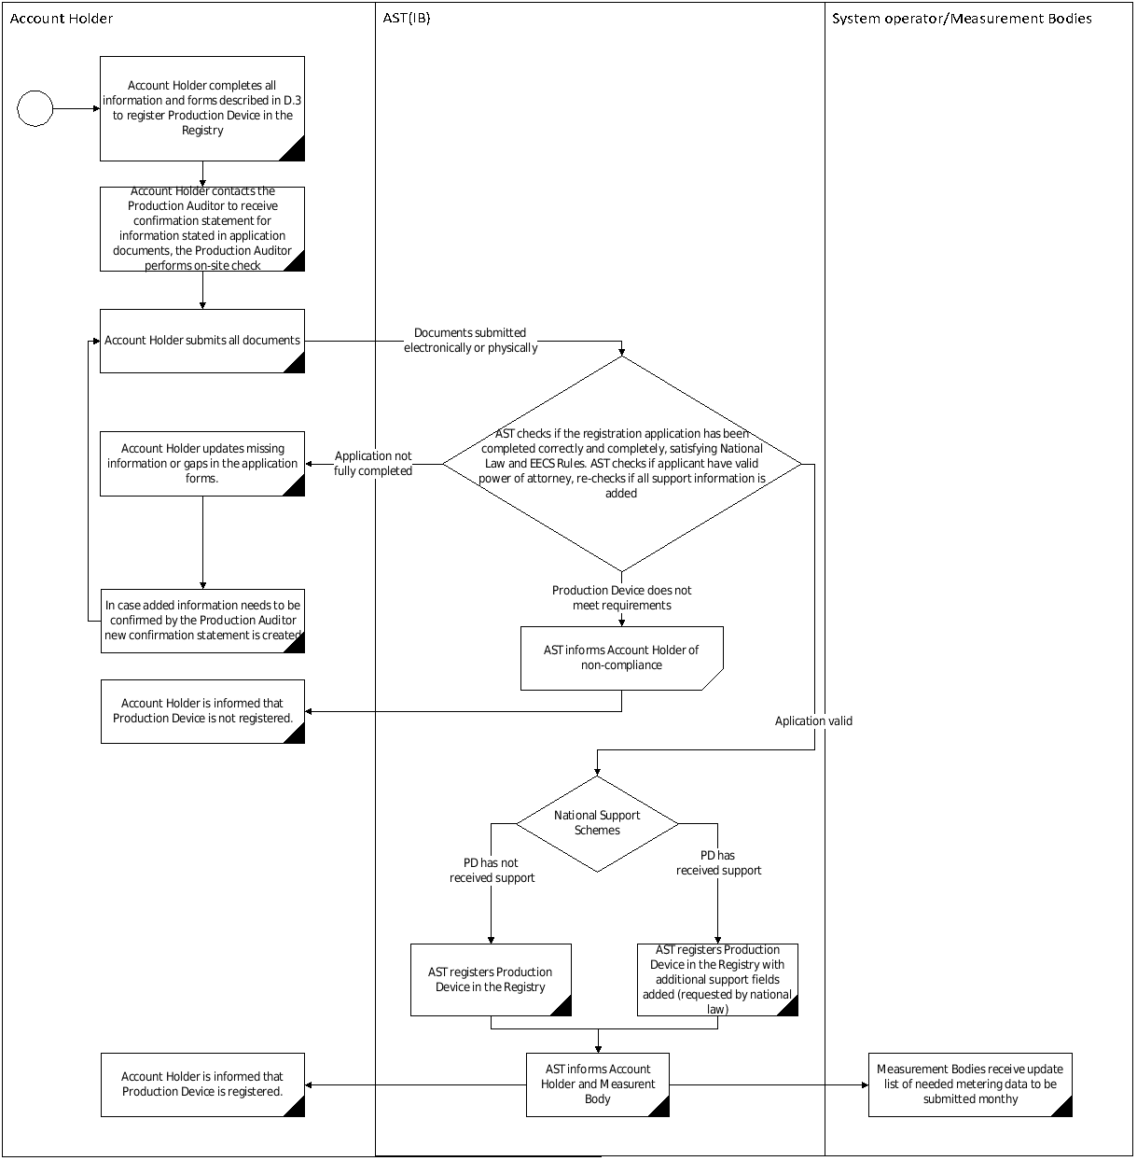

De-Registration of a Production Device

An Account Holder can apply for de-registration of a Production Device in the Registry. The effective date of de-registration must not be less than 30 working days from the date of receipt of the relevant application by AST. This can be done by (digitally) signing an Annex 3 and send to go@ast.lv . In this case Production Auditor signature is not needed, AST will respond to the Account Holder request within 10 working days and provide information of when the Production Device will be de-registered via e-mail.

AST will update the Registry for that Production Device to show that the Production Device no longer qualifies for EECS GOs with effect as of the effective date on the request or 30 working days from the date of receipt of the application by AST, whichever is later.

AST is not obligated to return already paid fees of the Account Holder. No additional fees are collected for performing the de-registering process.

Where AST becomes aware that a Production Device no longer fulfils, or will no longer fulfil the qualification criteria (meaning that the actual information does not correspond to that provided in the Annex 3) the Registry record for that Production Device will be updated to show that the Production Device no longer qualifies for EECS GOs with effect from:

(in relation to planned changes notified in advance) the date on which such planned changes are due to come into effect; or

(in relation to other changes) as soon as reasonably practicable after becoming aware.

Maintenance of Production Device Registration Data

In case of changes after Production Device registration the Account Holder is obliged to inform AST if the information no longer corresponds to submitted information in the Production Device Application/ Amendment Form (Annex 3) provided in registration process D.3 and/or latest version visible and active in the Registry. Amendments are made when the Account holder submits via e-mail to go@ast.lv the signed (electronically) Application/ Amendment Form (Annex 3) with changes made and marked "Amend Production Device".

Where the capacity of an existing Production Device increases for any reason, including refurbishment or enhancement of the Production Device, then in case added capacity has separate metering such additional capacity may be registered in the Registry as a separate Production Device with specified application process stated in D.3. In case added capacity doesn't have separate metering than existing Production Device information is amended by filling and submitting form available in Annex 3.

Only AST can change the information in the Registry related to the Production Device. In the Registry, Production Device information revisions can be done by the Account Holder, but changes in the Registry are only made once AST approves them. The Account Holder can view the Production Device version status within the Registry, and in case of questions contact AST via e-mail: go@ast.lv.

Where AST becomes aware of a change in the Production Device Registration Data (following an inspection or otherwise), AST will evaluate the impact of the changes on the Qualifying Criteria and respond to the Account Holder within 10 working days specifying the decision taken. AST may "lock" the Production Device in the system until the updated information is provided. The Production Device may cease to be recorded in the Registry if the PD Qualification Criteria for EECS GOs are no longer fulfilled.

In order to qualify for EECS GOs the Production Device must be re-registered every 5 (five) years otherwise registration of a Production Device expires. The Account Holder must re-apply for registration for the Production Device before the expiry date. The Account Holder must provide the same documents as in section D.3. AST will thereby re-check provided application and documentation and proceed to re-register the Production Device in the Registry as of the effective date on the request or the first day of the next calendar month in which AST received the request.

After Production Device ceases to receive production support described in C.4.2. and C.4.4. Production Device owner must submit the Production Device Application/ Amendment Form (Annex 3) with relevant changes in support information and changes in receiving account holder for issued EECS GOs or de-register production device. AST can use BVKB information for signing the Production Device Application/ Amendment Form if changes are updated in BVKB information, BVKB information is not older than 12 months and Production Device has ceased to receive support no longer than 12 months. After the Public trader has done issuance for all production periods when production support was received changes are made in the Registry and Production Device owner can request issuance of EECS GOs.

Audit of Registered Production Devices

The period between the Production Auditor inspections of a Production Device will not exceed 5 years.

The Production Devices that are registered in the Registry can be subject to an unplanned and planned audit. The Production Auditor may perform an on-site audit and inspection of records. Unplanned audits on Production Devices are conducted on an ad-hoc basis where there is reason to believe that the conditions of registration are no longer fulfilled. AST can perform or delegate to the Production Auditor to perform a planned audit in the case that AST considers it necessary. Refusal to permit access to the Production Device site or records may be considered a breach of the Standard Terms and Conditions.

If the Audit identifies material differences from the details recorded in the Registry, the Account Holder must re-apply for registration of the Production Device and EECS GOs will not be issued for respective Production Device before corrective actions have been performed.

Inspections verify that the Measurement Devices are correctly positioned in order to measure the quantity needed for calculating the amount of EECS GOs to be Issued.

Inspections confirm the accuracy of the Measurement Devices involved in the calculation of the amount of EECS Certificates to be Issued to be acceptable in accordance with the existing regulatory framework and applicable standards.

Inspections confirm that the formula for calculating the amount of EECS Certificates correctly reflects the amount of Output that qualifies for the Purpose of these EECS Certificates.

Audit of registration information is done by the Production Auditor who is independent of the owner or the Account Holder of the Production Device. This is a precondition for registration of Production Devices in the Registry.

The Account Holder is at all times responsible for the information provided to AST and the Account Holder must ensure that the relevant information in forms Annex 3, Annex 4 and Annex 5 provided to AST is confirmed by the Production Auditor.

The Account Holder is responsible at all times for reporting changes to the respective Production Device, approved to receive EECS GOs, to AST and to the relevant Authorised Measurement Body.

Production Devices, that produce electricity from high efficient cogeneration must provide the Production Auditor with confirmation of declarations (declarations form available at Annex 4) in the case of requesting EECS GOs. For calculation of input parameters (Primary Energy Savings, Overall Primary Energy Savings, CO₂ Saved, CO₂ Emissions) the AIB Cogeneration model must be used.

Production Devices, that use more than one energy source (multi-fuel) for producing electricity (for example sewage gas and agricultural gas), must provide the Production Auditor confirmation for declaration (declaration form available at Annex 5) in the case of requesting EECS GOs issuing.

Registration Error/Exception Handling

The AST can check at any time a Production Device that generates electricity from a renewable source or high efficient cogeneration, to determine whether the electricity is generated from a renewable energy source and whether the measurement of the produced (injected onto the grid) electricity and EECS Domain Protocol other measures necessary for the production from renewable energy sources as mentioned in the application file, corresponds with reality by performing unplanned audit described in D.6.1.

Any errors in EECS GOs resulting from an error in the registered data of a Production Device will be handled in accordance with section E.8

Where AST determines that the Account Holder is in breach of the Product Rules or determines that a Production Device does not meet Production Device Qualification Criteria for an EECS Product in relation to which it is registered, AST shall take such action as is necessary (by informing the Account Holder) to ensure that it is compliant with the EECS Rule’s section E3.3.9(b), such action include, in the case of material non-compliance by the Account Holder, the withdrawal of registration of the relevant Production Device for the purposes of that EECS Product.

AST informs AIB of such a breach if it could affect the transfer of EECS GOs out of the Registry into the Latvian Registry into the EECS Registration Database of another Member.

Certificate Systems Administration

Issuing EECS Certificates

In accordance with section B.1.4, the EECS GO is the only official EECS product in Latvia. Alteration of EECS GOs is not possible, as the system and all entries are under the responsibility of AST.

Only Production Devices registered in the Registry and that are connected to Distribution System Operator or Transmission System Operator grid are allowed to request EECS GOs. If the Production Device is not in the Registry, AST has no information of the Production Device or its metering, it is impossible to issue EECS GOs. Metering of Production output are done by the Authorised Measurement Bodies (more in E.3).

An EECS GO shall be issued per unit of electricity produced from renewable energy sources or high efficient cogeneration and supplied (injected) to the electricity grid. Also, in the case of high-efficient cogeneration from renewable energy sources, only one EECS-GO will be issued. The face value of one (1) EECS GO is one (1) MWh. Any identifiable residual kWh will be carried forward to the next issuing period until one MWh is reached. No more than one EECS GO shall be issued per unit of electricity produced from renewable energy sources, i.e. each energy unit shall be considered only once. EECS GO shall be issued only for Production Devices fulfilling qualification criteria described in section D.3. and for output fulfilling measurement criteria described in section E.3.

EECS GOs are issued for the total net amount of electricity produced by the Production Device and supplied to the network in Latvia during one calendar month period. Account holders can request for EECS GO issuance up until 12 months from the production period end date. EECS GOs are then issued with a shorter expiry period which correspond to end of respective production output (month).

GOs issued for electricity production that take place before AST is an official AIB member are prevented from export through the AIB Hub as they are not classified as EECS GOs and may not be converted to an EECS GOs.

AST will not issue EECS GOs to an Account Holder which is in debt to AST for unpaid invoices at the time the EECS GO is requested to be issued.

Issued EECS GOs are by default sent to Account Holders default Transferable account. Transferable accounts can be changed in the Registry.

Processes
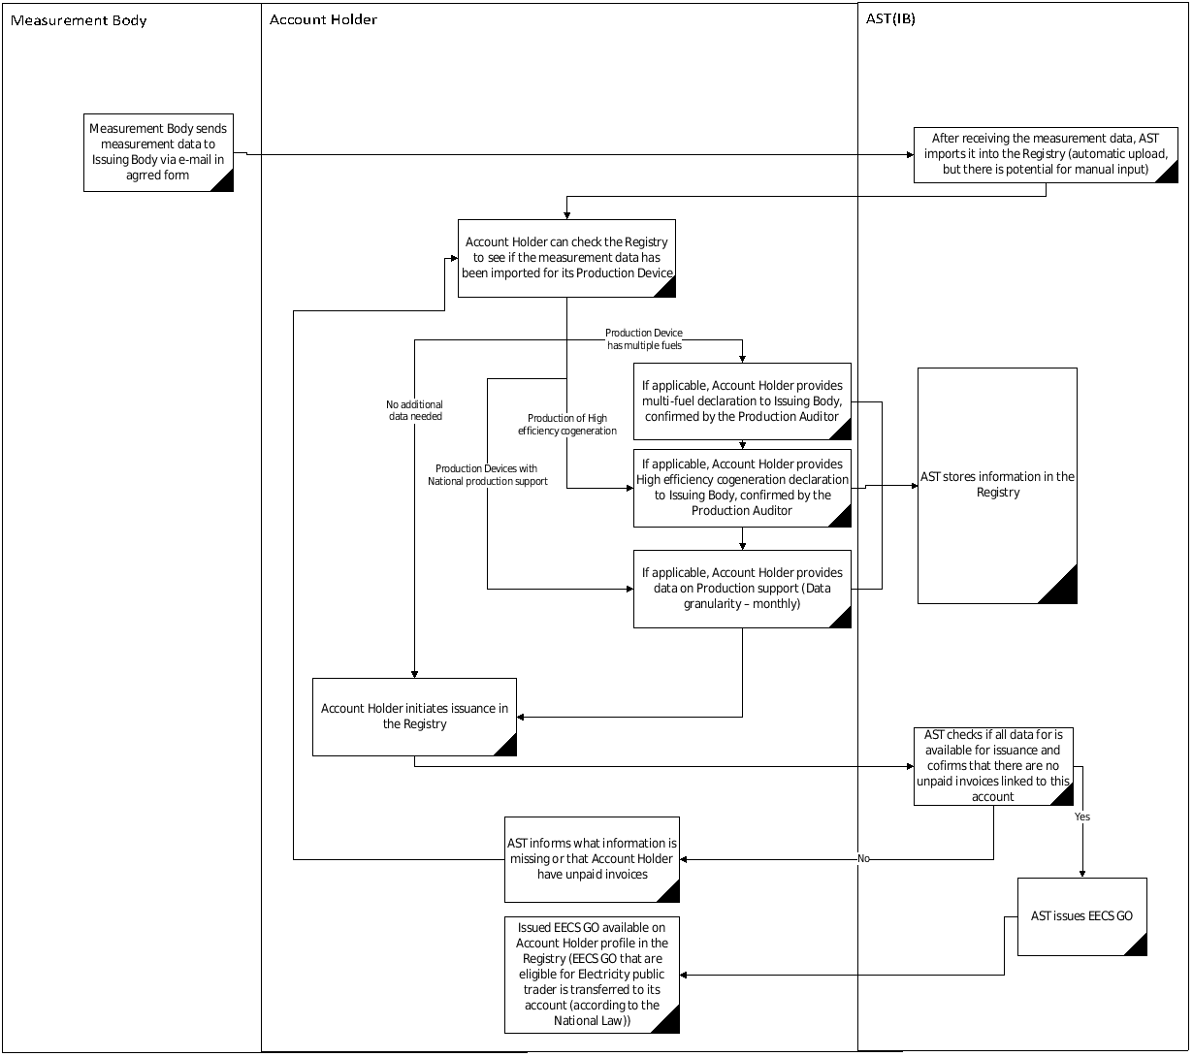

The Account Holder should request issuance of EECS GOs in the Registry. Request of issuance for the Account Holder is possible through the Registry, where the Account Holder can see if the metering data of the net electrical energy injected into grid for the Production Device is available and then request the issuance of EECS GOs or send electronically signed letter with request document where is listed Production Device GSRN number, name of Production Device, production period, requested EECS GO product type and amount to be issued.

In the case of high efficient cogeneration stations, the Account Holder fills out a declaration (Annex 4) and in the case of (multifuel) Production Devices, the Account Holder fills out a declaration (Annex 5) for issuance of EECS GOs from the respective production output period. For calculation of input parameters (Primary Energy Savings, Overall Primary Energy Savings, CO₂ Saved, CO₂ Emissions) the AIB Cogeneration model must be used. Declarations should be submitted monthly, for monthly issuance. It is possible to submit information in a single declaration (data should still be monthly) for multiple months, if issuance is requested for multiple production periods (expiry period is set from production period end not issuance date). Declarations must be accurate and reliable and confirmed by the Production Auditor otherwise AST will reject the request regarding the issuance of EECS GOs. If AST deems it sufficient, the Account Holder can provide a comparable Production Auditor confirmation to confirm the information the Account Holder provides in its declarations (Annex 4 and Annex 5). If some of the necessary information in the initial audit is missing, the Account Holder must provide the Production Auditor with confirmation of the missing items. In the case of if the Account Holder represents more than one Production Device, AST has the right on the basis of a mutual agreement to offer a different approach regarding receiving the data required in Annex 4 and Annex 5.

EECS GOs are issued for the monthly total net amount of electricity produced by a registered Production Device and supplied to the network in Latvia.

No later than 10 working days at the end of a calendar month the Authorised Measurement Bodies shall provide AST with information on the quantity of electricity (MWh) produced and supplied to the grid during the past calendar month, by each Production Device connected into their respective grids.

No later than within 10 working days after the end of a calendar month the Public Trader shall provide, in a format which has been agreed between AST and the Public Trader, information regarding what the Production Devices have received in capacity or energy production support for the previous month. When requesting for issuance the Public Trader will provide the extent the unit of energy has benefited in the related production period (month). Information will be entered manually into Grexel system as part of the issuance process.

In case of any doubts about the accuracy of meter readings and all declarations or National Support schemes, AST will not issue EECS GOs for that Production Device, it immediately stops the issuance for the Production Device until such doubts are resolved. After this AST contacts the Account Holder to find out if the discrepancy can be resolved. Issuance may only be done when discrepancies has been resolved.

AST will issue the EECS GOs in the Registry only after receiving data mentioned in E.2.2; E.2.4;E.2.5., Any identifiable residual kWh will be carried forward to the next issuing period until one MWh is reached. No more than one EECS GOs shall be issued per unit of electricity produced, i.e. each energy unit shall be considered only once.

In normal situation, EECS GOs issuing will take no longer than 8 working days from the initial request for issuance or from the point in time when all information listed in E.2.7. is received. In cases issuance request exceeds 320 unique requests (unique request consist of request for one Production Device in one production period) then issuing process can take proportionally longer period (example, 9 days for 360 unique requests).

The Account Holder shall receive information in the Registry of the issuance of EECS GOs into the Account Holder’s Transferable Account and the EECS GOs details.

The EECS GOs which will be issued for Production Devices based on the Public Trader request will be transferred to the Public Trader account based on C.4.5.

Measurement

Electricity metering equipment must be installed by the system operator on the grid border. The metering equipment must record the electricity received from the grid and transmitted to the grid. The installed electricity equipment must conform to the requirements laid down in the laws and regulations regarding the procedures for performing approval, primary verification and market supervision of the type of means of measurement, as well as in the laws and regulations regarding metrological requirements for means of measurement and regarding metrological requirements. The system operators are responsible for a periodic verification of the electricity metering equipment. National Law On Uniformity of Measurements:https://likumi.lv/ta/en/en/id/42562-on-uniformity-of-measurements.

Only Production Devices that are equipped with the required metering equipment shall be registered. Production Device metering equipment is located between the Production Device and transmission/distribution grid and from measurement device is possible to get both monthly aggregated data and hourly data. It is mandatory to have measuring equipment located at frontier points between the activities of generation, transmission and distribution. Measurement points to be assigned for Production Device are submitted via Production Device registration form (see D.3) by owner or its authorised representative. Measurement Bodies send electricity metering data directly to AST based on an agreed format between AST and the Measurement Bodies.

The electricity is measured using the electricity meters, which records at least hourly power transmission. All electric meters should be automated and be read automatically via PLC, GPRS connection or over the Internet. System operators shall compile and transmit to the AST the monthly electricity production data of each Production Device.

The Authorised Measurement Bodies (the electricity grid operators) who owns the electricity meter equipment are responsible for the measurement equipment, which shall comply with the requirements of Latvian law relating to periodical metrological control and testing, and for the measured data validation.

The Account Holder is responsible for the all non-electrical measurement equipment (if such data are necessary), which shall comply with the requirements of Latvian law relating to periodical metrological control and testing. This data shall be approved by the Production Auditor.

Before the issuance of EECS GO for a multi-fuel Production Device the Account Holder must (electronically) submit to AST a completed multi-fuel declaration form (Annex 5) which has been confirmed by the Production Auditor (or comparable audit results completed by a Production Auditor, if AST deems it sufficient (see E.2.2)). The proportion declared in Annex 5 in the case of combustible fuels should be calculated according to E.5. AST then issues EECS GOs according to the input fuel proportion factors, considering production declarations (Annex 5) and total net electricity produced from the measurement data sent by the Authorised Measurement Bodies. According to national legislation stated in C.4.1 Production Devices receiving production support (if applicable) must submit a multi-fuel declaration form 5 months after production period start for the Public trader to request issuance of EECS GOs. Each month until 10th day of the month AST informs BVKB with list of Production Devices that breaches this rule.

Before the issuance of EECS GO from high efficiency cogeneration Production Device Account Holder must (electronically) submit to AST filled cogeneration declaration form (Annex 4) which has been confirmed by the Production Auditor (or comparable audit results done by Production Auditor, if AST deems it sufficient (see E.2.2)). For calculation of input parameters (Primary Energy Savings, Overall Primary Energy Savings, CO₂ Saved, CO₂ Emissions) the AIB Cogeneration model must be used. AST then issues EECS GO according to input parameters in the cogeneration declaration (Annex 4) and total net electricity produced from the measurement data provided by the Authorised Measurement Bodies. According to national legislation stated in C.4.1 Production Devices receiving production support (if applicable) must submit a cogeneration declaration form or Approval form (Annex 6) stating that in particular month high-efficiency cogeneration criteria has not been met 5 months after production period start for the Public trader to request issuance of EECS GOs. Each month until 10th day of the month AST informs BVKB with list of Production Devices that breaches this rule.

In accordance to metering data and metering scheme AST estimates the net electrical energy injected into grid for each Production Device:

In case Production Device have only one metering point, net electrical energy injected into grid equals energy injected into grid for that metering point in corresponding production period.

In case Production device has multiple metering points (including metering solely for self consumption), net electrical energy injected into grid is calculated for each hour. From total energy injected into grid all energy received from grid in all metering points in particular hour is subtracted. In hours when energy received is larger than energy injected into grid net electrical energy injected into grid for that hour is set to 0. Hourly net electrical energy injected into grid values are aggregated to get net electrical energy injected into grid for production period (month).

In case Production Device has multiple metering points (including metering solely for self consumption), but net electrical energy injected into grid should be calculated differently as in E.3.8.2. Production Device owner or its appointed representative submits AST methodology (i.e. calculation equations and logic) on how to perform calculation of net electrical energy injected into grid and information why it should be different. Submitted methodology must be approved by Production auditor.

No arrangements applied to estimate and/or adjust line losses in meter readings.

Energy Carrier Conversion and Energy Storage (Including Pumped Storage)

There are currently no energy carrier conversion (as there are no GOs other than for electricity), energy storage or pumped storage systems in Latvia. If such Production Devices were introduced to the grid, this Domain Protocol would be updated to reflect such a change.

No certificates are issued for the Output of an energy storage device.

Combustion Fuel (e.g. Biomass) Input and Production Devices with multiple energy inputs

For a Production Device reporting the total production with multiple energy sources, the Account Holder will have to report in detail on the input factors and provide verification of the declaration from the Production Auditor prior to issuing of EECS GOs. The standard calculation set out in the EECS Rules section N6.3.2 is applied. The template of a production/consumption declaration can be found in Annex 5.

All combustible fuel inputs (where needed) are separately measured and required to be submitted by the Account Holders in tonnes or 1000 m3 and the lower calorific values of the fuels in MJ/kg or in MJ/m3.

In a Consumption Declaration (Annex 5) for each combustible Input, the following must be specified:

The values of M1, C1…. Mn and Cn; and

as the Energy Input Factor for that Input and that period, a factor no greater than L, where L is the proportion of the total Output produced during this period by the relevant Input and is calculated as follows:
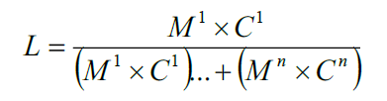
Where,
M1 - is the mass of the relevant Energy Input for that Production Device during the relevant period
C1 - is the average calorific value of the relevant Energy Input for that Production Device during the relevant period
Mn - is the mass of each relevant Input other than the relevant Input for that Production Device during the relevant period
Cn - is the average calorific value of each relevant Input other than the relevant Input for that Production Device during the relevant period.

Format

EECS GOs shall be Issued in such format as may be determined by AIB from time to time. EECS GO certificate example is shown in Annex 8.

EECS GOs and the information contained in it, or to be indicated by it, shall be in the format specified in the Subsidiary Document “HubCom”.

EECS GOs corresponding to High-Efficiency Cogeneration must specify the following information in respect of the Output:

lower calorific value in megajoules per kilogramme of fuel or megajoules per cubic metre of gaseous fuel or megajoules per litre of liquid fuels;

use of heat;

the CO2 emissions saved;

the CO2 emissions produced;

primary Energy Savings.

According to the National law for fossil fuel generation, in addition to requirements stated in the EECS rules, EECS GOs must contain the quantity of thermal energy produced at the same time as electrical energy and nominal efficiency of the electrical and thermal energy production of the cogeneration Production Device.

No radioactive waste information is foreseen for EECS GOs issued Latvian Domain, currently there are no Nuclear generation stations and according to the National law there is no mandate to issue EECS GOs from nuclear generation, in case of changes the Domain Protocol will be updated.

Transferring EECS Certificates

An Account Holder will get secure electronic access to their Account as stated in section D.1.5 to make transfers of EECS GOs to another Account in the Registry or to another EECS Registration Database in another Domain through the AIB Hub.

Only persons duly authorized by the Account Holder may request the transfer of EECS GOs from that Account Holder’s Transferable Account. Authorized persons must be identified on the account application form (Annex 2). Authorized persons can also be added by the root user(s) of that Account Holder.

In accordance with Latvian law, from Latvia EECS GO Registry there can be sent only GOs that fulfils EECS GOs requirements and can be received only EECS GO compatible certificates, issued in the European Union Member States and the European Economic Area.

The initiation of transfers is done in the Registry by the selling Account Holder. The transfer form shall be filled out by the selling Account Holder (whether it is the Producer itself or an Account Holder with power of attorney) containing the following data:

The amount of EECS GOs to be transferred;

Domain of the receiving Account Holder;

Receiving Account Holder.

The transfer of EECS GOs and the confirmation of that transfer is automated. After the Account Holder has initiated the transfer, the Registry instantly displays a message of whether or not the initiation has been successful. The EECS GOs are automatically transferred to the receiving account if the initiation of the transfer is successful. If the initiation of the transfer is not successful, the EECS GOs do not leave the Account of the original Account Holder. In transfers between Accounts located in different Registries, the success of the transfer is subject to the verification process of the AIB Hub and the receiving Registry. When EECS GOs are in transit they are not available for another transfer. If the transfer is not successful, the EECS GOs return to the Account of the original Account Holder.

EECS GOs that have been cancelled or expired are not available for transfer.

Once an EECS GOs has been held in the registry of a non-Hub User, it may not be transferred through the Hub. AST is only allowed to use the Hub when transferring EECS GOs to another Hub User, excluding other means of transfer or separate arrangements in this respect.

Ex-domain exports are handled as cancellations, where the beneficiary of the cancellation is located in another Domain or country, that is not connected with AIB HUB and respective Issuing body has signed agreement with AST for ex-domain export/import, is such agreement is needed.

Ex-domain imports are handled outside the Registry for EECS GOs (see also E.9.3), information about imports of EECS compliant GOs is saved in separate database. Ex-domain imports are allowed if Domain or country is not connected with AIB HUB and respective Issuing body has signed agreement (AIB standard agreement form to be used) with AST for ex-domain export/import.

There are no restrictions for transfer via AIB HUB of EECS GOs – all energy carriers and certificate types allowed.

Administration of Malfunctions, Corrections and Errors

Once issued, the details of an EECS GOs cannot be altered or deleted, except to correct an error.

AST has the right to perform corrective actions such as the transfer of EECS GOs in the Registry where EECS GOs have been erroneously transferred.

AST has the right to perform corrective actions such as the withdrawal of EECS GOs from an Account in the Registry where EECS GOs have been erroneously issued. AST has the right to recover the cost of securing the agreement of another Account Holder to the Withdrawal of Certificates of the same type from that other Account Holder’s Transferables Account, where the EECS GO is not in the Transferables Account of that Account Holder, so that, as far as reasonably practicable, EECS GOs are withdrawn with an amount and a financial value which make good the discrepancy.

AST has the right to correct an account number for an incoming transaction if the account number is not a transferable account number and correct account number can be identified.

If an error occurs in the measurement data on which EECS GOs are created, AST will correct this error. If EECS GOs are wrongly issued, i.e. a larger quantity, and traded, the error will be corrected in future, issuing a smaller amount of EECS GOs in the next period.

Where it is impossible to transfer for technical reasons, this can be overcome by cancelling EECS GOs for use in another domain, subject to an agreement between AST and the importing Issuing Body.

AST shall correct all errors in or with respect to the EECS GOs in question provided that such EECS GOs have not been transferred out of that Transferable Account.

AST may alter an EECS GO held in its Registry so as to rectify an error which occurred prior to its transfer into the Account in which it is held at such time, provided:
- the Account Holder has agreed to such alteration;
- it is reasonably satisfied that any unjust enrichment of an EECS Market Participant as a consequence of such error has, to the extent reasonably practicable, been nullified; and
- it is reasonably satisfied that the alteration itself does not give rise to undue enrichment of the Account Holder.

In the case where the EECS GOs are no longer in the Latvian domain, or in the case where erroneous EECS GOs are transferred to the Latvian domain from another Domain, AST will cooperate with other Issuing Bodies to withdraw or correct the erroneous EECS GOs.

An Account Holder or market participant involved in a transaction with an Account Holder from the Latvia Domain can report an issue by submitting identified malfunctions, errors or requested corrections via e-mail to go@ast.lv. If possible, AST will resolve the issue in 5 working days and inform the Account Holder of the resolution. If the issue can not be resolved within 5 working days AST, will respond to the e-mail to inform how this issue will be tackled and the estimated time to resolve it.

End of Life of EECS Certificates – Cancellation

Cancellation is removing EECS GOs from circulation. Once cancelled, EECS GOs cannot be moved to any other account, and so they are no longer tradable (transferable). Expired EECS GO are not valid for cancellation or transfer as the Registry automatically expires EECS GOs according to the Expiry rules described in E.10.

EECS GOs can be cancelled for use in the Latvian domain. Cancelation can be made for consumption for previous year up to 1st April in current year and cancelations for future use can be made only for consumption in current year.

EECS GOs may be cancelled for use in other EECS GOs Domains provided that the transfer of such EECS GOs is not possible to the other Domain, and there is a Cancellation Agreement in place with the Scheme Member of that other Domain. Such Cancellation Agreements require the provision by the Cancelling Scheme Member to the Scheme Member of the other Domain of statistical information concerning Cancelled EECS GOs and the inclusion on any related Cancellation Statement of the identity of the Domain, Account Holder and purpose for which the EECS GOs were Cancelled.

EECS GO can be cancelled for use in countries that are not connected to AIB Hub ex-domain cancellations.

Account Holders possessing EECS GOs in the Registry, can perform cancellations by executing the transaction in the Registry. The Account Holder must specify the EECS GOs to be cancelled as well as the country of consumption, cancellation purpose, usage category, name, type and location of beneficiary and related consumption period. The Account Holder may choose to cancel part of or all of a given certificate bundle or several bundles.

The cancellation of EECS GOs is automated using the cancellation functionality in the Registry. An EECS GOs can only be cancelled once and when the EECS GOs has been cancelled it is taken out of circulation and is not available for transactions. Cancelled EECS GOs are removed from the transferable account by changing their status to “cancelled”; they do not appear in any Account of the Registry after the Cancellation. The Account Holder performing the cancellation has full access to see the details of the cancellation process in the Registry or they can order an official Cancellation Statement from AST (Annex 7).

Having performed a cancellation, the Account Holder receives confirmation of a successful or failed cancellation process instantly in the Registry.

Each month AST will provide the Secretary General with a statement of the number of EECS GOs cancelled under the provisions EECS rules C7.1.2 and E.9.4.

Eligible for cancelation are only EECS GOs from renewable sources or high efficiency cogeneration type.

End of Life of EECS Certificates – Expiry

EECS GOs expire 12 months after the end of the related production period for the relevant energy unit. This means that for example an EECS GO issued for production of January 2021 shall expire on the 31st of January 2022.

EECS GOs which have expired are no longer valid for transfer or any other operation. The expiry-warning period is set to 30 days in the Latvian Registry. If the account holder does not react by cancelling the EECS GOs or transferring (selling) the EECS GOs to someone who then cancels them, then the EECS GOs will expire. No operations will be possible on these EECS GOs. The expired EECS GOs will be used in the calculation of the residual mix.

The Registry system ensures that expired EECS GOs are not available for transfer as the Registry automatically expires EECS GOs according to Expiry rules E.10.1.

End of Life of EECS Certificates – Withdrawal

EECS GOs which have been withdrawn are no longer valid for transfer.

AST may withdraw a EECS GOs held in an Account on its Registry at the request of the Account Holder of that Account, or otherwise in accordance with the provisions of the EECS scheme as described in section E.8.

Issuer’s Agents

Production Auditor

The Production Auditor verifies and approves information which is provided in forms (Annex 3, Annex 4 and Annex 5). Production Auditors use industry best practices and also include on-site inspection. Charges for Production Device services are concluded based on mutual agreement. AST has no responsibility in relation to Production Auditor charges for services. Requirements and link to the list of the Production Auditors is available in Annex 1.

Production Registrar

AST acts as the Production Registrar and is responsible for assessing applications to register Production Devices for the purposes of the relevant EECS Product and National Law.

Measurement Body(/ies)

Measurement bodies role is described in B.3.3 and their functions in Latvia Domain described under section E.3.

Activity Reporting

Public Reports

AST is obligated by National Law to publish on its website link (https://www.ast.lv/en/content/guarantees-origin), no later than 30 calendar days from the end of a calendar month, information on the:

The Quantities (in MWh) of electricity produced in Latvia from renewable energy sources, electricity produced from high efficient cogeneration and supplied to the electricity grids for which EECS GOs have been issued, for the past calendar month, shown according to the types of energy sources;

Each moth in the Registry public statistics1 will be published EECS GO transaction statistics for Latvia domain in previous month. Publication include following items (data items are published in total and divided to the types of energy sources):

Amount of issued EECS GOs;

Amount of cancelled EECS GOs;

Amount of imported EECS GOs;

Amount of exported EECS GOs;

Amount of internally transferred EECS GOs;

Amount of expired EECS GOs.

Recognition of the EECS GOs issued by other AIB Members and transfers and use of the EECS GOs, shown according to the types of energy sources.

AST, no less than once every three months, will make available to the Secretary General of AIB, the number of Scheme Certificates with respect to each EECS Product, within the preceding three calendar months.

AST ensures the confidentiality of the information provided by the EECS Market Participants and compliance with personal data legal protection requirements in the publication of all information.

Record Retention

AST shall retain all records to which it has had access to, relating to any EECS GOs on its Registry for no less than 10 years after its Cancellation or Expiry or for a period that may be required by applicable national legislation.

Orderly Market Reporting

AST will inform the AIB of any relevant changes in legislation regarding the EECS scheme in Latvia, especially if it involves changes to this Domain Protocol.

AST will enforce the rules in relation to any act of non-compliance. AST will provide all required information to AIB to resolve or investigate such action.

If AST becomes aware that Account Holders fail to comply with the EECS Product rules to the extent that breaches Competition Law, or any applicable law governing the conduct of financial markets, then AST will report it to relevant Competent Authorities. AST will report to AIB of such incidents to extent that it does not breach its duty of confidentiality to the relevant Account Holder.

If AST determines that an Account Holder is in breach of the Product Rules or determines that a Production Device does not meet the PD Qualification Criteria for an EECS Product in relation to which it is registered, then AST will:

take action to secure that EECS GO issuance is not done for Production Devices that fail to meet Product Rules and PD qualification Criteria. Such action to include, in a case of material non-compliance by the Account Holder, the withdrawal of registration of the relevant Production Device for the purposes of that EECS Product; and

AST will notify the AIB of such a breach where AST is of the reasonable opinion that such a breach could affect the transfer of EECS Certificates from its Registry to the EECS Registration Database of another Member.

Association of Issuing Bodies

Membership

The Association of Issuing Bodies brings together the issuing bodies of European energy certificate schemes. The AIB promotes the use of a standardised system, based on a harmonised environment, structures and procedures in order to ensure the reliable operation of European energy certificate systems. With its independent and peer reviews, and its periodic audits, the AIB provides a robust framework for reliable and fraud-resistant GO systems. Among others, it can also act by suspending transfers through the Hub. Membership of AIB facilitates mutual recognition of GOs across Europe AST considers AIB membership as a key step in removing possible barriers to EECS GOs imports and exports.

In the case that AST is replaced by another Issuing Body for the Latvian domain by a new Law, AIB would be informed immediately. In this situation, AST would take the necessary actions to guarantee the right transition to the new Issuing Body.

In case AST ceases to be an Authorized Issuing Body in relation to an EECS Product, it shall revise the Registry so that each Production Device in the Latvian Domain ceases to be registered for the purposes of that EECS Product, it shall stop issuing EECS GOs and after a transitional period the Registry shall be taken offline. The Account Holder is obliged to pay the invoices, which were issued during the period when AST was the Issuing Body.

In case AST ceases to be a Scheme Member of an EECS Scheme it shall revise the Registry so that every Production Device registered therein ceases to be registered for the purposes of each EECS Product in relation to the Output to which that EECS Scheme relates. The Registry shall stop issuing EECS GOs and after a transitional period the Registry shall be taken offline.

AST shall ensure that the Domain Protocol secures that the Product Rules for the relevant EECS Product and that it complies with the EECS Rules established for the EECS Scheme in relation to the relevant Output.

Complaints to the AIB

EECS Market Participants may notify, in writing, the Secretary General of AIB (and provide evidence substantiating their complaint) that:

An Authorised Issuing Body in relation to an EECS Product is in breach of the provisions of Product Rules in relation to that EECS Product; or

Product Rules do not comply with the relevant provisions of the EECS Rules. Then, provided that the evidence that the Authorised Issuing Body has been given allows adequate opportunity to respond to such allegation, the Secretary General shall invite the relevant Authorised Issuing Body to respond.
The General Secretary of AIB shall invite the relevant Authorised Issuing Body to respond to the allegation.

Change Control

Complaints to AST

AST will endeavour to deal with complaints received via e-mail go@ast.lv as soon as possible and within a period of 20 business days. Treatment of the complaint and disputes will be made in accordance with the national legislation of Latvia.

Disputes

All disputes and disagreements that may arise shall be resolved by negotiations via e-mail go@ast.lv. If no agreement can be reached within 20 business days, either party shall be entitled to initiate dispute resolution in the Latvian courts.

Change Requests

An EECS Market Participant may propose a modification to this Domain Protocol.

Such a proposal should include a detailed description, including an exact specification of any proposed modification of this Domain Protocol and be sent in writing to AST.

On receipt of such a request, AST will:

Respond to the request describing the procedures to be followed and estimating when a reply is expected;

Consult with the other EECS Market Participants within Latvia and when relevant with other AIB members;

Decide whether the request and its consequences are in its opinion reasonable;

Inform the Participants within Latvia of the outcome of this decision.

AST may make such modifications to this Domain Protocol as are in its opinion necessary to the effective, transparent and efficient operation of the market.

Any modifications to this Domain Protocol are subject to approval by the AIB (Assessment Panel in accordance with EECS rules section L5.2.1 and the prior consent of the General Meeting in accordance with the provisions of EECS rules section L5) that such changes do not conflict with the Principles and Rules of Operation of the Association of Issuing Bodies (AIB) for The European Energy Certification Registry.

Implementation of modifications will be sent by e-mail to the Participants and will take effect on publication of the documentation on the website www.aib-net.org and AST https://www.ast.lv/en/content/guarantees-origin

Annex 1: Contacts List
Authorised Issuing Body/Registry Operator
Latvian electricity transmission system operator AS "Augstsprieguma tīkls"; 86 Darzciema str., Rīga, LV-1073, Latvia (+371) 67728353 go@ast.lv; www.ast.lv

Registry support
Latvian electricity transmission system operator AS "Augstsprieguma tīkls"; 86 Darzciema str., Rīga, LV-1073, Latvia (+371) 67728353 go@ast.lv; www.ast.lv

Production Auditors
A Production Auditor can be:
- an auditor that has valid accreditation issued from the Latvian National Accreditation Bureau (LATAK) in the field of " Pārdotās lietderīgās vai efektīvi izlietotās siltumenerģijas, kas iegūta, ražojot elektroenerģiju koģenerācijā, izmantojot dabas gāzi vai atjaunojamos energoresursus, gada pārskata inspicēšana" (up until 01.10.2022.) and after accreditation "Elektroenerģijas ražošanas vienības un augstas efektivitātes koģenerācijas datu apstiprināšana". A list of possible Production Auditors is available on the LATAK website www.latak.gov.lv/;
- the State Construction Control Bureau of Latvia (BVKB) which is a state authority under the supervision of the Ministry of Economics website https://www.bvkb.gov.lv/en/node/407

Measurement Bodies
The Authorised Measurement Bodies are transmission and distribution system operators that are listed on The Public Utilities Commission website www.sprk.gov.lv

Annex 2: Account Application/Amendment Form
Account
Application purpose | ☐ New account  ☐ Amend account  ☐ De-register account
Company Name/name, surname
VAT code(Business ID)/Person ID
Legal address (country, city, street, postal code)
Organization type | ☐ Electricity Producer  ☐ Electricity Supplier  ☐ GO Trader  ☐ Disclosure
Trading Scheme | EECS GO
Account Holder Root user
Action | ☐New Root user  ☐Amend existing Root user
User name
User surname
User e-mail
User mobile phone
_________________________  Applicant Signature* |  | ___________  Date*
* if the document is signed with a secure electronic signature, see the Applicant's signature in the electronic signature, as well as the date in the time stamp of the document signature)

Annex 3: Production Device Registration/Amendment Form
Account Holder
Account Holder name
Account Holder VAT code (Business ID)/Person ID:
Production Device
Application purpose: | ☐ New Production Device  ☐ Amend Production Device  ☐ De-register Production Device
Production Device (object) name:
Installed capacity (kW)
Capacity specified in the system operator's permit (kW)
Address of Production Device (Country, City, Street, Postal code)
Coordinates (longitude, latitude)
The first date of commissioning
Grid connection | ☐ TSOs grid  ☐ DSOs grid _______________________________(name)
Metering ID (object EIC and metering point EIK (TSOs network) or metering point code (DSOs network), example, 43ZAST1111111111, 43Z-STO111111111). In case of multiple meter use, add all meters and used calculation formula
Meter corresponds to net electricity output of Production device | ☐ Yes
Fuel (-s)* | Level 1 | Level 2 | Level 3
Technology* | Level 1 | Level 2 | Level 3
Account Holder who receives issued EECS GO (Account Holder name and Business ID) (optional – fill in case differs from Account Holder from above)
Trading Scheme | EECS GO
*For fuel and technology input please see EECS Rules Fact Sheet 5 "TYPES OF ENERGY INPUTS AND TECHNOLOGIES"(https://www.aib-net.org/eecs/fact-sheets)

The State aid
Production Device received Investment support |  |  | ☐ Yes or ☐ No  If Yes, fill the table below
Production Device receives Production support |  |  | ☐ Yes or ☐ No  If Yes, fill the table below
Governor of Support scheme | Support scheme type (Production/ Investment support) | Purpose of the State aid | Support scheme number | Tool | Amount, EUR (In case of Investment support)

_________________________  Account Holder Signature** | ___________  Date**

__________________________________  Production Auditor (Registrar) Signature** | ___________  Date**
** if the document is signed with a secure electronic signature, see the signatures in the electronic signature, as well as the dates in the time stamp of the document signature

Annex 4: High Efficiency cogeneration declaration
Account Holder
Account Holder VAT code (Business ID)/Person ID:
Production Device name:
Production Device GSRN^{No}
Production period
Generated electricity volume (MWh) ^{CHP GO}
Primary Energy Savings (MJ/MWh)* ^{CHP GO}
Primary Energy Savings (%)*
Overall Primary Energy Savings (%)^{CHP GO}
Generated Heat (MWh)*
Use of Heat* | ☐ Heating, including district heating and Cooling  ☐ Industrial use, including process heating  ☐ Agricultural use
Lower Calorific Value (MJ/kg, m3 or l)*
Production Device operational electrical energy generation efficiency (%)* ^{CHP GO}
Production Device operational thermal energy generation efficiency(%)*^{CHP GO}
CO₂ Saved (kg/MWh) ^{CHP GO}
CO₂ Emissions (kg/MWh) ^{CHP GO}
Thermal Capacity (MW)
☐rading Scheme | EECS GO
^{No} Number automatically assigned in the Registry at the time of registration of the Production Device, for example, 643002406731001111;
*Parameters set by Electricity Market law, that has to be defined particularly for high efficiency cogeneration;
^{CHP GO} The result of the calculation of the cogeneration calculator (chp-go.tso.lv) developed by AIB (Association of Issuing Bodies).
_________________________  Account Holder Signature | ___________  Date
_________________________  Production Auditor Signature | ___________  Date
** if the document is signed with a secure electronic signature, see the signatures in the electronic signature, as well as the dates in the time stamp of the document signature

Annex 5: Declaration for the mixed-fuel Production Devices
Account Holder
Account Holder VAT code (Business ID)/Person ID
Production Device name
Production Device GSRN*
Production period
Total net generation in period (MWh)
Share of net generation in production period from fuel (please specify for all fuel(s)), %:
Share | Fuel (For combustible fuel specify mass of the relevant fuel and is average calorific value)
*Number automatically assigned in the Registry at the time of registration of the Production Device, for example, 643002406731001111.

_________________________  Account Holder Signature** | ___________  Date**

_________________________  Production Auditor Signature** | ___________  Date**
** if the document is signed with a secure electronic signature, see the signatures in the electronic signature, as well as the dates in the time stamp of the document signature

Annex 6: Approval form
I certify that the criteria for high efficiency cogeneration were not met during the specified production period.

Account Holder name
Account Holder VAT code (Business ID)/Person ID
Production device name
Production period
Primary energy savings (MJ/MWh)
Primary energy savings (%)*
*Parameter set by Electricity Market Law

_________________________  Account Holder Signature** | ___________  Date**
** if the document is signed with a secure electronic signature, see the signature in the electronic signature, as well as the date in the time stamp of the document signature

Annex 7: EECS Electricity Cancellation Statement
Cancellation Statement
This cancellation statement acts as a receipt for the certificates listed below and for the purpose shown. With this Cancellation Statement, released on the Transaction Date, the indicated certificates are no longer tradable. Onward sale of this Cancellation Statement is prohibited. The environmental qualities of the associated energy have been consumed and this Cancellation Statement and these certificates may not be transferred to any party other than the energy supplier or end-consumer specified below.

Transaction details
Transaction Type:
Transaction Date:
Transaction Number:

Message to Receiver:
From | To
Account Holder:  Account:  Domain:  Street:  Postal Code and City:  Country: | Name of Beneficiary:  Cancellation Purpose:  Consumption Period:  Country of Consumption:  Location of Beneficiary:  Usage Category:  Type of Beneficiary:

Total
Total MWh:
Total GO:
Certificate Number  (From - To) | Volume | Domain | Fuel,  Technology | S/T | Issuing  Date | Production  Period | Production Device  (GSRN, installed  capacity, name) | Trading  Schemes | Support

Production Device public information
Production Device Name:
Production Device GSRN:
Domain of Production Device:
Installed Capacity, MW:
Date of Commissioning:
Location of Production Device:
Technology:
Fuel:
Investment support:
Production support:
CO2 Saved(kg/MWh):
Primary Energy Savings(MJ/MWh):
Primary Energy Savings(%):
Use of Heat Code:
Lower Calorific Value(MJ/kg, m3 or l):
CO2 Emissions(kg/MWh):
Thermal Capacity(MW):
Mechanical Capacity(MW):
Overall Primary Energy Savings(%):
Useful Cogeneration Heat(GJ/MWh):
Electrical Efficiency(%):
Thermal Efficiency(%):

Annex 8: EECS GO view in the Registry
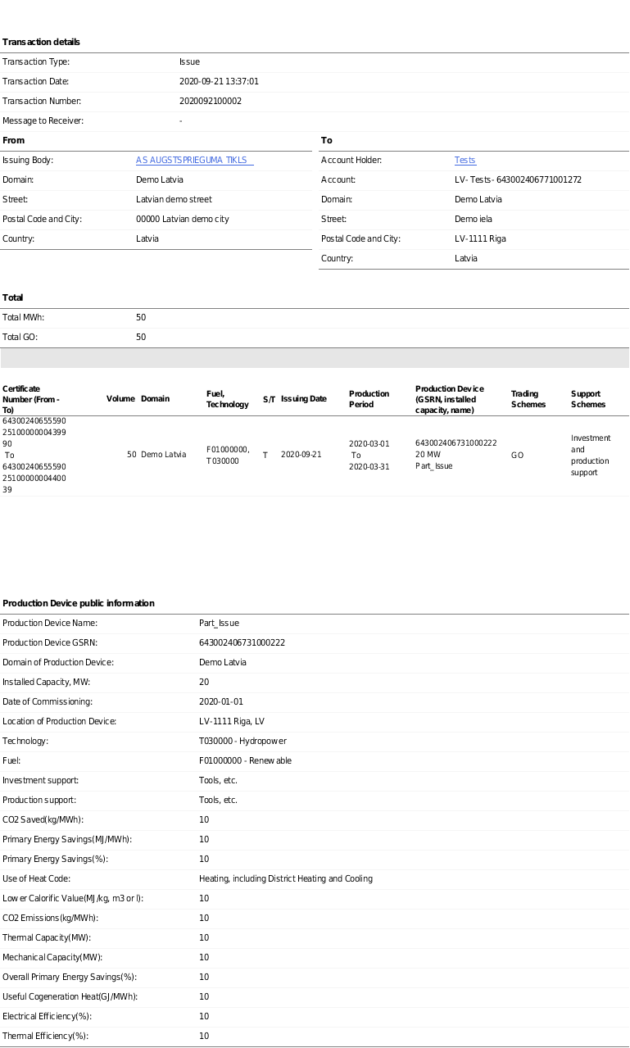

The statistic information can be found in Registry public page: http://cmo.grexel.com/Lists/PublicPages/Statistics.aspx

