Outage Coordination System
Concept document
v.1.

Table of Contents

Introduction 4
1 Description of the current situation 6
2 The role of the OCS in the AST IS architecture and integration with other IS 8
2.1 Solution IS Architecture (future) 8
2.2 Existing AST systems to be replaced by the OMS 9
2.3 OCS integration solutions planned 10
2.4 OCS interface 13
3 OCS functionality 16
3.1 Business functions 16
3.1.1 Receipt and coordination of the annual outage schedule with third parties. 16
3.2 Coordination and approval of the monthly outage schedule 20
3.3 Coordination and approval of the weekly outage schedule 23
3.4 Coordination and approval of D-2 outages 27
3.5 Supporting processes 31
3.5.1 Basic principles for communication with third parties 31
3.5.2 System configuration 32
3.5.3 Classifiers, basic system data 33
3.6 Integration requirements 34
3.6.1 Data exchange with TIDA 34
3.6.2 Transfer of outage data to the NMM 34
3.6.3 Transfer of the outage data to the BMS 35
3.6.4 Exchange of outage data with ENTSO-E OPC 35
3.6.5 Exchange of outage data with ENTSO-E CSA 36
3.6.6 Exchange of outage data with third parties (LV). 37
3.6.7 Transfer of outage data to the Operational Log 37
3.6.8 Transfer of equipment, device state data to MUSTANG; PSS®E 37
3.6.9 Receipt of data from SCADA 38
4 Assumptions 38
5 Development roadmap 39
6 Future functionality 39

Abbreviations and definitions

APAS | A tool developed by AST for outage data entry and coordination.
BRELL | Association of Electricity Systems of Belarus, Russia, Estonia, Latvia, Lithuania
DD | Dispatcher Department
Capacity manager | Tool developed by AST for the calculation and transmission of transmission network capacities
ENTSO-E | The European Network of Transmission System Operators for Electricity
LE | Latvenergo Group
Let’s coordinate | ENTSO-E outage coordination app
OPC | ENTSO-E outage planning app
CSA | Coordinated Security Analysis
TSO | Transmission System Operator
DSO | Distribution System Operator
SDrD | Power Power System Security Service
IS | Information System
IT | Information Technologies
D-2 | The next two days ahead
D-7 | The next seven days ahead
TIDA | Technical Assets Data Management System
Third parties | TSOs, DSOs, System users (manufacturers, consumers)
Third parties (LV) | DSOs, LV System users (manufacturers, consumers)
OCS | Outage Coordination System
RCC | Regional Coordination Centre
CESA | Continental Europe Synchronous Area
Mustang | Network Model Simulation Too
OPDE | Operational Planning Data Environment
ECP | Energy Communication Platform
NMM | Network Model Management system
BPD | Balance Planning Department
SAAD | System Protection and Automation Service
EIC | Energy Identification Codes
MRID | Master Resource Identifier

Introduction
This document describes AST’s outage management process with the aim of setting high-level requirements for a new Outage Coordination System which will be coordinate
The objective of the development of the Outage Coordination System is:
- To develop an integrated information system for the coordination of Outage Schedules with stakeholders and for the coordination of ongoing outages both between AST departments and with third parties.
- To optimise and automate the outage coordination and coordination processes.
- To develop standardised data exchange solutions for the exchange of information with third party IS as well as AST’s internal IS.
- To develop a centralised repository for data related to scheduled and ongoing outages to ensure that up-to-date outage data required for both internal AST systems and department personnel, as well as third party systems and linked processes, are available in one place.
- To enable information analysis (scheduled outage execution statistics, etc. reports).
The Outage Coordination System will replace the tools currently developed by AST for outage coordination: the APAS annual/monthly schedule app, the APAS app for current outage coordination, and MS Excel macros for collecting and analysing outage data. The Outage Coordination System will significantly facilitate the outage coordination process by ensuring the availability and automatic updating of schedules, the exchange of schedules with third parties and the coordination of outage data according to predefined flows.
The process of coordinating and reconciling high-level outages with stakeholders by time phase is illustrated below:
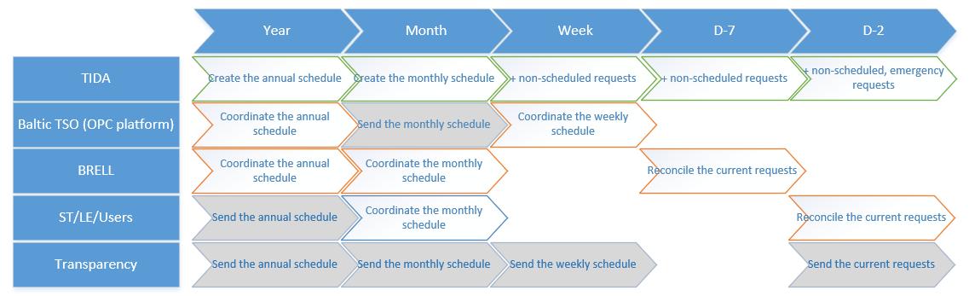Figure 0-1 “High-level process flowchart”
The coordination of outage schedules between European TSOs is carried out through the OPC platform through which the coordination and review of outage schedules of European TSOs by the RCC is carried out. The coordination of outage schedules (110 kV and 330 kV network and generation units) and requests between Baltic TSOs is currently performed through the BRELL coordination process, but after synchronisation with CESA, from 2026, Baltic TSOs have to ensure a European Union regulatory compliant process for the coordination and coordination of Annual, Monthly and Next Week outage schedules. The coordination of outage schedules and outages with ST, LE and AST users connected to the transmission grid in accordance with the procedures “Information exchange with Augstsprieguma tīkls Dispatching Service (K-60-110)” and ”Procedure for handling outage requests of Augstsprieguma tīkls AS (K-5/2-219)” is included within the scope of the OCS.
The transmission of outages to the ENTSO-E Transparency Platform will not be covered by the scope of the OCS, this function will be provided by the BMS; upon the receipt of the outage data from the OCS, the outage data together with the capacity data will be transmitted to the ENTSO-E Transparency Platform.
The above process flowchart shows that the outage schedules and current outages need to be coordinated with the different parties involved, at different time windows, and each party has its own specific outages (binding network elements) that need to be coordinated between the parties. It is therefore essential that the OCS provides for:
- the creation, viewing and modification of outage schedules at different times;
- the input and modification of outage requests;
- separate ‘views-sections’ for the processing of outage data for different purposes e.g., ‘OPC Outage View’, AST ‘Outage View’, etc.;
- the flexibility to include outage data and elements in schedules that are coordinated with each of the parties involved;
- flexible options for filtering outage data according to different parameters;
- automatic identification of the parties involved based on the operational responsibility of the asset;
- the ability to maintain party data and associated configuration parameters;
- the ability to configure the frequency and time of data exchange;
- the ability to configure data exchange channels between the parties (ECP, standardised web service, SFTP);
- the ability to configure workflows, outages and outage schedules for coordination and approval within AST and for coordination with third parties;
- the ability to easily analyse outage data using a graphical view of the original and adjusted schedules to determine the likelihood of outages and assess whether it can be combined with other scheduled outages, thereby optimising the outage schedule.

Description of the current situation
Currently, outage generation and coordination is carried out in different AST departments using tools developed by AST personnel and outsourced. The main problem at the moment is the decentralisation of the outage data, the lack of data integrity, the lack of a single access point for related systems and third parties to obtain up-to-date outage data at the required level of detail, as well as the time spent in each department to collect and coordinate outage data.
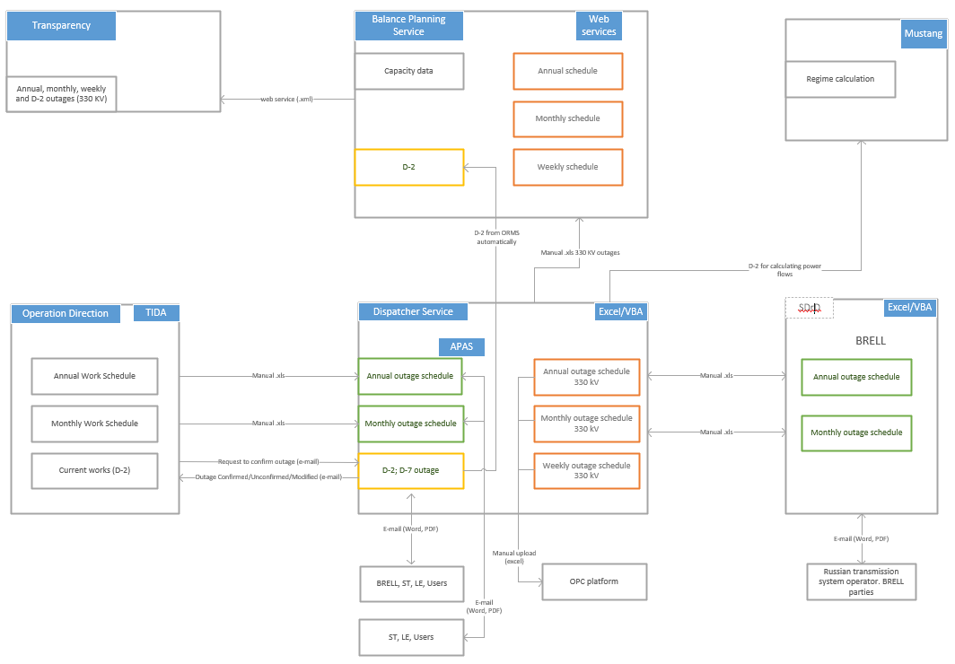
Figure 1-1 “High-level process flowchart of the current situation”
Technical Operation Department (TOD)
The annual and monthly outage schedule is drawn up by the Technical Operations Department using TIDA; the outages in the annual and monthly schedules arise from works foreseen in the AST Ten-Year Plan (capital projects), from periodically scheduled preventive maintenance works on assets and from unscheduled works, for which an indication of the outage is given. After the annual and monthly work schedules have been drawn up, they shall be reviewed and approved by the Dispatcher Department, the Power System Security Service, the DD Manager and the Member of the Management Board responsible for the Operational Direction. The TIDA outage schedule is approved after the annual and monthly outage schedules have been coordinated with BRELL and third parties (TSO, ST, LE, users connected to the transmission network).
Power System Security Service (SDRD)
SDRD uses the outputs from TIDA and APAS to evaluate the outage schedules from the point of view of the probability of electrical modes, respecting the security conditions and parameters of the electrical system, and to coordinate the annual and monthly outage schedules within the BRELL ring. MS Excel with VBA automation is currently used to collect and analyse data for the annual and monthly schedules. The outage schedules are received and sent by e-mail from the BRELL parties. The data received from the BRELL parties is received in XLSX, DOCX, PDF and MPP file formats and manually or semi-automatically entered into MS Excel for the generation and analysis of the outage lists.
The annual and monthly outage schedule data is also used in the electricity system modelling and analysis application Mustang to perform the necessary power mode calculations.
In view of the objective to start the synchronous operation of the Baltic electricity system with CESA in 2026, the BRELL Power System Security Service perf APAS outage assessment for the ENTSO-E outage coordination processes in parallel with the existing outage coordination processes.
For the outage evaluation of the ENTSO-E outage coordination processes, which are annual, monthly and weekly, the output data from TIDA is used, in PDF file format.
The SDRD shall perform the identification of the assets that are binding on the electricity transmission system for the ENTSO-E outage coordination process; the list of identified binding assets shall be updated in the OPC application.
Balance Planning Department (BPD):
The Balance Planning Service needs the outage data to perform capacity calculations and send the outage data to the Transparency platform.
Currently, the Balance Planning Service manually enters the outage data into an application developed by AST personnel. The annual, monthly and weekly outage data are taken from Excel files prepared by the SDD; the D-2 coordinated outages are automatically taken from the APAS application. Together with the outage data, capacity data is also sent to the Transparency platform and automatically fetched from the Capacity Manager application. The 330 kV outage data together with the capacity data is formatted in an .xml file and sent to the Transparency platform using the ECP client software. It is planned that this function will be taken over by the BMS with the introduction of the BMS.
Dispatcher Department (DD):
The Dispatcher Department receives the annual and monthly outage schedules from TIDA (in Excel format) and analyses and optimises the scheduled Outage data (DD is currently adjusting the scheduled work in TIDA so that scheduled work is carried out with minimum outages, e.g., scheduled work by different services on the assets is put in sequence rather than each at its own time). For the analysis of the outage data, DD uses the TIDA graphical output, an Excel file exported from TIDA and SCADA data.
For the coordination of the annual and monthly outage schedule with third parties (users connected to the AST network, ST, LE) DD uses the APAS annual/monthly application; the annual and monthly schedule is manually exported in .xlsx format from TIDA and entered into the APAS annual/monthly application. E-mail and Word/PDF documents are used for coordination activities with third parties.
D-2, emergency and unscheduled outages are coordinated by the Dispatcher Department using the APAS software, within which outages are coordinated between AST departments, neighbouring TSOs, BRELL and third parties. E-mail and Word/PDF documents are used for the coordination/confirmation activities.
In test mode, DD also coordinates 330 kV outage schedules (Year, Month, Week) with European TSOs using the OPC platform. Currently, data is submitted to the OPC platform using standardised Excel spreadsheets.

The role of the OCS in the AST IS architecture and integration with other IS
Following the analysis of the current situation and taking into account the needs of future IT systems for outage data, the development of a single Outage Coordination System is planned, covering the coordination of outage schedules (annual, monthly, weekly) as well as the coordination of actual outages (D-7; D-2) and the opening and closing of outage requests in the dispatch process, providing and receiving information from the parties involved in the process.

Solution IS Architecture (future)
The figure below shows the high-level data exchange scheme with internal and external systems as well as the high-level functional architecture.
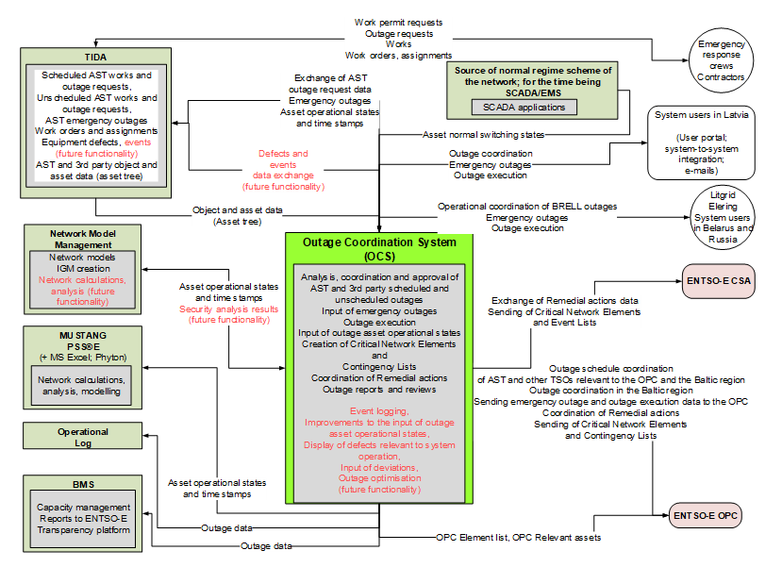
Figure 2-1 “Future IS Architecture”
The planning and recording of AST activities, including those requiring outages, and the approval of the AST outage schedule by the Operation Service are carried out in TIDA.
A new system, the Outage Coordination System (OCS), will be introduced to replace the existing applications, see Table 2-1 “Existing AST solutions”.
The coordination and coordination of all outages, including with third parties, as well as the validation of AST outage schedules will take place in the OCS, ensuring data exchange with the AST and external IS.
The OCS shall be the primary source of data for outage coordination, coordination, publication, use of assets states in network models and calculations, etc., and shall ensure the corresponding exchange of outage data and update of network equipment data from TIDA and receipt of normal assets states of network s from SCADA/EMS.
Data integrity is ensured – data is not re-entered, AST work data is sourced from TIDA; outage coordination and coordination, etc. processes are sourced from OCS.
An alternative to this IS architecture is:
all work and outage scheduling, coordination and coordination processes, including with third parties, take place in TIDA and TIDA is the source of all data; in this scenario, all functionality of the OCS is implemented within TIDA and no separate Outage Coordination System (OCS) is implemented.

Existing AST systems to be replaced by the OCS
The coordination and coordination of outages is currently done through decentralised solutions used by each service for its own needs. The following solutions will be fully or partially replaced by the implementation of the OCS:
Table 2-1 “Existing AST solutions”
Existing system/tool | Functions | Recommendation
APAS annual/monthly application | Coordination of annual and monthly outage schedules with third parties (LE; ST; connected users) is carried out via an application. | Replace with the OCS providing the annual and monthly schedule coordination and D-2 outage coordination in a single environment.
APAS D-2 application | The application ensures the coordination of D-2; D-7 (including third parties) and emergency outages between responsible persons of AST departments, neighbouring TSOs, BRELL and third parties. Internal coordination is performed through the status transitions of the outage request. External coordination activities are performed using e-mail and Word/PDF documents, reconciling results in the manual input of changes to the outage data into the application. | Replace with the OCS providing D-2 outage coordination and coordination confirmation in a single environment.
ENTSO-E .xlsx to .xml converter | For the transfer of outage data to the ENTSO-E OPC platform, the ENTSO-E .xlsx to .xml converter is used, which converts the outage data prepared in the DD .xlsx file into an .xml document, which is manually uploaded to the ENTSO-E OPC application. | Replace with the OCS ensuring automatic data collection and transmission to ENTSO-E OPC via OPDE (ECP).
BRELL outage scheduling MS Excel assistant | To ensure the feasibility of scheduled outages from a system security point of view, as well as to perform annual and monthly scheduling within the BRELL ring. SDRD uses an MS Excel file with macro functions to enter the outage schedules and make changes to them as the data received from the BRELL parties is reviewed. Automated functions and visualisations are used to analyse the data received, resulting in proposals for necessary changes. Changes and proposals for change are formatted in MS Excel and MS Word files and sent by e-mail. | Retain for BRELL coordination purposes.
APAS/TIDA data analysis MS Excel assistant | For the analysis of the APAS annual, monthly, D-2 and TIDA data for the considered time intervals and electricity system elements, SDRD uses an MS Excel file with macro functions, which allows the automated or manual retrieval of data on work orders and scheduled outages; the data can be selected by the selected time period and responsibility to a user-defined condition (geographic area, responsibility to a party, voltage, coordination/coordination process), presenting the filtered data in the form of data tables with the relevant fields of the analysis process highlighted and providing a generalised view of the outages for the different selected time periods in a graphical Gantt chart. | Replace with an OCS providing equivalent functionality.

OCS integration solutions planned
In order to ensure the full functioning of the OCS, as well as access to other IS, it is necessary to integrate the OCS with the following IS:
Table 2-2 “Integration solutions”
IS | Internal/external responsibility | Description
AST IS and tools
TIDA | Internal | Exchange of data on AST-related outages with TIDA: TIDA shall provide the OCS with data on works, that require outage, including work schedules created in the TIDA system; the OCS shall provide TIDA with current outage statuses, changes in outage start and end times, changes in restitution times, as well as detailed information on the status of the s of the facility(ies) specified in the outage request that will be involved in outage; the OCS shall also provide TIDA with data on emergency outages of assets;  TIDA shall provide the OCS with data on network s, its characteristics and operational affiliation, connections, objects, in a data structure that allows the OCS to register new outages and to analyse and process outages taking into account network topology, perimeter, operational responsibility, operational management, operational manager, information manager, etc.
MUSTANG; PSS®E; | Internal | the OCS provides on-demand outage operational status data for use in the electricity system modelling applications MUSTANG, PSS®E, etc. via the OCS API; the source of off-the-shelf network models for these applications in the future will be the NMM.
Dispatchers  log | Internal | The OCS will automatically transfer outage request opening and closing data to the Dispatchers log.
SCADA/EMS | Internal | The OCS receives data on demand from the network normal scheme source, which is currently SCADA/EMS, on the status of the object equipment or device according to the normal regime scheme.
AST systems currently under development
NMM | Internal | Transfer of outage data to the NMM; the NMM integrates the outage operational status data into the electricity system models and uses it in the calculations, as well as when transferring the network model data to other systems (MUSTANG, PSS®E, Dispatcher Training Simulator, etc.).
BMS | Internal | The OCS transfers outage data to the BMS on demand and/or periodically for transfer to the ENTSO-E transparency platform.
External systems
ENTSO-E OPC | External | The OCS provides integration with ENTSO-E OPC for data exchange necessary for outage coordination according to the Continental Europe Synchronous Area requirements and solutions:  - coordination and coordination/information of the annual outage schedule;  - coordination and coordination/information of the monthly outage schedule;  - coordination and coordination/information of the weekly outage schedule;  - transmission of outage requests for freely defined periods (e.g., from the next month to the end of the year, from the next days to the end of the week);  - transmission of a specific outage request or set of requests (e.g., scheduled outage requests for which changes have been made and no changes have been transmitted to the OPC);  - transmission and update of the list of network elements of the TSO control and monitoring areas, which is binding for the OPC process;  - preparation and transmission of Remedial Actions, Critical Network Elements and Event List data;  - receipt of recommendations for Remedial Actions.
ENTSO-E CSA | External | The OCS ensures the exchange of data necessary for the CSA process:  - preparation and transmission of Remedial Actions, Critical Network Elements and Event List data to the RCC;  receipt of reports and recommendations of Remedial Action from the RCC.
BRELL | External | If the AST is still operating under a BRELL contract, the OCS provides the necessary outputs for outage coordination with BRELL D-7 and the emergency outage coordination/information process.
Third party IS | External | The OCS provides the necessary integrations with other Third Party Systems for the exchange of outage coordination, emergency outage and outage execution data: with the Baltic TSOs, with ST, LE and Latvian transmission system users for the annual, monthly, weekly and D-2 processes.

OCS interface
The OCS will provide a user interface for AST users and third parties, as well as a data exchange interface for communication with third party systems.
The following table shows the functionality of the OCS by user interface:
Table 2-3 “OCS interfaces”
Form | Purpose
OCS User Interface (third party)
Home screen | The user workspace that opens after the AST user has logged in. The workspace contains the main navigation panel, which allows the user to navigate to the functionality they require. The home screen also displays information relevant to the user, such as system alerts, system state, tasks, actual and nearest outages etc.
Outage schedule submission, and coordination | Outage schedule submission and coordination functionality:  - third parties can submit outage schedules (.xls; .xml formats) or manually enter them and see the status of the schedule coordination.  - third parties can view the outage schedules and outage requests addressed to them, and can change their status, e.g., to ‘coordinated’, ‘read’.  Outage schedules and requests can be submitted for network elements – asset, – that are registered in the OCS asset tree (the asset tree is sourced from TIDA).
Request and coordination of outages (D-2 time period) | Third party outage request functionality – possibility to request third party outage and route them to AST for coordination, possibility to see the status of coordination.  Coordination of AST or third party outages – possibility to coordinate or reject outage performed by the AST or a third party.
OCS User interface (AST)
Home screen | The user workspace that opens after the AST user has logged in. The workspace contains the main navigation panel, which allows the user to navigate to the functionality they require. The home screen also displays information relevant to the user, such as system alerts, system state.
Administration panel | System process monitoring, data exchange log, system event and error log, technical reports.
Audit trail dashboard | Business event audit log.
Data exchange log | Message exchange information, messages sent/received, their status.
User and role management | Access rights management – users and roles.  Maintenance of basic information on organisation profiles, maintenance of AST users, maintenance of system users.  Management of user roles and access.
System configuration panel | Management of system configuration parameters (see 3.5.1 for a list of configuration parameters).
Coordination, coordination and approval of annual/monthly/weekly outage schedules | Receipt of annual/monthly/weekly schedules from TIDA. Receipt of third party outage schedules. Visualisation of outage data and schedules, creating views with different selection parameters, making changes to schedules from a graphical and list view. Coordination of schedules with third parties, return of coordination results to TIDA.
Coordination and approval of D-2 outages. Opening/closing of requests | Transfer of D-2 outages to internal and/or external coordinators/approvers for coordination, approval or information according to operational responsibility. Opening and closing of requests.
Graphical view for the analysis and optimisation of outage data | Visualisation of outage data in the form of a Gantt chart, by selected time periods, the possibility to filter outage data by different characteristics, e.g., specific date, asset , voltage. Possibility to change the outage times (slide outages in graphical view by day, by hour). Selecting a specific outage allows one to move to the edit view of the outage. By selecting the time period and the versions that have been created during the coordination of the outages, it is possible to compare what changes have been made between the versions.
Preparation of data for transmission to OPC and CSA and receipt of RCC recommendations | Possibility to enter and maintain a list of remedial actions, critical network elements and Contingency Lists for transmission to OPC and CSA (period, text of Remedial Actions, etc.) and to receive RCC reports and recommendations for the implementation of remedial actions.
Input of outages | Possibility to manually enter and maintain outages, including emergency outages, using asset tree data as required.
Reports | Possibility to select outage data for different periods, by parties involved, by status. Scheduled and actual implementation.
OCS data exchange interface
System to System data exchange interface | Data exchange via SOAP or REST web services and standardised data exchange formats .xml are provided.
Sharing data using file-sharing services | Data exchange via ECP/EDX services, SFTP server and standardised exchange formats .xml, .xlsx are provided.

OCS functionality
Scope of the objective to start synchronous operation of the Baltic electricity system with CESA in 2026, the scope of the CAS includes the coordination of outage schedules with European and Baltic TSOs using the OPC platform, D-15, D-2, and the coordination of emergency outages with Baltic TSOs and third parties (LV). D-15 The OCS domain does not include the coordination of outage schedules and coordination of outage requests within the BRELL ring.

Business functions
This section describes the core functions of the OCS that are necessary to support the Outage Coordination, Coordination and Approval process. The following figure provides a high-level diagram of the third parties involved in the Outage Coordination and Coordination process, broken down by time frames and activity to be performed.
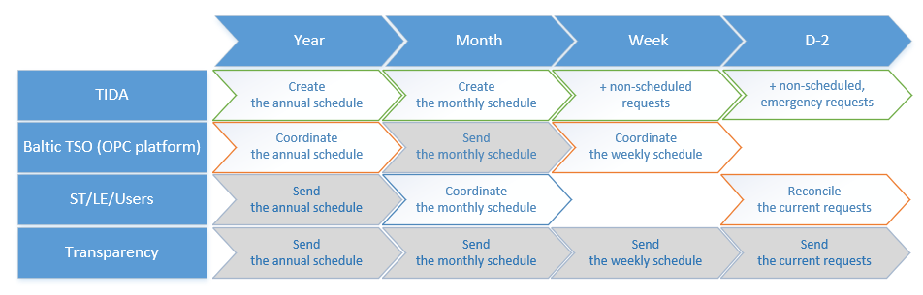
Figure 3-1 “High-level process flowchart”

Receipt and coordination of the annual outage schedule with third parties.
The work schedule (including works with and without outage required) for the Latvian TSO’s network asset, for the following year is created in the TIDA system based on the scheduled operational activities for the following year. The initially generated work schedule is reviewed, updated, adjusted and approved by the involved Operation Direction Services in TIDA.
- In the context of the OCS, it is assumed that before the annual schedule is received from TIDA: it has been approved by the responsible departments from the Operation Direction (IRG, TED, AD groups, LD, RD) and the PVD;
- the group leaders and foremen in TIDA have made a grouping of the works requiring an outage, creating master tasks – outage requests for creation in the OCS.
The OCS domain includes:
- initial assessment (review/correction) of asset, outages received from TIDA and the transfer of changes back to TIDA;
- coordination of the annual outage schedule in the CESA outage scheduling process (Baltic and Polish TSO outage data) using the OPC platform, including the receipt, evaluation and coordination of outage requests for the binding asset;
- after the completion of the annual outage scheduling process, the annual outage schedule is approved by the System Management Direction Services (DD, SDRD etc. if necessary) in CESA and sent to the involved parties;
- approval of the annual outage schedule by the System Management Direction Services is done via the OCS, as well as the transfer of the fact of approval to the TIDA Operation Direction work tasks and other involved parties;
- on request, the annual outage schedule data is also passed on to BMS and NMM.
Flowchart of the annual outage schedule coordination process:
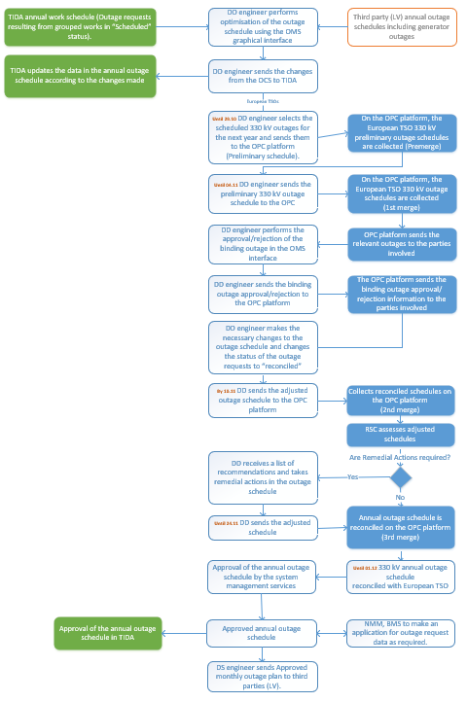
Figure 3-2 “Annual outage schedule coordination”

The following table summarises the high-level requirements for the OCS to ensure the coordination of the annual schedule with third parties.
Table 3-1 “Business requirements for the coordination of the annual outage schedule”
Function | Description
Receipt of the annual work, which require outage, schedule from TIDA | On request, it shall be ensured that the annual work schedule is received from TIDA in detail by outage request, with start and end times for each outage request, assets and connections and other necessary information. The annual outage schedule may be requested again from TIDA as necessary if there is a need to update the annual outage schedule entries with up-to-date information from TIDA.
Receipt of the annual outage schedule from third parties (LV), including generator outages | The receipt of third party (LV) outages, including information on generator outages, shall be ensured in the OCS so that the outages of all third party , including generating units, can be seen together when assessing the overall situation with scheduled outages. The outages of the generating units can also be used in the future for sending outage data to the BMS.
Obtaining the status of the object from SCADA | The DD engineer shall specify the object data in the outage request and make a request to SCADA for information on the object status according to the normal regime scheme.
Displaying and editing the outage schedule in graphical view | In order to allow the evaluation and optimisation of scheduled outages, the outage schedule shall be displayed and edited in graphical view with various selection parameters, such as period (year, month, week), voltage, operational responsibility, etc.
Transmission of changes made by DD to TIDA | It shall be ensured that the changes made by the DD to the outage data for the purpose of outage and work optimisation are returned to TIDA. The forwarding of changes to TIDA may be done at different steps of the process as required.
Coordination of the annual outage schedule with CESA through the OPC platform. | The coordination of the annual outage schedule with CESA using the OPC platform shall be ensured by providing the possibility to:  - select the outages required for the coordination process according to predefined parameters;  - specify the appropriate coordination flow;  - specify the addressee/s.
Receipt of binding outages (third party outages) from the OPC platform during the CESA coordination process | The annual outage schedule coordination process shall ensure the receipt of AST binding outages from the OPC platform. Coordination, rejection, initiation of changes with comments, return to the OPC platform.
Receipt of approval from the OPC platform of AST outages that are binding for other European TSOs | As part of the annual outage schedule coordination process, it shall be ensured that information on AST outages binding on other European TSOs is received. The information shall be received on a per outage basis, indicating whether the outage has been coordinated, rejected, changes proposed, with a comment on the reason for rejection or the changes required to the outage data.
Coordination status | Each outage schedule and the outage entries contained therein shall provide the ability to see which third party the coordination has been performed with, the status of the coordination, and what changes are being or have been proposed if the outage has not been approved.
Approval/rejection of changes | Based on the responses received during the coordination, it should be possible to make changes to the outage schedule data and indicate the reason for doing so, e.g., changing the start and end time of an outage based on RSC instructions or a suggestion from a European TSO.
Initiation of repeated coordination | The annual, weekly and outage coordination process shall provide the possibility to re-send outage schedules or individual outages to the OPC platform after outage data changes and status changes have been made to previously sent schedules.
Data exchange with RCC | It shall be possible to prepare and send data to the RCC (Remedial Actions, Critical Network Elements and Contingency Lists) and receive a list of remedial action recommendations from the OPC platform after the RCC has carried out the annual outage schedule review and recommendation development. The Remedial Action List is an unstructured .pdf or .xlsx file which is received by e-mail and can be manually added to the system.
Versioning of the outage schedules | Versioning of both the outage schedules and their entries shall be provided to allow the tracking of changes made.
Approval of the annual outage schedule by the system management services | After the CESA coordination process has been completed, the approval of the annual outage schedule by the system management services should be ensured, indicating the responsible approvers and the action to be taken (coordination, approval).
Transmission of changes to TIDA | After the approval of the annual schedule by the system management services, it shall be ensured that the changes made (e.g., changed outage times, outage statuses) are transmitted to the TIDA system for necessary secondary approval.
Transmission of the schedule to third parties (LB) | It shall be ensured that the approved outage schedule is sent to third parties (LV), and that the annual schedule is approved by the system management services  When preparing the outage schedule for transmission it shall be possible to:  - select the outages required for each third party according to predefined parameters;  - specify an appropriate coordination flow (e.g., informative transmission);  - specify the recipient/s.
Transfer of the outage schedule to the BMS | On request, the transfer of the annual outage schedule to the BMS shall be ensured.
Transfer of the outage schedule to the NMM | On request, the transfer of the annual outage schedule to the NMM shall be ensured.

Coordination and approval of the monthly outage schedule
The outage schedule for the Latvian TSO’s network asset, for the following month is created in the TIDA system based on the scheduled operational activities for the following month included in the annual work schedule. The work schedule for the following month, initially generated by TIDA, shall be reviewed, updated, adjusted and approved by the involved Operation Direction Services:
- In the context of the OCS, it is assumed that before the monthly schedule is received from TIDA: it has been approved by the responsible departments from the Operation Direction (IRG, TED, AD groups, EUD, LD, RD, TKD) and the PVD;
the Work planner / manager in TIDA have made a grouping of the works requiring an outage, creating master tasks – outage requests. The OCS scope includes:
- initial assessment (review/correction) of the monthly outage schedules received from TIDA and the transfer of the changes made back to TIDA;
- coordination of monthly outage schedules with third parties (LV);
- transmission of the monthly outage schedule to the OPC platform used in the CESA outage scheduling process (the process can also update the annual outage schedule from the beginning of the following month until the end of the year) and the receipt of approved third party outage schedules from European TSOs;
- after the coordination of the monthly outage schedule with third parties is completed, approval of the monthly outage schedule is carried out by the system management services (DD, SDRD, etc. if necessary);
- after approval of the monthly schedule by the system management services, transmission of the monthly outage schedule is sent to:
  - third parties (LV);
  - TIDA for the final approval of the annual outage schedule by the Operation Direction;
- on request, the annual outage schedule data is also passed to BMS and NMM.
Flowchart of the monthly outage schedule coordination process:
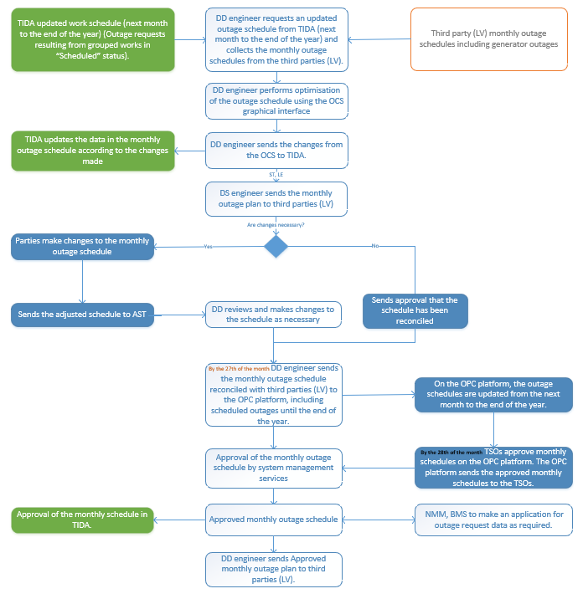
Figure 3-3 “Coordination of monthly outage schedule”
High-level requirements for the coordination of monthly outage schedules with third parties:
Table 3-2 “Business requirements for the coordination of the monthly outage schedule”
Function | Description
Receipt of the monthly outage schedule from TIDA | On request, it shall be ensured that the monthly outage schedule (including from the beginning of the following month until the end of the year) is received from TIDA in detail by outage request, with start and end times for each outage request, assets and connections and other necessary information. The monthly outage schedule may be requested again from TIDA as necessary if there is a need to update the monthly outage schedule entries with up-to-date information from TIDA.
Receipt of the monthly outage schedule from third parties (LV), including generator outages | The receipt of third party (LV) outages, including information on generator outages, shall be ensured in the OCS so that the outages of all third party , including generating units, can be seen together when assessing the overall situation with scheduled outages. The outages of the generating units can also be used in the future for sending outage data to the BMS.
Displaying and editing the outage schedule in graphical view | In order to allow the evaluation and optimisation of scheduled outages, the monthly outage schedule shall be displayed and edited in graphical view with various selection parameters, such as period (year, month, week), voltage, operational responsibility, etc.
Obtaining the status of the object from SCADA | The DD engineer shall specify the object data in the outage request and make a request to SCADA for information on the object status according to the normal regime scheme.
Transmission of changes made by DD to TIDA | It shall be ensured that the changes made by the DD to the outage data for the purpose of optimising the outages are returned to TIDA. The forwarding of changes to TIDA may be done at different steps of the process as required.
Coordination of monthly outage schedules with third parties (LV) | The coordination of the annual outage schedule with third parties (LV) shall be ensured by providing the possibility to:  - select the outages required for the coordination process according to predefined parameters;  - specify the appropriate coordination flow;  - specify the addressee/s.
Coordination status | Each outage schedule and the outage entries contained therein shall provide the ability to see which third party the coordination has been performed with, the status of the coordination, and what changes are being or have been proposed if the outage has not been approved.
Approval/rejection of changes | Based on the responses received during the coordination, it should be possible to make changes to the outage schedule data and indicate the reason for doing so, e.g., it is proposed to change the start and end time of the outage. Changes shall be possible either by manual adjustment of the outage data or by automatic reading from standardised .xml files.
Change of the status of the outage schedule | After the coordination process has been completed, it shall be ensured that the status of the schedule requests is changed to “Coordinated”.
Versioning of the outage schedules | Versioning of both the outage schedules and their entries shall be provided to allow the tracking of changes made.
Transmission of the monthly outage schedule to CESA through the monthly coordination process using the OPC platform | It shall be ensured that the monthly outage schedule (including from the beginning of the following month until the end of the year) is sent to the OPC platform.
Receipt of binding outages (third party outages) from the OPC platform during the CESA monthly coordination process | The monthly outage schedule coordination process shall ensure that AST binding outages are received from the OPC platform and included in the monthly outage schedule approved by the system management departments.
Approval of the monthly outage schedule by system management services | After the coordination of the monthly outage schedule with third parties (LV), the approval of the monthly outage schedule by the system management departments shall be ensured, indicating the responsible approvers and the action to be taken (coordination, approval).
Transmission of changes to TIDA | After the approval of the monthly schedule by the system management services, it shall be ensured that the changes made (e.g., changed outage times, outage statuses) are transmitted to the TIDA system.
Transmission of the schedule to third parties (LB) | It shall be ensured that the approved outage schedule is sent to third parties (LV) after it has been approved by the system management services.  When preparing the outage schedule for transmission it shall be possible to:  - select the outages required for each third party according to predefined parameters;  - specify an appropriate coordination flow (e.g., informative transmission);  - specify the recipient/s.
Transfer of the outage schedule to the BMS | On request, the transfer of the monthly outage schedule to the BMS shall be ensured.
Transfer of the outage schedule to the NNM | On request, the transfer of the monthly outage schedule to the NMM shall be ensured.

Coordination and approval of the weekly outage schedule
The process of scheduling and approving the next week’s outages is currently not carried out in the Operation Direction. Unscheduled works and resulting outages are registered with TIDA and submitted to DD for coordination in accordance with the Procedure for handling outage requests of Augstsprieguma tīkls AS.
According to the requirements of coordination with CESA, coordination of weekly outage schedules with European TSOs has to be carried out, therefore it is necessary to ensure the selection of outage data from the TIDA system for a freely defined period so that the DD engineer can use the OCS to select the outages scheduled for the current week from the TIDA system, as well as to ensure that the OCS can transfer changes in outages that have occurred during the coordination of the weekly schedule to TIDA. The CESA weekly outage coordination process shall start on Wednesday of the current week for the period from Saturday up to and including the following Friday.
Considering that TIDA does not currently have a weekly scheduling process, it is assumed that Operation Services will plan, group and submit the weekly work to DD by the end of the working day on Tuesday (the weekly schedule should include work on the that TIDA will indicate is involved in the CESA scheduling process) for the period of Saturday to Friday of the next week (inclusive).
The OCS domain includes:
- initial assessment (review/correction) of the weekly outage schedules received from TIDA and the transfer of the changes made back to TIDA;
- transmission of the weekly outage schedule to the OPC platform used in the CESA outage scheduling process, receipt and approval of binding outages from European TSOs;
- after the coordination of the weekly outage schedule with CESA is completed, approval of the monthly outage schedule is carried out by the system management services (DD, SDRD, etc. if necessary);
- after approval of the weekly schedule by the system management services, transmission of the monthly outage schedule is sent to:
  - third parties (LV);
  - TIDA to make the changes made during the coordination process available;
- on request, the weekly outage schedule data is also passed on to BMS and NMM.

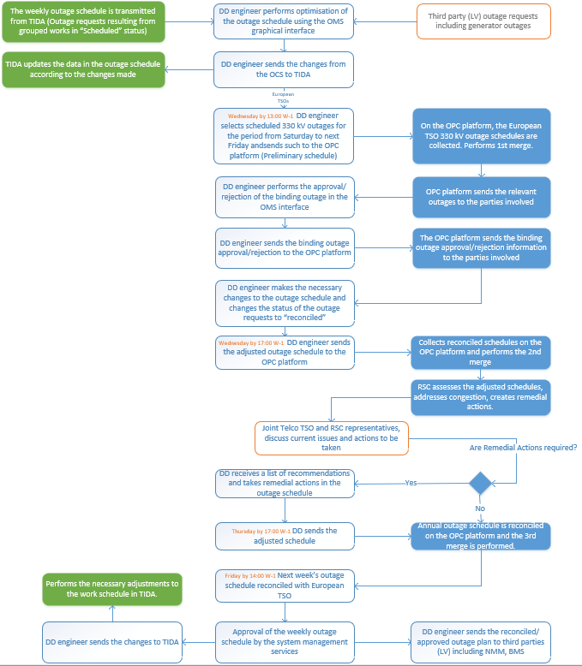
Figure 3-4 “Weekly outage schedule coordination”
High-level requirements for the coordination of weekly schedules with third parties:
Table 3-3 “Business requirements for the coordination of the monthly outage schedule”
Function | Description
Receipt of the outage schedule from TIDA | On request, it shall be ensured that the weekly outage schedule (including from the beginning of the following month until the end of the year) is received from TIDA in detail by outage request, with start and end times for each outage request, outage and connections as well as other necessary information. The weekly outage schedule may be requested again from TIDA as necessary if there is a need to update the monthly outage schedule entries with up-to-date information from TIDA.
Receipt of the outage requests from third parties (LV), including generator outages | The receipt of third party (LV) outages, including information on generator outages, shall be ensured in the OCS so that the outages of all third party , including generating units, can be seen together when assessing the overall situation with scheduled outages. The outages of the generating units can also be used in the future for sending outage data to the BMS.
Displaying and editing the outage schedule in graphical view | In order to allow the evaluation and optimisation of scheduled outages, the outage schedule shall be displayed and edited in graphical view with various selection parameters, such as period (year, month, week), voltage, operational responsibility, etc.
Obtaining the status of the object from SCADA | The DD engineer shall specify the object data in the outage request and make a request to SCADA for information on the object status according to the normal regime scheme.
Transmission of changes made by DD to TIDA | It shall be ensured that the changes made by the DD to the outage data for the purpose of outage and work optimisation are returned to TIDA. The forwarding of changes to TIDA may be done at different steps of the process as required.
Coordination of the weekly outage schedule with CESA through the OPC platform | The coordination of the annual outage schedule with CESA using the OPC platform shall be ensured by providing the possibility to:  - select the outages required for the coordination process according to predefined parameters;  - specify the appropriate coordination flow;  - specify the addressee/s.
Receipt of binding outages (third party outages) from the OPC platform during the CESA coordination process | The weekly outage schedule coordination process shall ensure the receipt of AST network binding outages from the OPC platform. Coordination, rejection, initiation of changes with comments, return to the OPC platform.
Receipt of approval from the OPC platform of AST outages that are binding for other European TSOs | As part of the annual and monthly outage schedules coordination process, it shall be ensured that information on AST outages binding on other European TSOs is received. The information shall be received on a per outage basis, indicating whether the outage has been coordinated, rejected, changes proposed, with a comment on the reason for rejection or the changes required to the outage data.
Coordination status | Each outage schedule and the outage entries contained therein shall provide the ability to see which third party the coordination has been performed with, the status of the coordination, and what changes are being or have been proposed if the outage has not been approved.
Approval/rejection of changes | Based on the responses received during the coordination, it should be possible to make changes to the outage schedule data and indicate the reason for doing so, e.g., changing the start and end time of an outage based on RSC instructions or a suggestion from a European TSO.
Initiation of repeated coordination | The annual, weekly and outage coordination process shall provide the possibility to re-send outage schedules or individual outages to the OPC platform after outage data changes and status changes have been made by previously sent and approved schedules.
Data exchange with RCC | It shall be possible to prepare and send data to the RCC (Remedial Actions, Critical Network Elements and Contingency Lists) and receive a list of remedial action recommendations from the OPC platform after the RCC has carried out the weekly outage schedule review and recommendation development. The Remedial Action List is an unstructured .pdf or .xlsx file which is received by e-mail and can be manually added to the system.
Versioning of the outage schedules | Versioning of both the outage schedules and their entries shall be provided to allow the tracking of changes made.
Approval of the weekly outage schedule by the system management services | After the CESA coordination process has been completed, the approval of the weekly outage schedule by the system management services should be ensured, indicating the responsible approvers and the action to be taken (coordination, approval).
Transmission of changes to TIDA | After the approval of the weekly schedule by the system management services, it shall be ensured that the changes made (e.g., changed outage times, outage statuses) are transmitted to the TIDA system.
Transfer of the outage schedule to the BMS | The transfer of the weekly outage schedule to the BMS shall be ensured.
Transfer of the outage schedule to the NNM | The transfer of the annual outage schedule to the NMM shall be ensured.
Submission of changes to the weekly schedule on the OPC platform | It shall be ensured that when the OPC weekly scheduling process has been completed but changes to the weekly outage schedule have occurred (new outage request or change to an existing request) it is possible to send the changes to the OPC platform for coordination and feedback on the coordination of the request, as well as to submit data on emergency outages and outage performance.
Receipt of changes from the OPC after the weekly coordination process has been completed | It shall be ensured that, after the weekly scheduling process has been completed, it is possible to receive third party requests for coordination from the OPC platform and to send back information on the coordination, as well as data on emergency outage and outage performance.

Coordination and approval of D-2 outages
The D-2 outage coordination/approval process includes the coordination and approval (opening, closing, extension) of AST outage requests received from TIDAs within the weekly schedule, as well as the coordination of outage requests received from third parties (Baltic TSOs, Contractors, ST, LE, users connected to the AST transmission network). Currently, two workflows are primarily foreseen in the OCS: the approval workflow (for AST requests) and the coordination workflow (for third party requests).
The approval workflow for outage requests (see Figure 3-5) includes the coordination of requests with the AST responsible departments (DD, SDRD, BPD, SAAD) as well as with third parties that need to be involved in the approval process according to the operational responsibility of the asset. The process of coordination with AST departments and third parties is carried out in parallel; following the results of the coordination process, the Head of DD decides on the approval of the request.
Outage request approval flow:
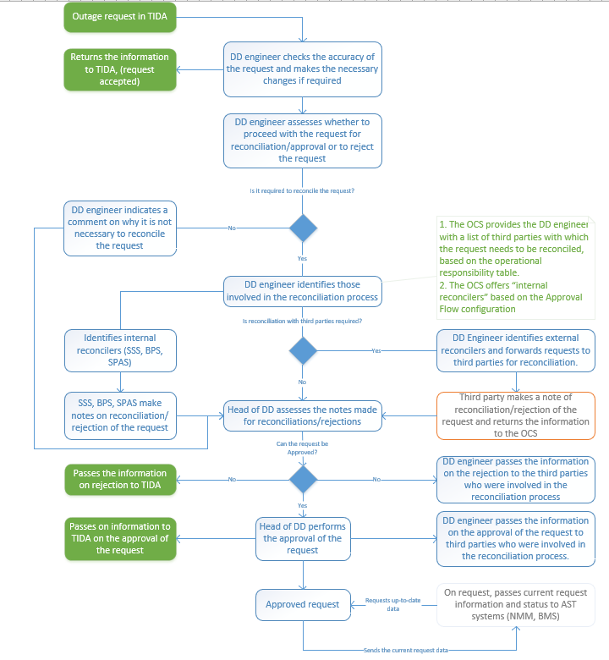
Figure 3-5 “D-2 request approval flow”
Outage request coordination flow
Procedure for handling outage requests of Augstsprieguma tīkls AS specifies the times for the submission, coordination and response of outage requests depending on the operational responsibility of the asset; the OCS domain includes functionality that infAPAS the DD employee that the times for the submission, coordination and response of requests are approaching or not respected, but will not restrict the DD from submitting, reconciling or approving requests if these times are not respected.
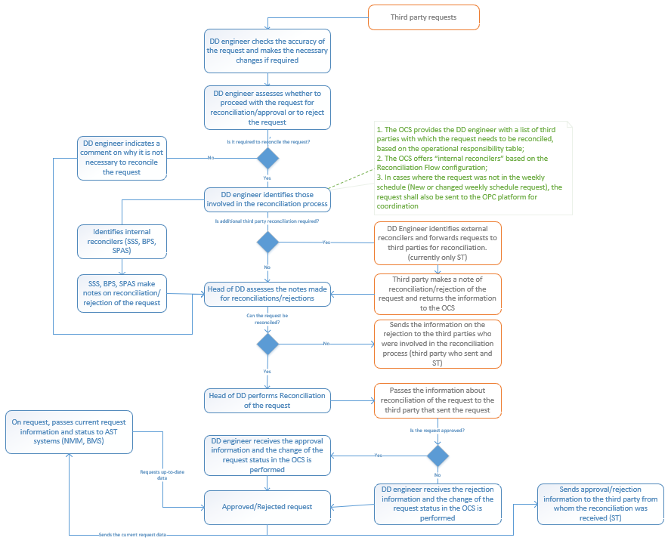
Figure 3-6 “D-2 Third Party request coordination flow”
The following table summarises the high-level requirements for the OCS to be able to provide the coordination and approval of outage requests as part of the D-2 process.
Table 3-4 “Business requirements for the approval and coordination of D-2 requests”
Function | Description
Receipt of requests from TIDA | The receipt of scheduled, unscheduled outage requests from TIDA, as well as the display and correction of request information (e.g., outage start, end and restitution times) shall be ensured.
Feedback to TIDA | After the DD engineer has verified the correctness of the request data, feedback to TIDA should be provided, sending the information that the request has been accepted and will be routed through the approval flow.
Input of emergency outages | Manual entry of emergency outages into the OCS and their transfer to TIDA shall be ensured after the outage request has been closed.
Input of additional instructions | Additional instructions shall be provided for the input of the request, for the outage connections, the relevant asset, e.g., object, connection, asset, state, start time, and end time. The input of additional instructions will be performed in a structured way.
Change of asset, status with respect to the normal regime scheme | The OCS shall, at the request of the DD engineer, receive data from SCADA on the asset, and status of the objects specified in the outage request according to the normal regime scheme. The DD engineer shall evaluate the information provided in the outage and related outages and shall perform the change of the desired status with respect to the normal regime scheme.
Receipt of requests from third parties | The receipt of requests for scheduled, unscheduled and emergency outages from third parties shall be provided by:  - system to system integration with third party systems;  - manual data entry into the OCS user interface;  - data entry into the OCS external portal.  Requests can be received for a variety of assets, s, including generation units.
Display of related requests | The display of requests associated with an Outage Request shall be provided, according to predefined criteria, e.g., time period, object, asset.
Linking of current requests to schedule requests | Scheduled outage requests shall be linked to the annual, monthly, weekly schedule entries in order to allow the schedules to see the current status of the request and the actual request execution data, as well as to report on the execution and actual execution of scheduled outages.
Graphical display of requests | In order to allow the evaluation of the request and the impact on previously scheduled and approved outages, the display and editing of requests in graphical view shall be ensured, together with the outages scheduled, coordinated, approved in the selected time period (year, month, week, freely chosen time period).
Editing of request data | Before the request is routed for coordination/approval, it should be ensured that the DD engineer can edit the request data, e.g., the start, end and emergency restoration times of the outage. Editing of request data shall be possible from both list view and graphical view.
Routing of an outage request for coordination/approval | It shall be possible to route an outage request through the coordination or approval flow (see Figure 3-5 and Figure 3-6) by specifying the reconcilers within AST and, where necessary, the third parties to be coordinated with, according to the operational responsibility table.
Feedback on the coordination of the request | It shall be ensured that feedback is received/manually entered on whether the request has been coordinated/rejected by the AST services and third parties (status change, suggestions to change request times).
Assessment of the request | It shall be ensured that the coordinations of the request can be clearly viewed in order to be able to decide on the coordination/approval/rejection of the request in a timely manner.
Change of status of the request and notification of third parties | It shall be ensured that it is possible to reconcile/approve/reject a request and to send information to third parties according to the operational responsibility table.
Transmission of the status and changes of the request to TIDA | It shall be possible to transmit information on the Approval/Rejection of a request to TIDA, indicating the status of the request and the changes made to the request data (e.g., request start, end, restitution times changed).
Receipt of feedback on third party request | It shall be ensured that third parties are informed that a request that has been sent to the AST for coordination has been approved or cancelled.
Transfer of the outage data to the BMS | It shall be ensured that up-to-date outage data are transferred to the BMS for the requested period.
Transfer of the outage data to the NNM | It shall be ensured that up-to-date outage data are transferred to the NNM for the requested period.
Warning of the time for submission, coordination and response of outage requests | A functionality shall be ensured to inform the DD engineer, based on the times for the submission, coordination and response of outage requests, depending on the operational responsibility of the asset, that the time for submission, coordination and response of requests is approaching or is not respected. The functionality is informative and will not restrict the DD engineer from submitting, reconciling or approving requests if these times are not respected.
Input of communication request outages | Input of LE communication outage requests and input of additional information (e.g., instructions to the technical operation service, instructions to DD engineers) shall be ensured.

Supporting processes

Basic principles for communication with third parties
For data exchange with third parties, the OCS will provide:
- system to system data exchange using SOAP and/or REST web services and ENTSO-E compliant .xml files;
- file exchange services using ECP/EDX and SFTP data exchange interface and ENTSO-E compliant .xml files, standardised .xlsx files are allowed for SFTP;
- external portal for outage data browsing, coordination and request. The external portal allows uploading of data using standardised .xlsx templates or standardised .xml files. It is assumed that the OCS data exchange portal can be built by complementing the BMS external portal with new but separate functionality;
- export of data selected in standard or customised views in .xlsx format;
- standardised API for the retrieval of outage data from the OCS;
- OPDE(ECP) is used for communication with ENTSO-E OPC and ENTSO-E CSA systems.

! The OCS Data Exchange Services will use the BMS integration platform.

System configuration
Requirement | Description
Automatic retrieval of third party data based on operational responsibility | Based on the operational responsibility of the asset, equipment. device, automatic reading of third party data shall be initiated during the outage request and outage schedule coordination process.
User management | The OCS shall provide for the role-based management of user rights (user->role->access rights).  AST users are authenticated using the Active Directory. System users required for data exchange are created in the AST Active Directory and used for service authentication.
Workflow Management Module | Currently, the following workflows are provided in the OCS:  - annual and weekly schedule coordination workflow, where it is possible to define the number of coordination steps (e.g., 1st merge, 2nd merge, 3rd merge) and to perform sequential coordination actions;  - the transmission workflow, which informally sends outages or outage schedules to the parties involved;  - annual, monthly and weekly schedule approval workflow;  - outage request approval workflow (for AST requests);  - outage request coordination workflow (for third party requests).  Given the number of parties involved and the need to adapt to changing business processes, it is necessary to provide workflow configuration options within which it is possible to:  - change the business process;  - change the steps of the workflow;  - define thresholds;  - define user decisions;  - view the progress of the workflow, etc.
Process scheduler | In order to ensure regular communication with third parties, automatic messages should be sent at predefined times using the process scheduler functionality, with the flexibility to configure the content and recipients of the information to be sent.
Creation of personalised filters | The functionality to create and save user filters shall be provided.
View creation functionality | It shall be ensured that users can create personalised views with defined data filters and columns.
Creation of Critical network elements and Contingency Lists | The creation of Critical network elements and Contingency Lists (creation of network elements and combinations of network elements) shall be provided.
Versioning | The creation of versions for the annual, monthly, weekly schedule and for the outage entry shall be provided to allow data analysis functions to be performed during the life cycle of the asset, outage request.
Approval of changes to the asset tree | When receiving changes or a first-time asset tree from TIDA, it shall be possible to enter the necessary descriptive data for the asset, , if required, and to confirm that the asset, is added to the asset tree.
Creation of audit trails | An audit functionality shall be ensured to record the activities performed in the system:  documents (documents received, generated and sent, including all its versions, etc.);  user and system activities (data entry, data correction, data deletion, business process execution activities, etc.).

Classifiers, basic system data

Requirement | Description
Asset tree | It is necessary to maintain the asset tree and its Operational IDs. It is planned that the asset tree is primarily maintained in the TIDA system, including third party asset and the OCS must immediately receive updated asset tree from TIDA.
Asset, operational responsibility | For each asset, piece of , the type of responsibility and the third party to which the asset, responsibility relates shall be indicated, under Operational control, Operational monitoring and Informative monitoring. When performing the request coordination/approval it is necessary to see the type of asset, responsibility and the third parties covered by each type of responsibility; this is necessary for the DD engineer to decide on the appropriate coordination flow for the outage request and the parties involved, to whom the request should be sent for coordination or simply for information.  The asset, operational responsibility table is maintained in TIDA, the OCS imports the operational responsibility table and updates it periodically from TIDA.  Multiple operational responsibility entries and responsible parties may be specified for a single asset.
List of binding elements | It is necessary to maintain a relevant asset list, a list of third party elements to which the binding outages in the AST need to be coordinated with CESA as part of the coordination.
Outage request | Outage request (Information from TIDA: object, connection, asset, status, description of works, start time, end time, restitution time; Additional instructions: object, connection, asset, state, start time, end time; Information on the coordinations performed and approval of the request; Information on the opening and closing of the request; Information on the response to the parties in relation to the execution of the request).
Outage schedule | A list of outages from which it is possible to select specific outages, filterable according to different criteria (year, month, week, freely selectable period).
State of the asset, | Definition of the state of the asset, according to the scheme required for the outage (asset, at work; under repair; on standby, etc.).
Register of third parties | Third party data logging shall be provided. In the register of third parties, for each party, it shall be possible to specify at least the following information:  - name and role (e.g., TSO, DSO, System User, Contractor, RCC);  - Period (valid from – valid to);  - EIC  - contact details and other relevant information;  - communication channel and related configuration information;  configuration, which shall be included in the outage schedules when coordinated with each of the third parties.

Integration requirements

Data exchange with TIDA
Requirement | Description
Network asset tree | The asset tree required for the OCS (330 kV lines and asset, , 110 kV interconnectors, generators, third party binding asset) shall be periodically transferred to the OCS.
Asset, data | After any data or asset updates in TIDA, the new data must be provided to OCS (EIC, MRID, Operational responsibility, Critical element, OPC element).
Transfer of the annual, monthly and weekly outage schedule to the OCS | The annual, monthly and weekly outage request schedule shall be made available to the OCS on request. The works will be grouped by outage requests and the outage requests will be transferred to the OCS.
Changes to annual, monthly and weekly schedule in the OCS | It shall be ensured that changes occurring in the outage data within the framework of the AST review and changes occurring within the framework of coordination with third parties are transferred from the OCS to TIDA (opening time, closing time, restitution time, status).
Transfer of the request | The transfer of the outage request to the OCS for execution shall be ensured, as well as the receipt of changes made to the request from the OCS (e.g., in coordination, coordinated, rejected, open, closed, opening time, closing time, restitution time).
Receipt of emergency outages | It shall be ensured that the data for emergency outage requests are received from the OCS.
Receipt of operational states of outage | The receipt of operational state data of the outage from the OCS shall be ensured.
Configuration provision | To ensure correct integration, TIDA shall maintain a configuration of the to which the binding outages are to be transmitted to the OCS.

Transfer of outage data to the NMM
Requirement | Description
operational state | Scheduled operational state with date and time stamps according to the current outage schedule. The transfer of data to the NMM shall be ensured on demand according to the time periods defined in the IGM creation and automated calculation functions.
Configurable content of the outage schedule/document | It shall be possible to configure the list of elements with which the binding outages are included in the data exchange document that is transferred to the NMM (e.g., 330 kV lines, 110 kV lines, 330 kV substation busbars).

Transfer of the outage data to the BMS
Requirement | Description
Exchange of annual, monthly, weekly schedule data | It shall be ensured that approved annual, monthly, weekly outage schedules are exchanged with the BMS on request or sent to the BMS according to a predefined schedule.
Exchange of D-2 outage data | It shall be ensured that D-2 coordinated/approved outage requests are exchanged with the BMS on request or sent to the BMS according to a predefined schedule.
Exchange of outage data for a freely defined period | In addition to the predefined outage schedules (year, month, week), outage data for a freely defined period shall be collected and transmitted to the BMS on demand or to the BMS on a predefined schedule.
Configurable content of the outage schedule/document | It shall be possible to configure the list of elements with which the binding outages are included in the outage schedule/document that is transferred to the BMS (e.g., 330 kV lines, 110 kV lines, 330 kV substation busbars). Currently, the BMS requires the outage related to 330 kV lines and substation busbar outages, but the list of elements to be included may change depending on changes in business requirements.

Exchange of outage data with ENTSO-E OPC
Requirement | Description
Annual outage schedule coordination | The annual outage schedule shall be sent to the ENTSO-E OPC platform in .xml format.  It shall be possible to receive information from the ENTSO-E OPC platform in .xml format on whether submitted outages have been approved, partially approved or rejected with a reason.  It shall be possible to receive information from the ENTSO-E OPC platform in .xml format on the binding outages to be coordinated by the AST and to ensure that the coordinations made are sent back to the OPC platform.
Transmission of the monthly schedule | The monthly outage schedule shall be sent to the ENTSO-E OPC platform in .xml format. Currently, the transmission of the monthly schedule is informative, but in the future it may also be subject to a coordination process.
Weekly outage schedule coordination | The weekly outage schedule shall be sent to the ENTSO-E OPC platform in .xml format.  It shall be possible to receive information from the ENTSO-E OPC platform in .xml format on whether submitted outages have been approved, partially approved or rejected with a reason and to ensure that the coordinations made are sent back to the OPC platform.
Processing of acknowledgement documents | The syntax checking of the received .xml documents, the creation of the corresponding acknowledgement documents and the sending of the .xml documents upon receipt from the OPC platform shall be ensured. The receipt and processing of the acknowledgement document after the .xml documents have been sent to the OPC platform shall be ensured
Exchange of outage data for a freely defined period | In addition to the predefined outage schedules (year, month, week), outage data for a freely defined period shall be collected and exchanged with the OPC platform on demand or sent to the OPC according to a predefined schedule.
Transfer of the list of network and transfer of binding | Transmission and update of data on network equipment relevant to OPC processes – list of network assets (assets for which outage may be scheduled) and marking of other PSO relevant to the OPC process (Relevant assets) – transmission and update of the list of relevant elements.
Configurable content of the outage schedule/document | It shall be possible to configure the list of elements with which the binding outages are included in the outage schedule/document that is transferred to the OPC platform (e.g., 330 kV lines, 110 kV lines, 330 kV substation busbars). Currently, the OPC platform requires the outage related to 330 kV lines and substation busbar outages, but the list of elements to be included may change depending on changes in business requirements.
Remedial Actions | It shall be ensured that remedial actions (period and corresponding remedial actions) are sent and recommendations are received.

Exchange of outage data with ENTSO-E CSA
Requirement | Description
Remedial Actions | It shall be ensured that remedial actions (period (D-1, ID) and corresponding remedial actions) are sent to the ENTSO-E CSA platform and that RCC reports and recommendations are received via OPDE (ECP).
Event List | It shall be ensured that the Event List containing network elements and combinations of network elements is sent in .xml format to the ENTSO-E CSA platform via OPDE (ECP).
Critical network elements | It shall be ensured that the list of critical network elements is sent in .xml format to the ENTSO-E CSA platform via OPDE (ECP).

Exchange of outage data with third parties (LV).
Requirement | Description
Transmission of the annual and monthly schedule | It shall be ensured that the annual and monthly outage schedule is sent to third parties (LV) for information purposes.
Monthly outage schedule coordination | It shall be ensured that the monthly outage schedule is coordinated with the ST and that information on coordination, rejection or necessary changes can be received or entered manually.
Receipt of outage of generating units | It shall be ensured that the data on the outage of generating units are received from LE.
Receipt of outage request for coordination | It shall be ensured that a third party can submit an outage Request to AST for coordination and receive feedback on the coordination.
Transmission of outage request for coordination | It shall be ensured that the OCS can send an outage request to the third party for coordination and receive or manually enter information on coordination, rejection or required changes.
Exchange of emergency outage and outage execution data | It shall be ensured that data exchange (sending, receiving, manual input) of emergency outage and outage executions is possible.

Transfer of outage data to the Operational Log

Requirement | Description
Data on opening and closing of the outage request | It shall be ensured that data on the opening and closing of outage requests are automatically transferred to the Dispatcher Department Operational Log.

Transfer of state data to MUSTANG; PSS®E

Requirement | Description
Transfer of operational states | It shall be ensured that the OCS provides on-demand outage operational status data for use in the electricity system modelling applications MUSTANG, PSS®E, etc. via the OCS API.

Receipt of data from SCADA
Requirement | Description
Receipt of and its status data | It shall be ensured that data on object (substation) s and its states can be retrieved from SCADA/EMS on demand according to the normal regime scheme.
! The exact communication channels with third parties will be defined during the development of the technical requirements. At the moment it is assumed that automated data exchange is possible:
- with LE (transmission of outage schedules, receipt of assets of generating units, coordination of requests via .xml files and web service);
- with ST (transmission of outage schedules, coordination monthly outage schedule, coordination of requests via .xml files and web service);
- system users are expected to have access to outage schedules via the external portal of the OCS, as well as to make outage requests for coordination.

Assumptions
In order to ensure the exchange of key data between TIDA and the OCS, it is assumed that:
- TIDA will introduce the grouping of works into master tasks and the transfer of master tasks to the OCS;
- TIDA will implement add-ons to receive changes to outage data from the OCS and correctly apply them to the works below the master task;
- TIDA will manually enter the outage assets that is related to the works;
- TIDA will introduce a “weekly” scheduling process for works requiring outages (330 kV only), resulting in works for the period from the following Saturday to the following Friday to be transferred to the OCS by the end of the working day on Tuesday of the current week;
- A solution will be found so that the outages entered by the PVD in TIDA for new construction and reconstruction projects are processed in the overall outage and works scheduling flow.
It is assumed that the Baltic TSOs will agree on the use of the OPC platform for the coordination of annual, monthly and weekly schedules, including sending changes to OPC after the weekly scheduling process is completed.

Development roadmap
Preliminary development roadmap with the assumption that the procurement of a developer is launched by no later than 30.11.2023. As the procurement deadline shifts, the deadlines for future activities also shift proportionally.
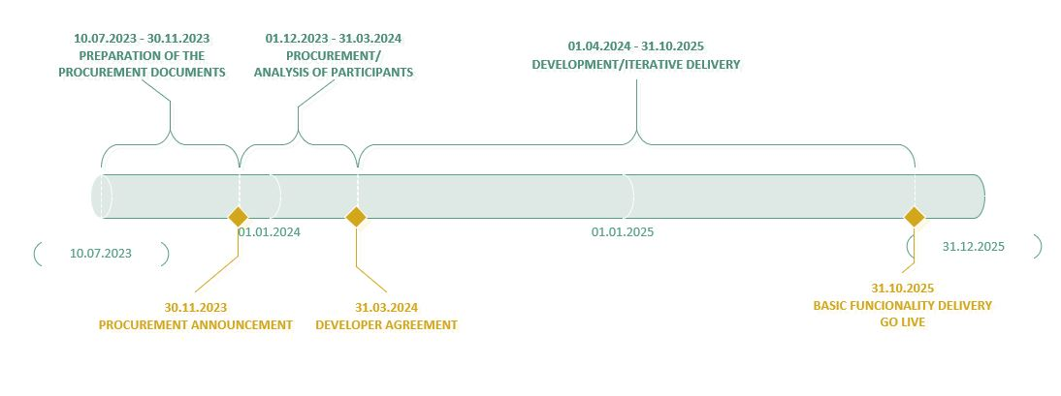

Future functionality
In the future, the OCS may be developed with the following functionality:
- event logging and display of defects relevant for operational work, in integration with the TIDA system;
- improvements in the input of operational states through the use of switching schedule, real-time receipt of state data from SCADA/EMS;
- receipt of data from NMM on the results of the outage security analysis;
- recording and reporting of deviations from normal scheme, normal regime;
- outage analysis to optimise work execution and the outages required for the work;
- other additional functionalities.

